Resources for Studying the History of the Olympic Games

Last updated August 2016


RESOURCES FOR STUDYING THE HISTORY OF THE OLYMPIC GAMES

The following listing highlights a range of archival and printed material in our collections relevant to the study of the history of the Olympic Games. These resources include institutional archives, personal and family collections, printed materials, collectables and other ephemera.

We welcome enquiries from potential researchers at any level and are very pleased to offer advice and assistance in using our archives in one-to-one or small group sessions by appointment.

National Athletics Archive

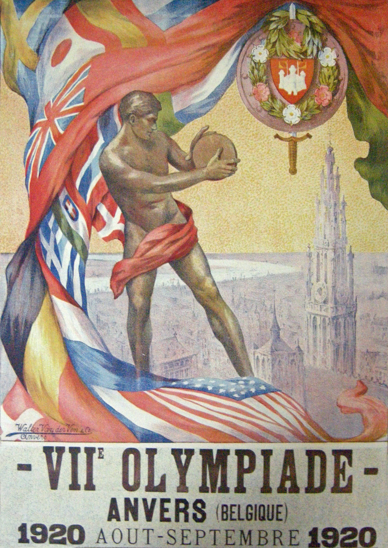

Comprises archival material formerly housed in the centre for National Collection of Athletics Literature (NCAL). This extensive artificial collection of literature and ephemera relating to athletics includes photograph albums, newspaper cuttings, ticket stubs and other material relating to Olympic Games held from 1908-1988.

A full electronic catalogue of this collection is available on our online archive catalogue at
http://www.calmview.bham.ac.uk (Finding No: ATH)

Papers of Harold Abrahams

The papers of Harold Abrahams (1899-1978) include various items related to Olympic Games held in the first half of the twentieth century. Abrahams was awarded the gold medal in the 100 metres at the 1924 Paris Olympics, a feat which was depicted in the film Chariots of Fire.

A full electronic catalogue of this collection is available on our online archive catalogue at http://www.calmview.bham.ac.uk (Finding No: ATH/HA)

Records of the Amateur Athletics Association of England

Material relating to the Olympics includes W. M. Barnard’s scrapbook of the 1908 London Games. This includes material relating to controversial marathon race which saw Dorando Pietri disqualified. Material inserted within the scrapbook includes arena tickets, booklets and a marathon programme. Barnard acted as an official for this race and the volume includes his invitation to act as timekeeper as well as his timekeeper’s arm band.

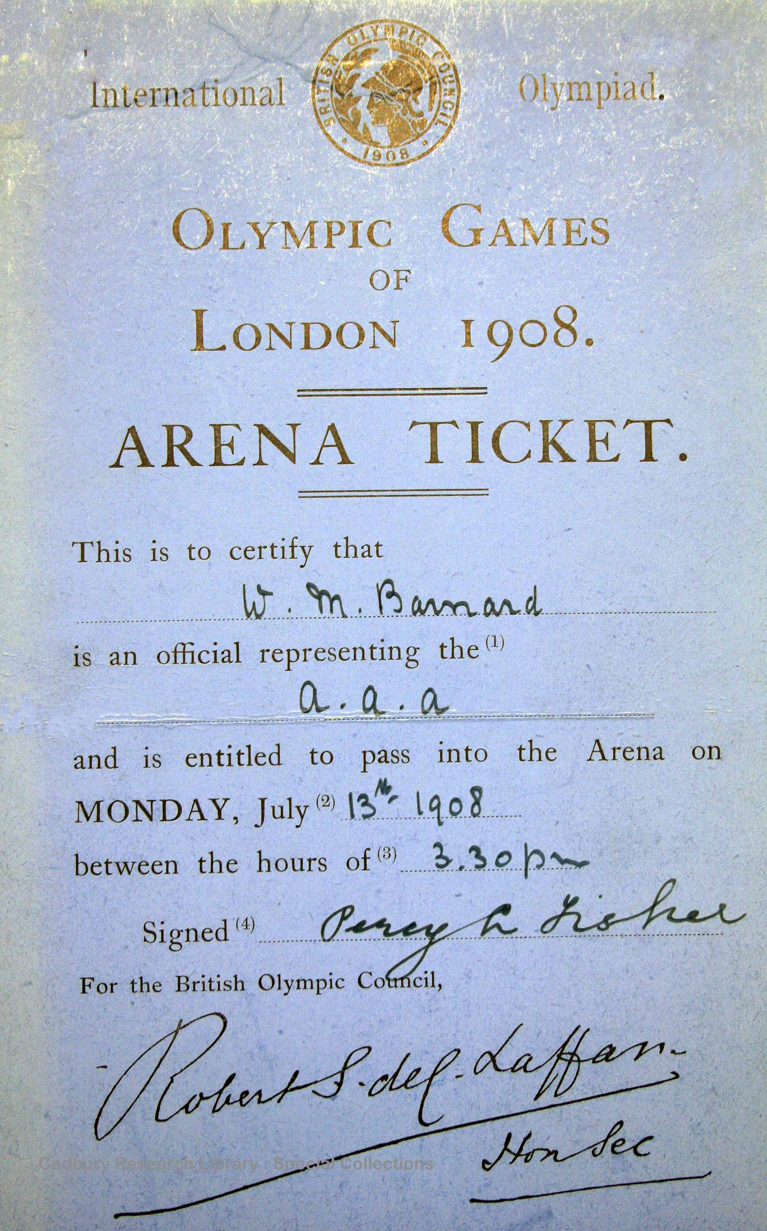

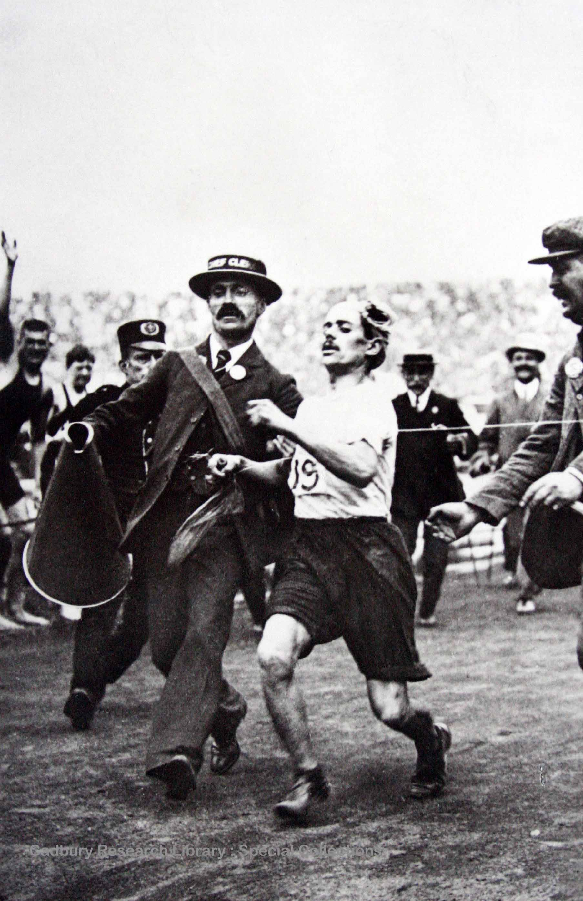

Other material includes minutes of the General Olympic Committee, 1911-1932, which was established to organise the association’s connections and position regarding the games.

A full electronic catalogue of this collection is available on our online archive catalogue at http://www.calmview.bham.ac.uk (Finding No: ATH/AAA)

Papers of Eric Bidlake

Album entitled ‘Memories and Glimpses of our England’ which was compiled by Lew Lake and presented to his friend, Eric Bidlake, both of whom were involved with the London Central YMCA. The volume contains images taken at the 1924 Paris Olympics.

A full electronic catalogue of this collection is available on our online archive catalogue at http://www.calmview.bham.ac.uk (Finding No: YMCA/ACC39)

Papers of William G. Tatham

A collection of four scrapbooks which illustrate the athletics career of William Tatham (fl. 1899-1934) and his contemporaries. Includes newspaper cuttings relating to the 1924 Paris Olympics where Tatham fell whilst leading in the hurdles race.

A full electronic catalogue of this collection is available on our online archive catalogue at http://www.calmview.bham.ac.uk (Finding No: ATH/WGT)

Papers of Wilf Richards

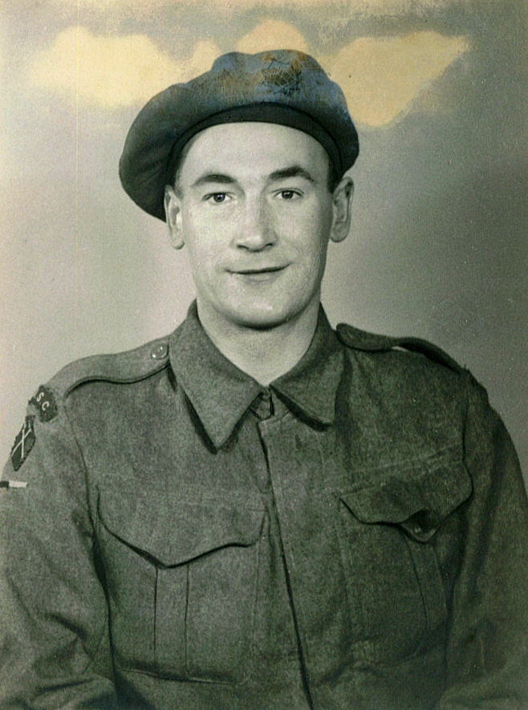
Wilf Richards’ papers include a scrapbook relating to the 1928 Olympic Games which was held in Amsterdam.

A full electronic catalogue of this collection is available on our online archive catalogue at
http://www.calmview.bham.ac.uk (Finding No: ATH/WR)

Papers of E. R. L. Powell

This collection contains a variety of material relating to athletics, especially in the North West of England. It also includes a fascinating scrapbook of the 1936 Berlin Games, comprising newspaper cuttings, photographs and maps. Other ephemera includes a commemorative medal struck to mark the 1948 London Olympics.

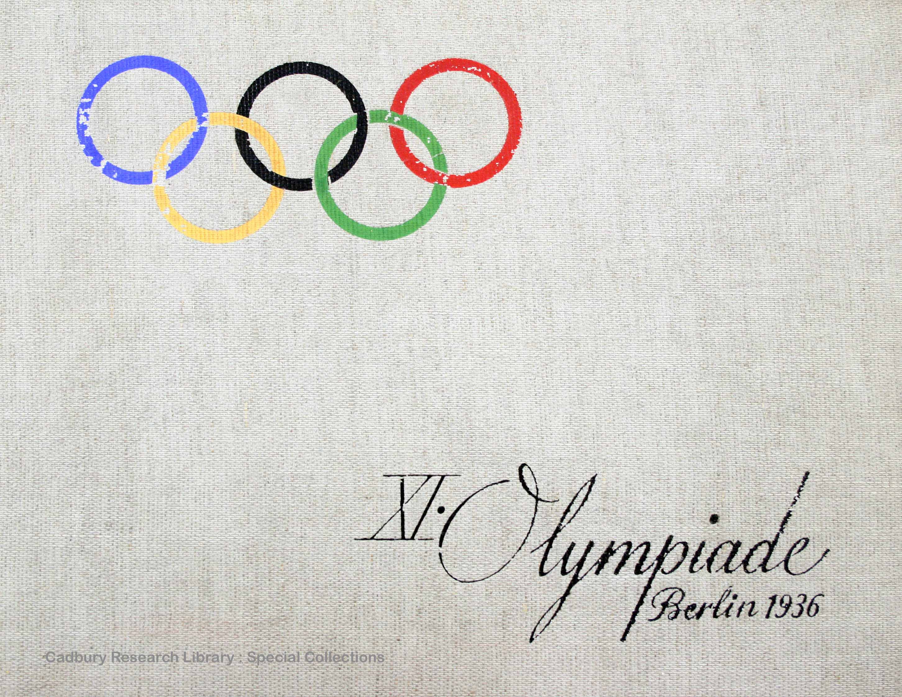

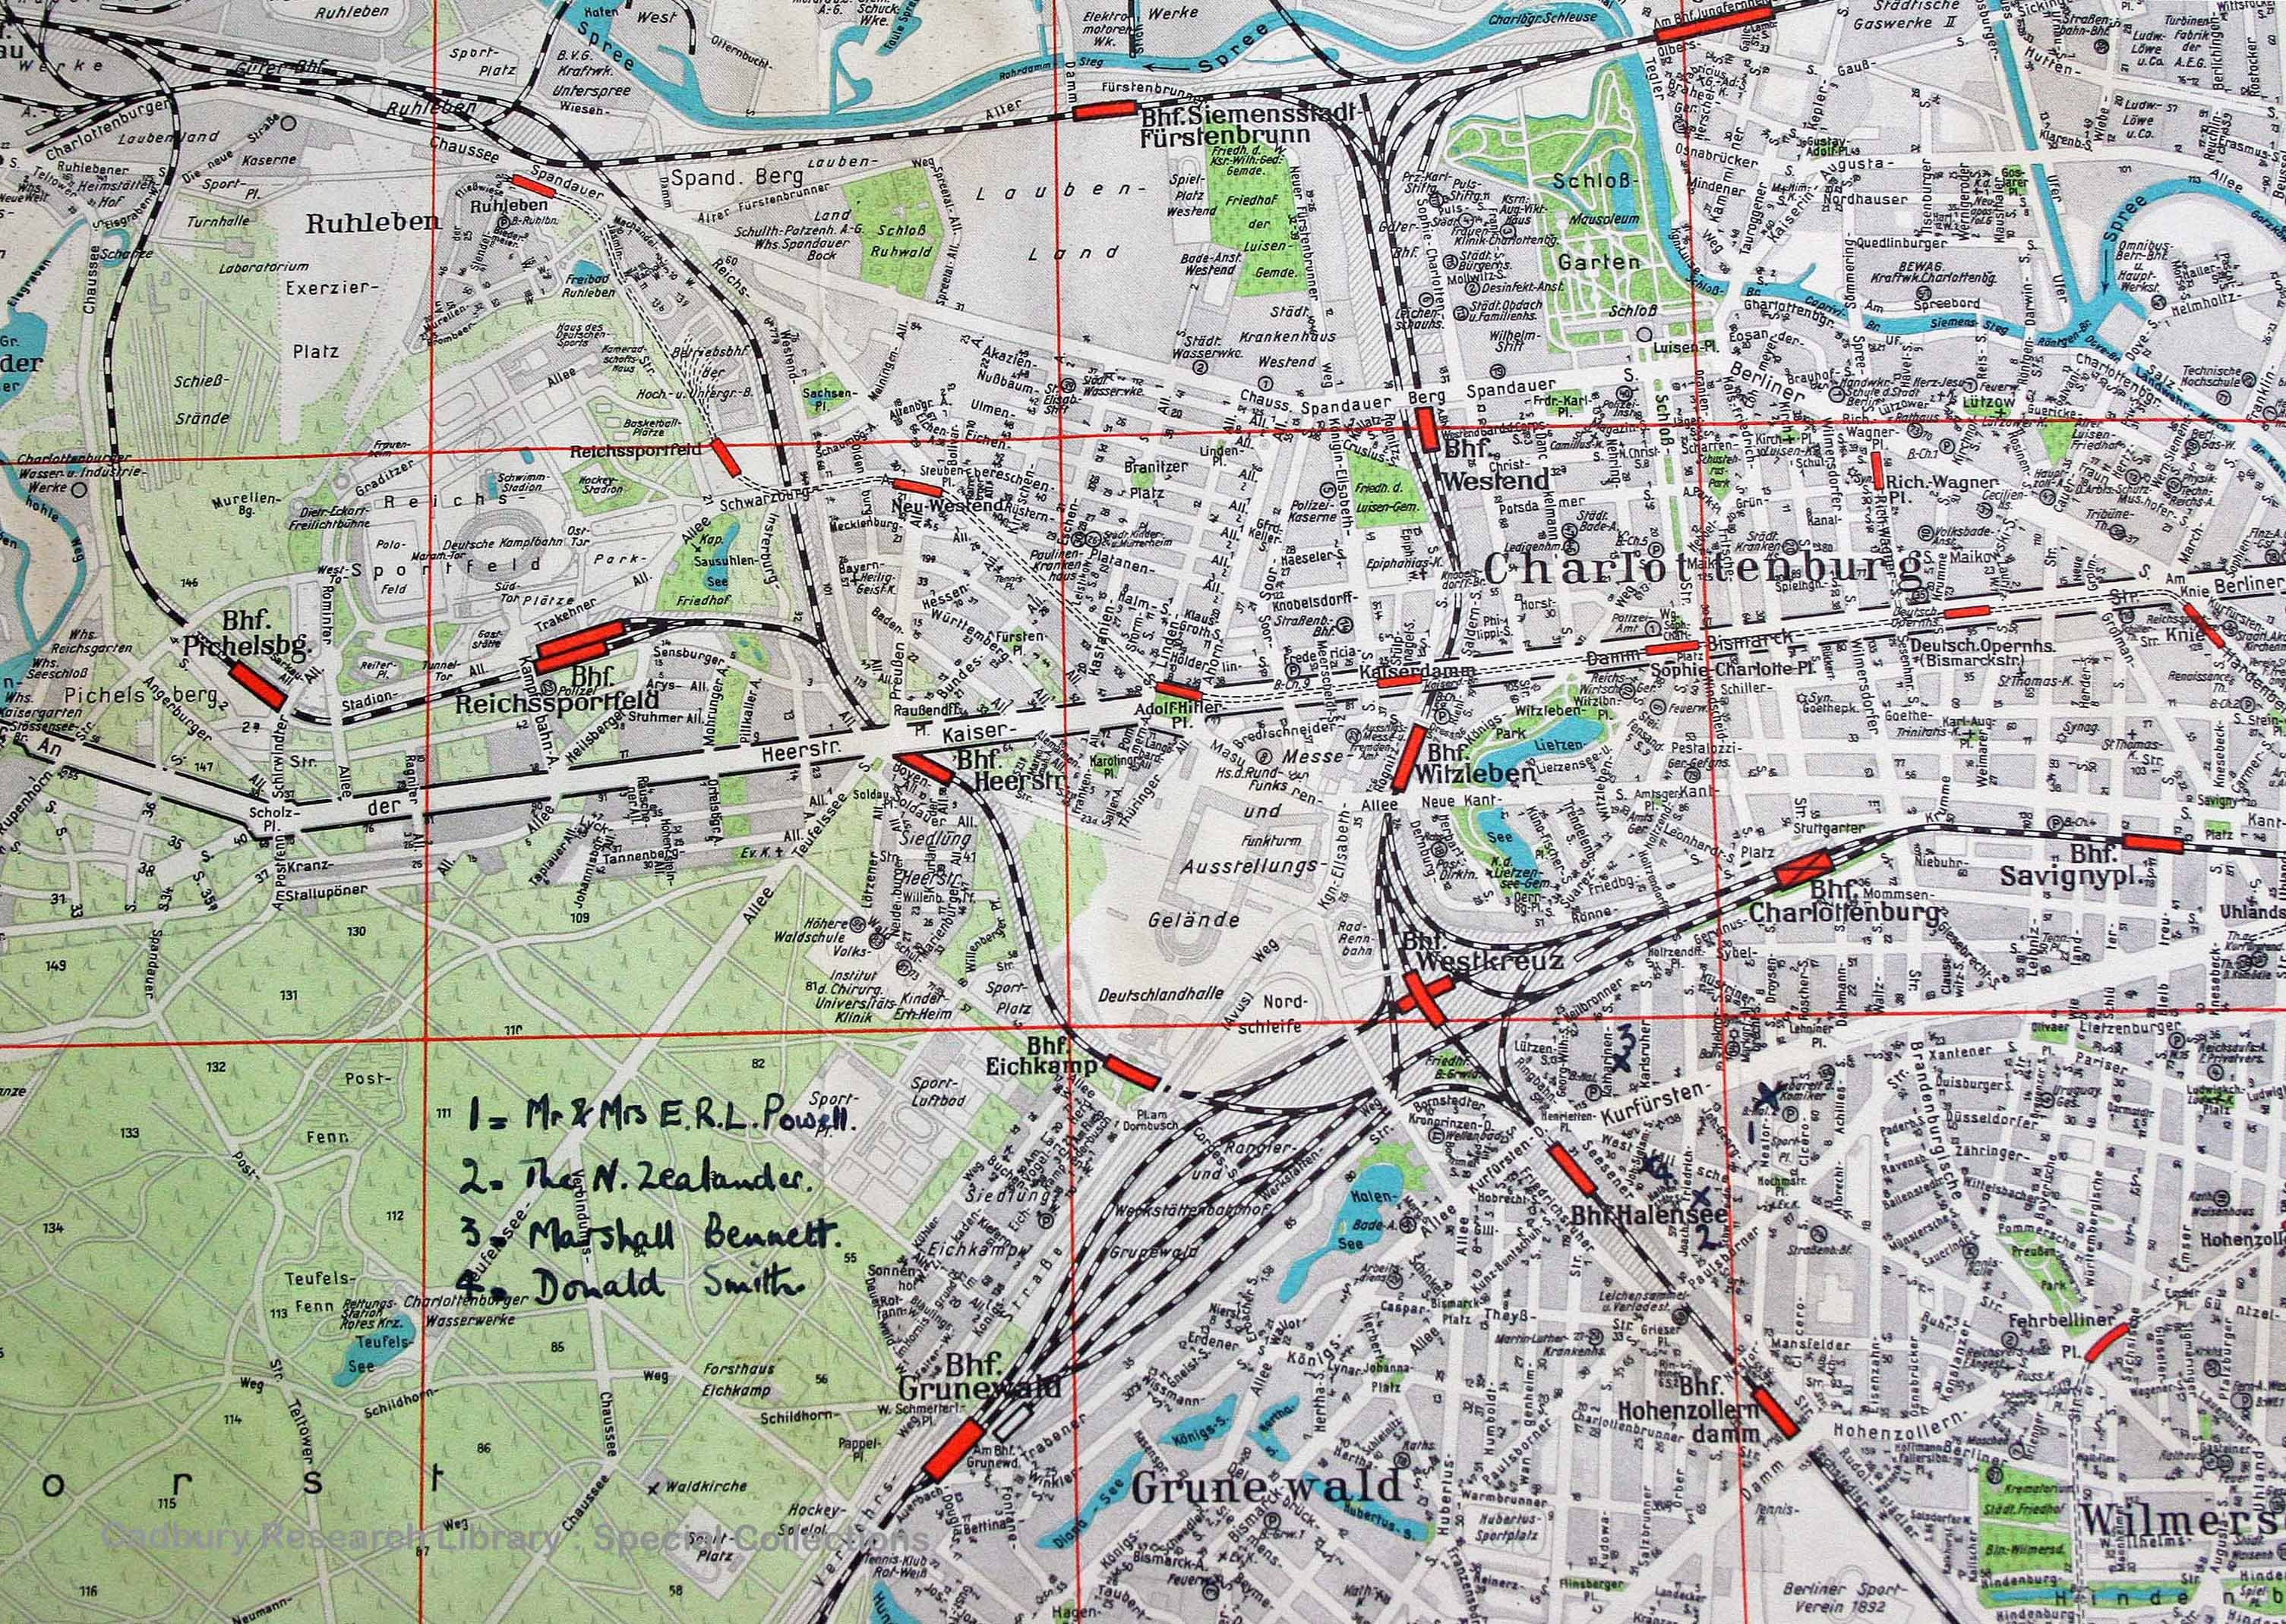

A full electronic catalogue of this collection is available on our online archive catalogue at http://www.calmview.bham.ac.uk (Finding No: ATH/ERLP)

Papers of Audrey Court (nee Brown)

Material relating to University of Birmingham alumna Audrey Kathleen Court (nee Brown) who won a silver medal in the 4 x 100 metre relay at the 1936 Berlin Games. Papers include medals relating to her sporting successes at international meets, photographs, badges and newspaper cuttings.

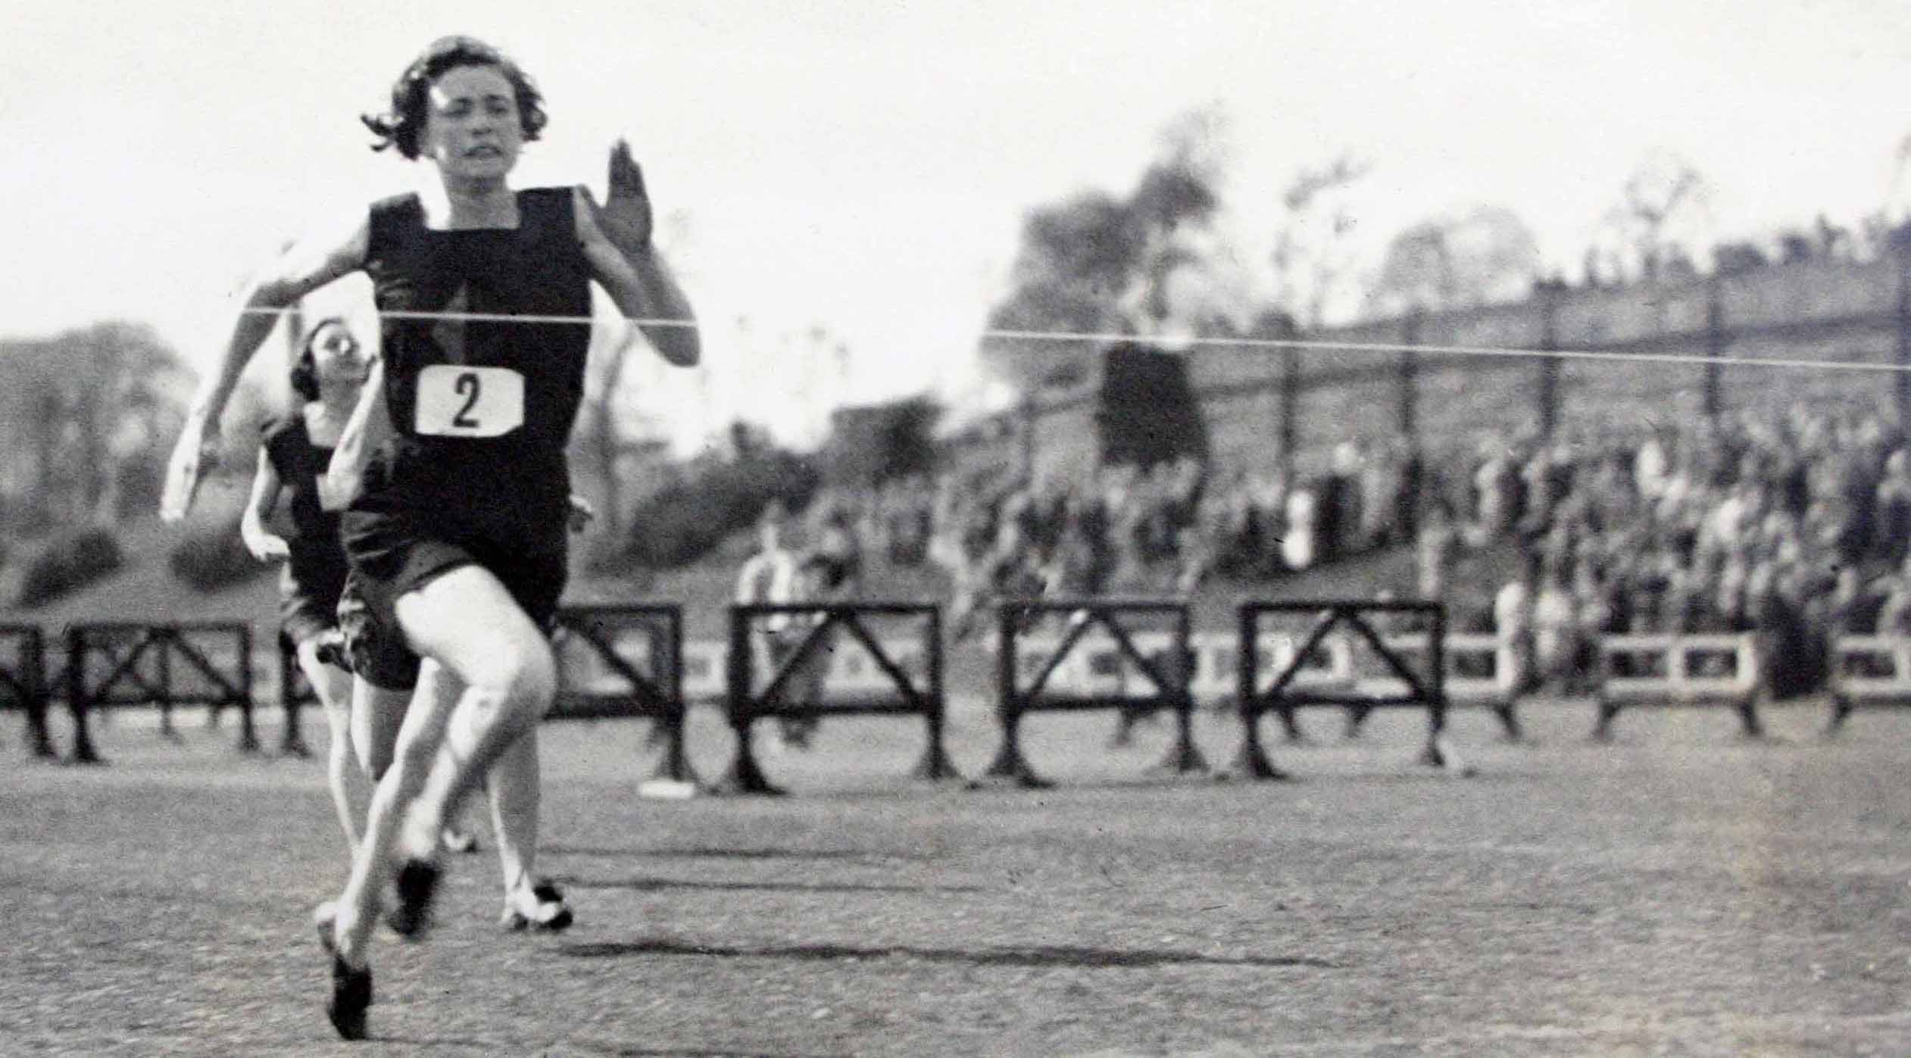

A collection level description for this catalogue is available on our online archive catalogue at http://www.calmview.bham.ac.uk (Finding No: USS22)

Olympic named collection of printed book material

The Cadbury Research Library: Special Collections also holds a wealth of printed book material relating to past Olympic Games. These are fully catalogued on our online book catalogue at http://findit.bham.ac.uk

This named collection includes official reports, numerous souvenir pamphlets, printed programmes, histories, biographical records and even ticket stubs. Also included are items relating to Birmingham’s unsuccessful bid to host 1992 Games.

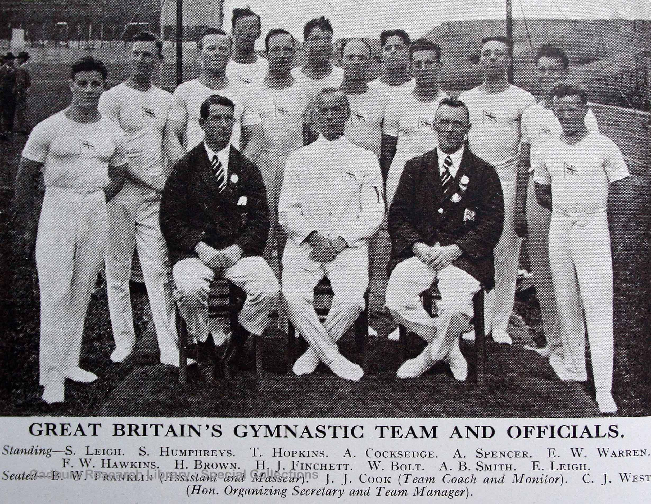

Illustrated London News

The department holds an incomplete run of the Illustrated London News, 1843-1990. Some issues include reports from Olympic Games, notably the issue for 1948 which covers newsworthy items relating to the London Games held that year.

This title can be found on our online book catalogue at http://findit.bham.ac.uk (Shelfmark: r f AP 4.I5)

