Guide to the records of Mason Science College

Last updated July 2016

Guide to the records of Mason Science College

Finding Number: UB/MC

The University of Birmingham archives include records of the university’s predecessor institution, Mason Science College. These records mostly date from 1880-1900 when the college was open to students, but there is also material dating from the 1870s which provides information about the planned structure and management of the college and the design of the college building. This guide contains an overview of the history and development of Mason College, gives details of the types of records the archive contains, and suggests some topics for research (Last updated July 2016).

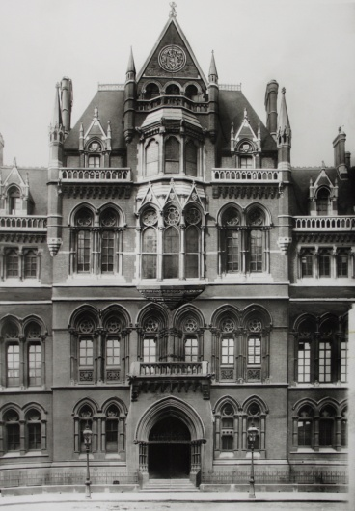

Front of Mason College building UB/MC/N/5/1

Mason College was founded by Sir Josiah Mason, a wealthy businessman who was born in Kidderminster in 1795 but worked in Birmingham from the 1820s. He made his fortune producing steel pen nibs and also invested in electroplating. He used some of his wealth to establish almshouses and an orphanage for girls in Erdington in 1858, which was expanded to include boys in 1868. He was given a knighthood in 1872 in recognition of his philanthropy. Mason wanted to found a college to provide an institution dedicated to science teaching, mainly for people living in Birmingham and the surrounding area who worked in manufacturing and other local industries. Soon after the college opened, however, the trustees had to make alterations to the foundation deed to allow a broader curriculum to be taught which included English language and literature, classics, and modern languages as well as additional science subjects. This was necessary in order for the college to comply with the regulations of the University of London which awarded degrees to Mason College students completing degree-level courses.

Mason appointed trustees to assist him in managing the business of the college, and during the 1870s the trustees acquired pieces of land and properties in the area around
Edmund Street in the centre of Birmingham where the college building would stand. They also commissioned a local architect, Jethro Cossins, to design the college building. The foundation stone was laid on 23 February 1875, and the college opened to students in October 1880.

Once the college opened, its managerial and administrative responsibilities were undertaken by Mason College Council, made up of some of the trustees and other representatives. The Council set up a number of sub-committees to manage academic policy; the maintenance and care of college property; and the business of the library and departmental museums. The academic staff reported to the Council and initially had no formal power to influence the curriculum or academic policy. The establishment of an Academic Board was authorised by the Council in 1881, and a Principal was appointed in 1890 when the Academic Board became the Senate. During the 1890s the academic staff were able to exert more control over the educational work of the college, but the institution was still managed by the Council.

Courses in physics, chemistry, biology and mathematics were offered to students during the first academic session of the college in 1880. By 1881 it was also possible to study geology and mineralogy, botany and vegetable physiology, engineering, English language and literature, Greek and Latin, and French and German language and literature. The college offered additional evening classes, and ‘popular’ lectures on general topics. Medical students at Queen’s College in Birmingham were able to attend classes in botany, physiology and chemistry from 1882, and in 1892 the medical faculty of Queen’s College was transferred to Mason College.

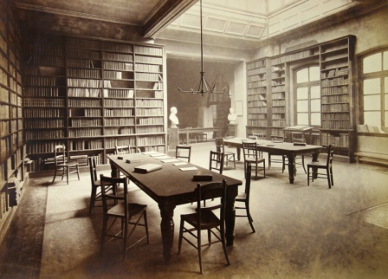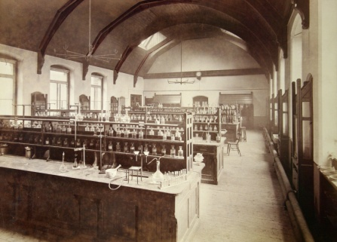

Mason College library, UB/MC/N/1/2 Mason College chemistry laboratory, UB/MC/N/2/5

From October 1890 women students enrolled at the new Birmingham Day Training College for Elementary Teachers were able to take academic lectures at Mason College, and in 1894 the existing day college for women became the women's section of the department of education at Mason College. Buildings were acquired next to the existing college building to accommodate both the medical faculty and the Day Training Department.
Mason College had an active student’s union for current and former students, and members of staff also attended meetings.
In 1898 Mason College was incorporated by Act of Parliament, and the trustees were replaced with a wider and more powerful Court of Governors. Different ways for the college to gain degree-giving powers had been discussed from the mid 1890s, but at the first meeting of the new Court of Governors in 1898 Joseph Chamberlain’s idea for an independent university in Birmingham was accepted, and the fund raising campaign began. Chamberlain was instrumental in securing donations from wealthy benefactors including Andrew Carnegie and Lord Strathcona, and these funds together with a gift of twenty five acres of land at Bournbrook by Lord Calthorpe, enabled buildings for the new university to be constructed. The university charter received royal assent in May 1900, Mason College and its teaching staff were absorbed into the new institution, the University of Birmingham.

Types of Records

The records contain information about the organisation and management of Mason College, and about its educational work. They also contain details about staff and students. They comprise

- Minutes and meeting papers of Mason College Board of Trustees, Mason College Council, Mason College Senate and various sub-committees, 1872-1900
- Correspondence and administrative files of the Principal of Mason College 1888-1901
- Financial records 1875-1901
- Student registers 1892-1900
- Legal records 1870-1900
- Publications including calendars and syllabuses, annual reports, and transcripts of lectures and speeches by staff and others 1870s-1900
- Architectural drawings of the college building 1870s-1880s
- Photographs 1890s
- Press cuttings 1880-1900
- Records of the exhibition held to celebrate the meeting in Birmingham of the British Association for the Advancement of Science in 1886
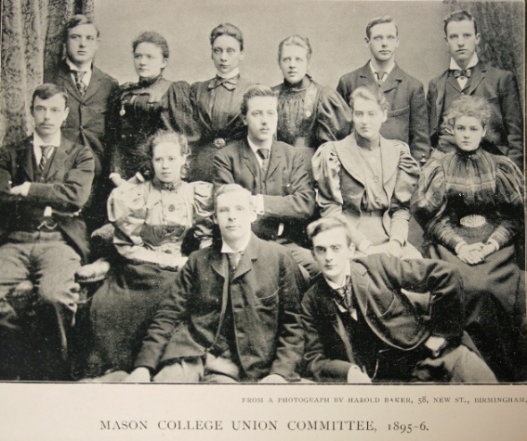
Mason College Union committee members, taken from Mason College Magazine UB/GUILD/F/1
Research uses of the records

- The development and organisation of Mason College from its beginnings in 1870 to its absorption into the University of Birmingham in 1900
- Aspects of learning at Mason College including the range of subjects offered by the college, the courses themselves and how they were taught and examined, the practical element of many science courses and their links with local industry
- Recruitment of staff at Mason College and their relationship with the college authorities; their views and attitudes towards academic policy and the development of the institution
- The student demographic at Mason College including the social backgrounds of students, the proportion of women students at the college, and the numbers of students studying for degrees or other qualifications and those studying for general interest
- The design of the college building, the provision of space for teaching and for other activities
- The urban landscape in the area immediately around the college site in the 1870s and 1880s as seen through the college rentals and plans,
- The campaign for university status from c.1895 to 1900 including alternative proposals and the progress of the fund raising campaign from 1898 to 1900
- Research for a comparative study of 19th century higher education institutions in England and Wales, using the records of Mason College and records of similar institutions, for example Owens College in Manchester

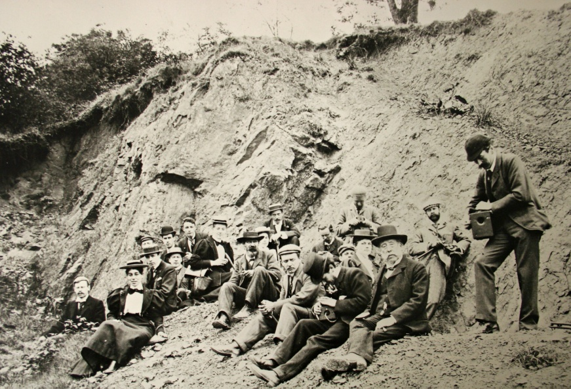

Geology students on a field trip to Comley Quarry in Shropshire, May 1896 UB/MC/N/4/3

Other records relating to Mason College

Records of Mason College student’s union are catalogued with records of the Guild of Students at UB/GUILD. There is a separate catalogue and resource guide for this collection. The Mason College material provides a valuable source of information for the study of student life at the college.
Records of Queen’s College Birmingham, which included the medical faculty transferred to Mason College in 1892 (UB/QC)

Papers collected by Professor Bertram Windle, Dean of the Faculty of Medicine at Mason College and the University of Birmingham, include correspondence relating to the campaign to establish a university in Birmingham together with memoranda, reports, circulars and other printed materials relating to the proposals for the University (US40)

Letters to and from Georg Fiedler, Professor of German at Mason College and the University of Birmingham and Charles Harding, with correspondents including Joseph Chamberlain and Andrew Carnegie, contain important material on the founding of the University of Birmingham, particularly the establishment of a school of Modern Languages, 1888-1909 (UB/MISC/HGF)

Miscellaneous correspondence relating to the incorporation of Mason College, and to fund raising for the new university, including letters to and from Joseph Chamberlain and Andrew Carnegie, 1890-1903 (UB/MISC/C/1)

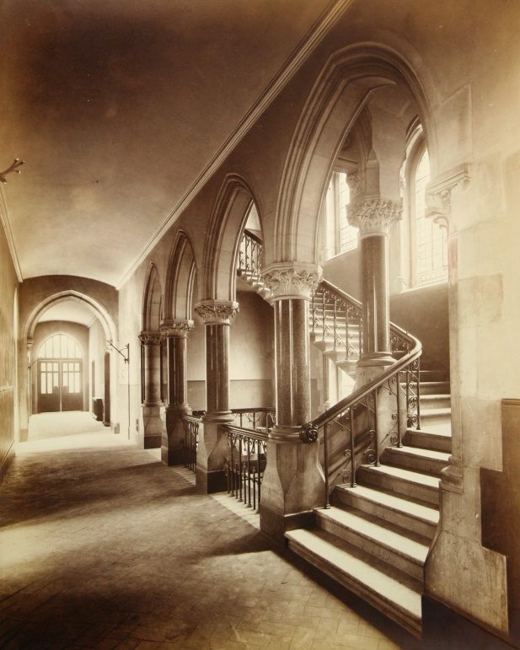

Staircase in Mason College building, UB/MC/N/1/1

