Carbon Accounting.

Birmingham.

University of Birmingham.

SUSTAINABILITY

ANNUAL REPORT 2021/22

REVISION 06 – 15 November 2023



# Audit sheet.

|  |  |  |  |  |  |
| --- | --- | --- | --- | --- | --- |
| Rev. | Date | Description of change / purpose of issue | Prepared | Reviewed | Authorised |
| 02 | 03/10/2023 | Revision 02 | A. Barton | A. Payne | D. Sanchez |
| 03 | 05/10/2023 | Revision 03 | A. Barton | A. Payne | D. Sanchez |
| 04 | 03/11/2023 | Revision 04 | R. Winch | A. Barton | D. Sanchez |
| 05 | 05/11/2023 | Revision 05 | R. Winch | A. Barton | D. Sanchez |
| 06 | 15/11/2023 | Revisions 06 | A. Barton |  | D. Sanchez |
|  |  |  |  |  |  |
|  |  |  |  |  |  |
|  |  |  |  |  |  |

This document has been prepared for University of Birmingham only and solely for the purposes expressly defined herein. We owe no duty of care to any third parties in respect of its content. Therefore, unless expressly agreed by us in signed writing, we hereby exclude all liability to third parties, including liability for negligence, save only for liabilities that cannot be so excluded by operation of applicable law. The consequences of climate change and the effects of future changes in climatic conditions cannot be accurately predicted. This report has been based solely on the specific design assumptions and criteria stated herein.

Project number: 2325026

Document reference:

Contents.

Audit sheet. 2

Our carbon footprint 2021-2022 4

Progress from our baseline yearProgress by Scopes 5

Introduction. 7

Methodology 8

Standardised Carbon Emissions Framework (SCEF) 8

Re-baselining to align with SCEF 8

Consolidation Approach 8

Calculation approach 8

Re-baselining exercise 9

Our results 2021-2022 10

Carbon footprint results 2021-2022 compared to baseline year 11

Results Scope 1. 12

Fleet. 12

Refrigerants 12

Other fuel use. 12

Natural gas. 12

Results Scope 2 13

Scope 3 emissions. 14

Procurement emissions 14

Student commuting and home visits 15

Fuel and energy procurement. 15

Business travel 15

Staff Commuting & Working from Home 16

Leased Buildings (downstream) 16

Waste 16

Next Steps 17

# Our carbon footprint 2021-2022

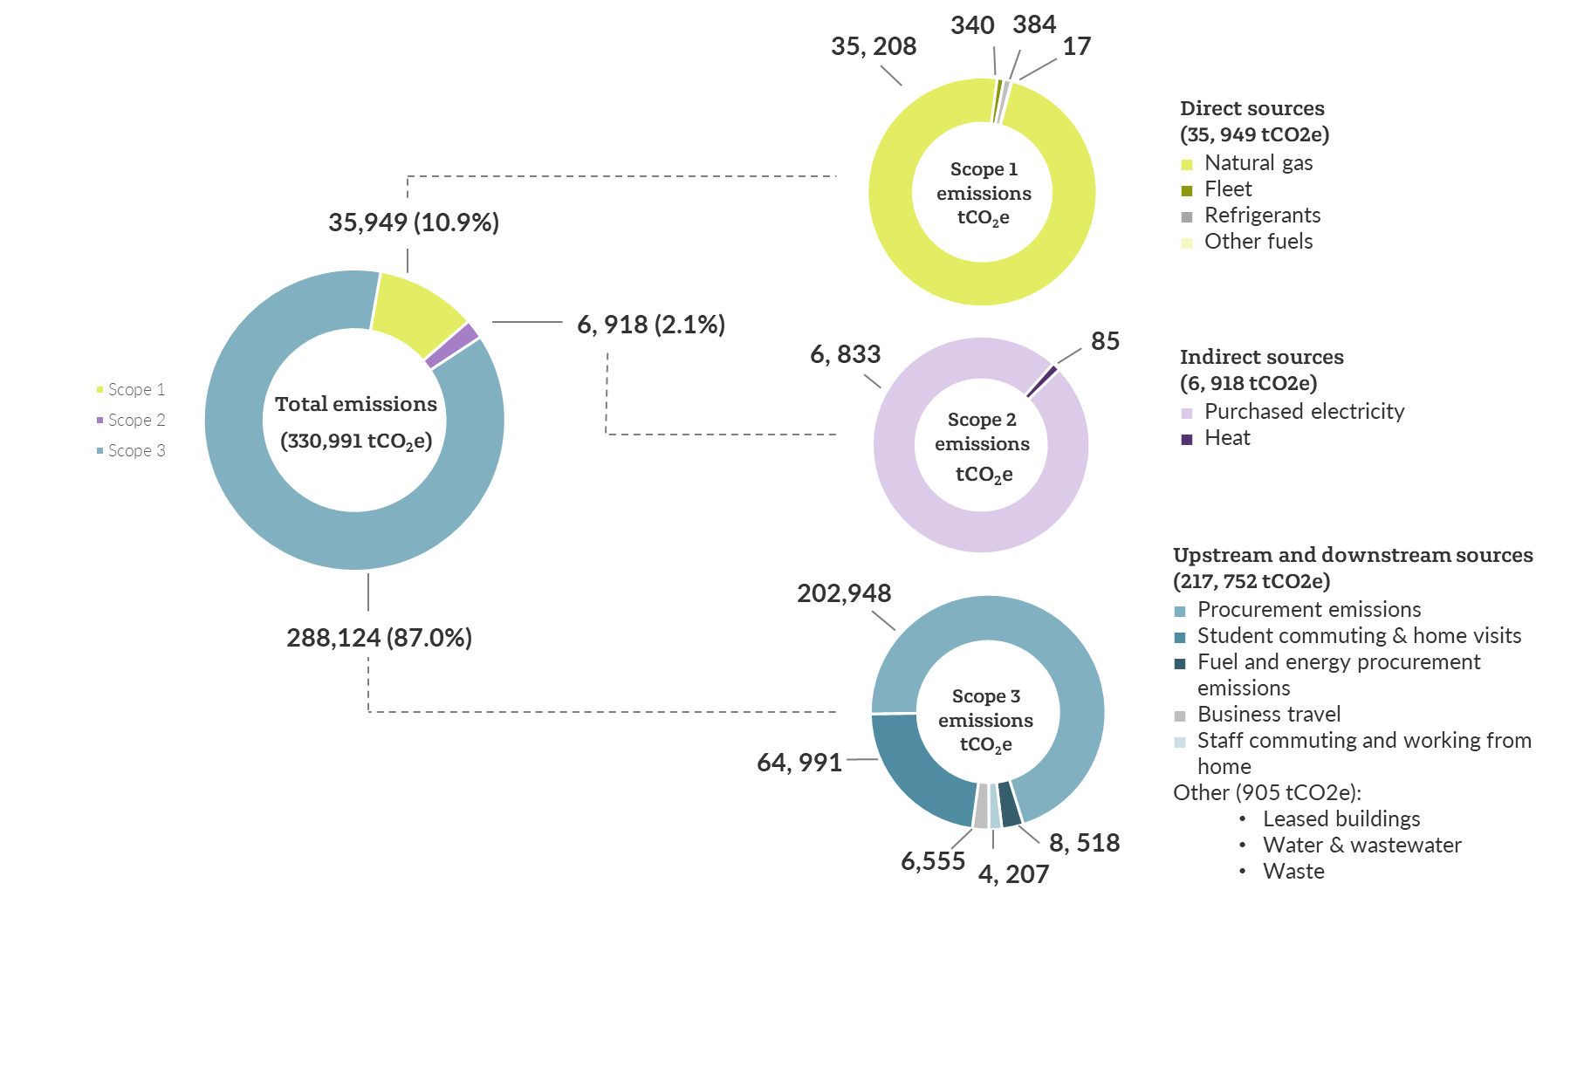

# Progress from our baseline yearProgress from our baseline year by Scopes

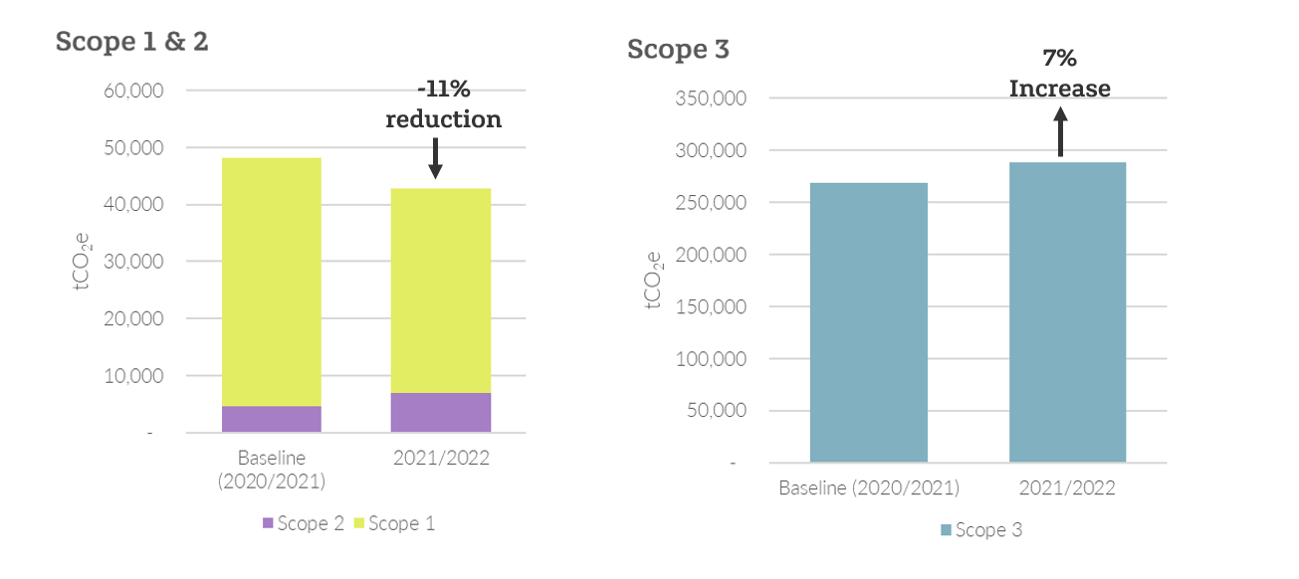

# Introduction.

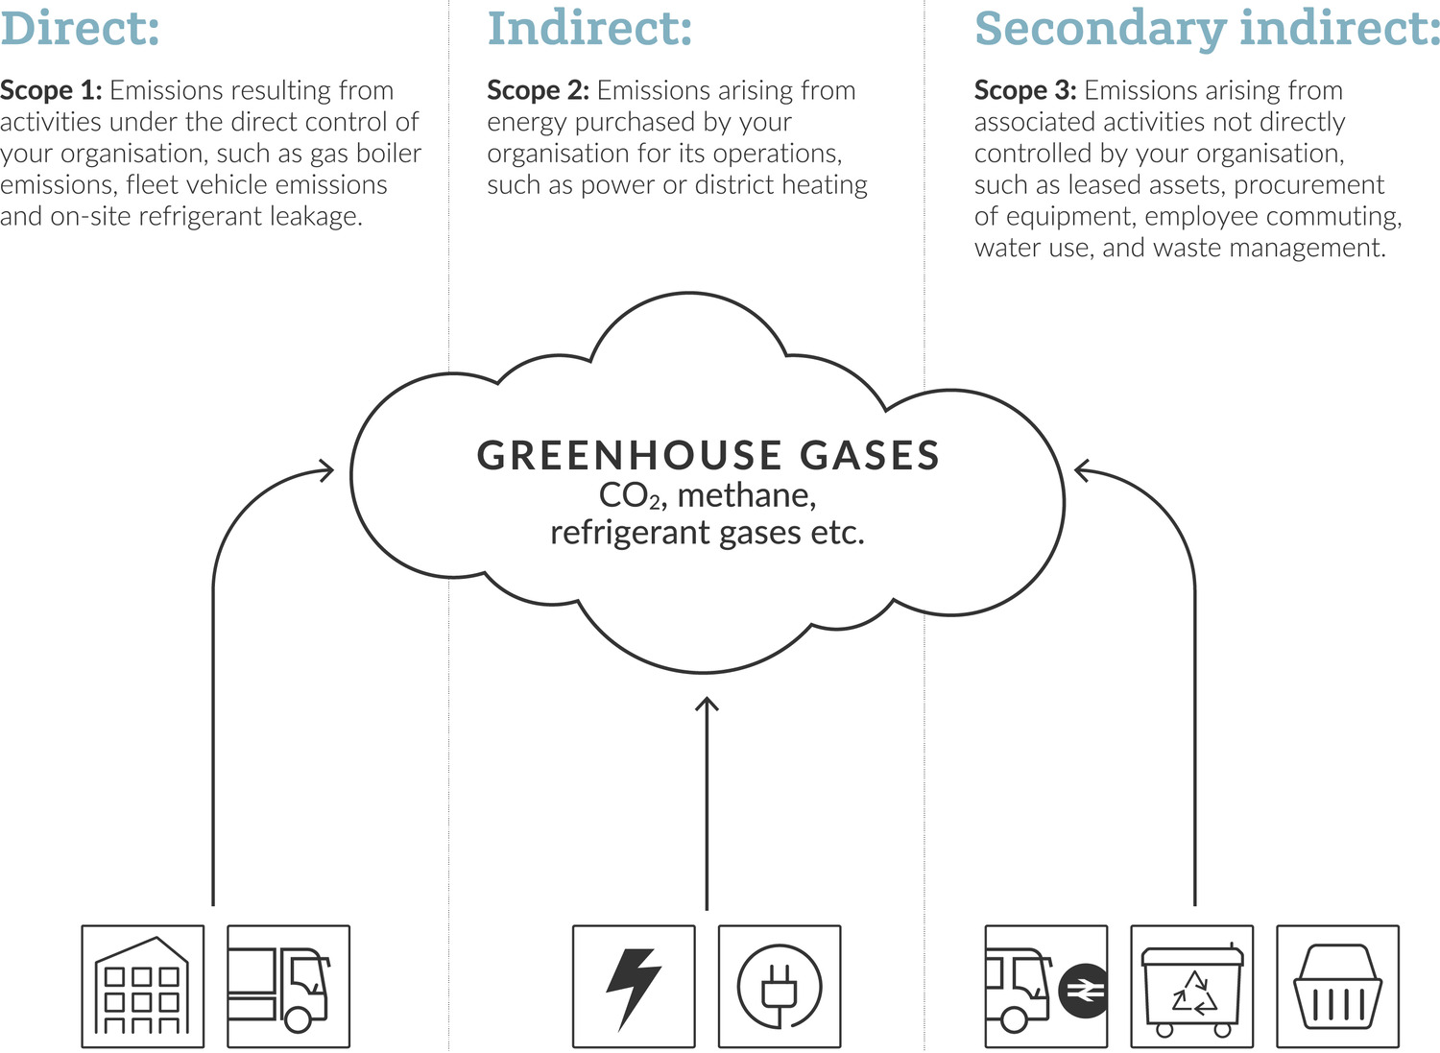

Direct:

**Scope 1**: Emissions resulting from activities under our direct control, such as combustion of gas and oil in boilers, fleet vehicles, and on-site refrigerant leakage.

Indirect:

**Scope 2**: Emissions arising from energy purchased for our operations such as power or district heating.

Secondary indirect:

**Scope 3**: Emissions arising from associated activities not in our direct control such as procurement of equipment, staff and employee commuting, water use and waste management.

As a University founded on social responsibility, we deliver sustainability through pioneering research and innovative education, the behaviour and actions of our students and staff, and engagement with our local communities. In response to the Climate Emergency, the University of Birmingham has committed to achieving Net Zero carbon emissions against Scopes 1 and 2 by 2035 and Scope 3 by 2045.

A comprehensive understanding of our carbon footprint is an essential step to establishing a net zero carbon pathway. Following a review of applicable methodologies, we have adopted the Environmental Association for Universities and Colleges (EAUC)’s Standardised Carbon Emissions Framework (SCEF), which is based on the World Resource Institute’s GHG Protocol, to assess our emissions. The GHG Protocol is internationally recognised as the best practice approach to reporting and is widely adopted. The SCEF translates the protocol into a Further and Higher Education context, creating a standardised approach to reporting for sector specific emissions categories. Following standardised approaches and principles to measuring our emissions will allow us to:

* Prepare a GHG inventory that represents a true and fair account of our emissions.
* Provide us with information that can be used to build an effective strategy to manage and reduce GHG emissions.
* Increase consistency and transparency in GHG accounting and reporting in UK Higher Education (HE).

A separate appendix details the calculation approach taken and any assumptions necessary to determine the emissions. This report summaries the work we have done to align with the EAUCs SCEF and the most recent years accounting for the academic year of **July 2021 to August 2022**.

.

Figure : Different emission scopes

# Methodology

## Standardised Carbon Emissions Framework (SCEF)

The EAUC, or the Environmental Association for Universities and Colleges, is a non-profit organisation based in the United Kingdom. Established in 1993, the EAUC is dedicated to promoting sustainability within the further and higher education sectors. Its primary mission is to support educational institutions in becoming more environmentally and socially responsible. By acting as a hub for knowledge exchange, the EAUC aims to advance sustainability practices across educational institutions, ultimately contributing to the global effort to address environmental challenges and promote a more sustainable future.

The EAUC released the Standardised Carbon Emissions Framework (SCEF), which is based on the World Resource Institute’s GHG Protocol. The SCEF takes the widely adopted GHG protocol and adapts it into the context of Further and Higher Education, creating a standardised approach to reporting for sector specific emissions categories.

## Re-baselining to align with SCEF

To ensure alignment with the SCEF, we returned to the baseline assessment conducted for the academic year 2020 -2021 and conducted a gap analysis against the SCEF. This highlighted the need to include some sources of emissions which were omitted in the baseline year, as well as recategorise other emissions.

Undergoing this process now will ensure that we are aligned to the SCEF, and therefore industry standard, from the baseline year, and will allow us to track annually our changes in emissions. The significant changes in our re-baselining exercise included:

* Including emissions associated with student visiting home outside of term time – this includes international students visiting home countries.
* Including emissions associated with staff working from home.
* Disaggregating our data to remove downstream leased assets from our Scope 1 & 2 data and include them in our Scope 3 data.

## Consolidation Approach

An organisation must select a single GHG Protocol-defined method (operational control, financial control, or equity share) to determine its organisational emissions boundary. The selection of a consolidation approach affects which activities in the company’s value chain are categorised as direct Scope 1 emissions and indirect Scope 2 & 3 emissions.

The EAUC suggests that, in many cases, Operational Control is the most suitable choice for a university, and it has been chosen here as the preferred option; an organisation has operational control when it, or one of its subsidiaries “has the full authority to introduce and implement its operating policies at the operation.”

It is a popular way to define the organisational boundary as it is relatively straightforward and makes intuitive sense, i.e., if you have operational control of the emissions sources, it is reasonable that you should be responsible for those emissions. As an organisation changes over time, organisational boundaries will change. We will conduct an annual review of our organisational boundaries to ensure accurate monitoring and reporting of carbon emissions.

Our emissions associated with the spend from our operations on our Dubai campus is included within this report, however, our emissions associated with the buildings we lease are not yet included due to data availability. A full list of emissions included in our calculations can be found in table 2.

## Calculation approach

As outlined in the introduction an accompanying appendix details the calculation approach taken and any assumptions necessary to determine the emissions. The appendix also provides qualitative review of the data quality based on the below factors:

Table : Data quality indicators. Source: Table 7.6 of the GHG Protocol’s Corporate Value Chain Accounting Reporting Standard.

|  |  |
| --- | --- |
| ***Indicator*** | ***Interpretation*** |
| *Technological* | *The degree to which the data set reflects the actual technology used* |
| *Temporal* | *The degree to which the data set reflects the actual time (e.g. year) or the age of the activity* |
| *Geographical* | *The degree to which the data set reflects the actual geographic location of the activity (e.g., country or site)* |
| *Completeness* | *The degree to which the data is statistically representative of the relevant activity. Completeness includes the percentage of locations for which data is available and used out of the total number that relates to a specific activity. Completeness also addresses seasonal and other normal fluctuations in data.* |
| *Reliability* | *The degree to which the sources, data collection methods and verification procedures used to obtain the data are dependable.* |

# Re-baselining exercise

Changes incorporated into new baseline:

* Including emissions associated with student visiting home outside of term time – this includes international students visiting home countries. This is the most significant change and has added around 50,000 tCO2e
* Including emissions associated with staff working from home
* Disaggregating our Scope 1&2 data to remove downstream leased assets and include them in our Scope 3 data

*A full break down of the new baseline emissions is shown in table 2*

# Our results 2021-2022



# Carbon footprint results 2021-2022 compared to baseline year

The carbon footprint for the academic year of 2021-2022 has been calculated at 260,619 tCO2e this is an increase of 5% from the baseline year.

Table : Emissions reported compared to baseline year

|  |  |  |  |  |  |  |  |  |
| --- | --- | --- | --- | --- | --- | --- | --- | --- |
| *Scope* | *Emission Category* | *Emissions*  *Baseline 2020-2021* | *Emissions*  *2021-2022* | *Percentage Change from Baseline* | *Contribution to Total*  *Baseline 2020-2021* | *Contribution to Total*  *2021-2022* | *Summary*  *Baseline 2020-2021* | *Summary*  *2021-2022* |
|  |  | (tCO2e) | (tCO2e) | % | (%)* | (%)* | (%)* | (%)* |
| 1 | Natural gas | 42,923 | 35,208 | - 18% | 13.57% | 10.64% | 13.7% | 10.9% |
| Fleet (owned/ operated) | 75 | 340 | +354% | 0.02% | 0.10% |
| Refrigerants | 225 | 384 | +71% | 0.07% | 0.12% |
| Other fuels | 192 | 17 | -91% | 0.06% | 0.00% |
| 2 | Purchased electricity | 4,652 | 6,833 | +47% | 1.47% | 2.06% | 1.5% | 2.1% |
| Heat & steam | 24 | 85 | +258% | 0.01% | 0.03% |
| 3 | Procurement Emissions | 191,866 | 202,948 | +6% | 60.67% | 61.32% | 84.8% | 87.0% |
| Fuel and energy procurement emissions | 9,145 | 8,518 | -7% | 2.89% | 2.57% |
| Waste | 628 | 57 | -91% | 0.20% | 0.02% |
| Business travel | 9,767 | 6,555 | -33% | 3.09% | 1.98% |
| Staff commuting & working from home | 6,962 | 4,207 | -40% | 2.20% | 1.27% |
| Student commuting (during university term time and home visits) | 48,565 | 64,991 | +34% | 15.36% | 19.64% |
| Leased buildings (downstream) | 1,031 | 680 | -34% | 0.33% | 0.21% |
| Water and wastewater | 185 | 168 | -9% | 0.06% | 0.05% |

*\* Percentages may not reach 100% due to rounding*

# Results Scope 1.

Scope 1 emissions are direct emissions that occur from sources that are owned or controlled by University of Birmingham (UoB). This includes emissions from the combustion of gas for heating our building or the leakage of refrigerants we use to cool them. It also includes the fuel used in our vehicle fleet and grounds maintenance. Scope 1 emissions represent 11% of the overall carbon footprint.

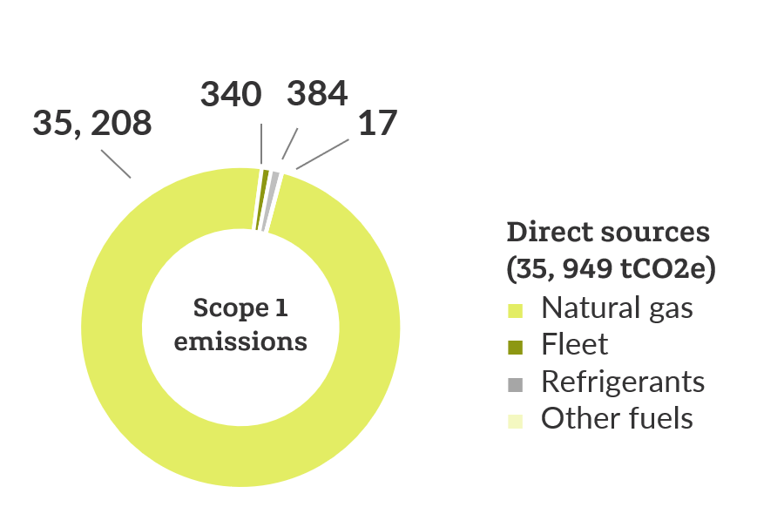

Figure : Scope 1 emissions (tCO2e) for academic year 2021/22

Figure :Proportion split of gas (kWh) in downstream leased assets between University owned halls of residence and teaching and research buildings

## Fleet.

UoB fleet emissions include those from UoB owned vehicles used for transportation, maintenance, and service purposes. They do not represent a significant source of emissions, however, as these emissions are within the University’s direct control, they are straightforward to decarbonise. The University operates an increasingly sustainable fleet, including a number of electric vehicles (EVs) which are used for a range of services in and around campus including postal delivery and by the Estates team. Our increase in emissions compared to our baseline year is likely do to with an increasing vehicle fleet and an improvement in our records, our baseline had around 85 vehicles whereas this year we recorded 200 vehicles in our own fleet.

## Refrigerants

Our emissions stemming from refrigerant leaks saw a slight increase this year. This is likely attributable to improvements in our record-keeping practices, which have resulted in capturing and accounting for a more emissions. Continuing to establish consistent records for refrigeration systems maintenance will ensure that all emissions are accounted for.

## Other fuel use.

Other fuel use includes any oil or LPG used to fuel-powered equipment used in grounds maintenance activities, such as landscaping, irrigation, and maintenance of green spaces. These emissions have a relatively minor impact on our overall carbon footprint. Nonetheless, as they fall within our direct control, it is essential to account for and manage them effectively.

## Natural gas.

Gas use compared to our baseline year has decreased by 18% percent. It is still however, a significant source of our direct emissions, representing nearly 11% of our total carbon footprint. Our gas use is also significantly higher that our electricity use; this isn’t necessarily because our buildings consume less electricity than the average, but because of how we source it. Our Energy Centre burns gas via combined heat and power (CHP) units to generate both heat and electricity, which are distributed across our Edgbaston campus. Therefore, we only import electricity where we cannot generate it ourselves.

The reduction in gas consumption might be attributed to reduced utilisation of our CHP system during this timeframe, resulting in an increased reliance on electricity sourced from the grid. As the national grid continues to decarbonise and the generation of electricity becomes ever cleaner, the University will need to move away from gas fired to electrically powered heating systems to reduce emissions.

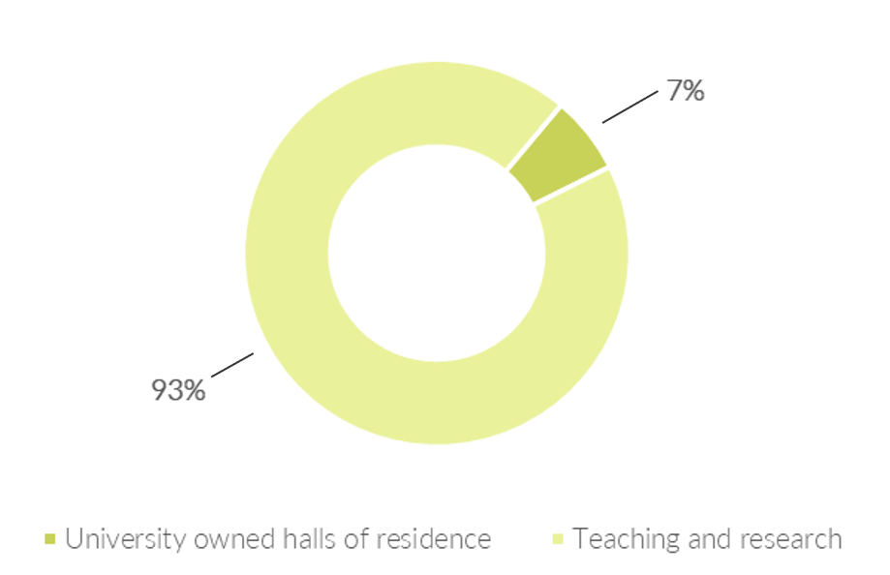The distribution of gas consumption between teaching and research buildings and university-owned halls of residence is shown in the pie chart below. 7% of gas is consumed by university-owned halls of residence.

Most of our buildings are connected to our heat network, and as a result, our current metering infrastructure does not always provide the granularity needed to track consumption at the individual building level. In future, greater focus will be placed on using data from heat sub-meters to enable us to understand our emissions at a building level and improve our building level performance.

**Scope 1 Summary**

**Carbon Hotspots:**

Natural gas represents the majority of Scope 1 emissions and accounts for 11% of UoB’s total footprint. As the national grid continues to decarbonise and the generation of electricity becomes ever cleaner, the University will need to move away from gas fired to electrically powered heating systems to reduce emissions.

**Reporting improvements**:

Most of our buildings are connected to our heat network, and as a result, our current metering infrastructure does not always provide the granularity needed to track consumption at the individual building level. In future, greater focus will be placed on using data from heat sub-meters to enable us to understand our emissions at a building level and improve our building level performance.

# Results Scope 2

Scope 2 emissions are indirect emissions from the generation of purchased electricity as well as those emissions attributed to heat purchased from the local district heating system. For UoB Scope 2 emissions represent 2% of our total emissions.

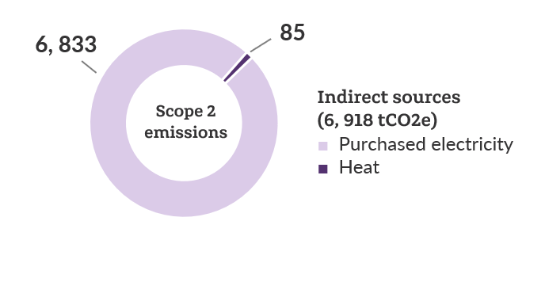

Figure : Scope 2 emissions (tCO2e) for academic year 2021/22

There are two methods for reporting Scope 2 emissions, location based, and market based: The location-based method reflects the grid average emission factors; it does not account for any active purchasing choices an organisation makes, including if they procure additional, renewable electricity. The market-based method reflects the GHG emissions associated with the procurement choices an organisation makes regarding its electricity supplier or products.

This report uses location-based emissions as it aligns with the methodology used in the baseline year, however, wherever possible, we maximise the opportunity for green electricity and reduce our market-based emissions by purchasing some of our electricity on a Renewable Energy Guarantee of Origin (REGO) backed tariff.

Our electricity use has increased by nearly 50% this year. As discussed previously this is likely due to the decreased use of our CHP system and therefore increased reliance on importing electricity. Despite this, the emissions attributed to our electricity consumption is relatively low compared to other sources. The purchase of heat from the local district heating system has again remained low.

Figure : Proportion split of electric (kWh) in downstream leased assets between University owned halls of residence and teaching and research buildings

The National Grid projections produced by the [Department for Business, Energy & Industrial Strategy](https://www.gov.uk/government/organisations/department-for-business-energy-and-industrial-strategy), indicate that the UK’s National Grid could be zero carbon between 2035 and 2040 – meaning that any electrical power building / system would effectively be zero carbon in operation. As a result of this, future regulations and drivers are focussed on reducing primary energy consumption to prevent the National Grid becoming overloaded with energy intense buildings. Therefore, we will still need to reduce electricity consumption in our buildings to play our part in a net zero future.

**Scope 2 Summary**

**Carbon Hotspots:**

Our purchased electricity accounts for the majority of our Scope 2 emissions and has increased nearly 50% from the previous year. Despite this, the emissions attributed to our electricity consumption is relatively low compared to other sources and only accounts for 2% of the total emission footprint.

**Reporting improvements**:

Just like with gas, an emphasis on expanding our sub-metering capabilities will empower us to assess consumption at a building level and enhance our building-specific performance.

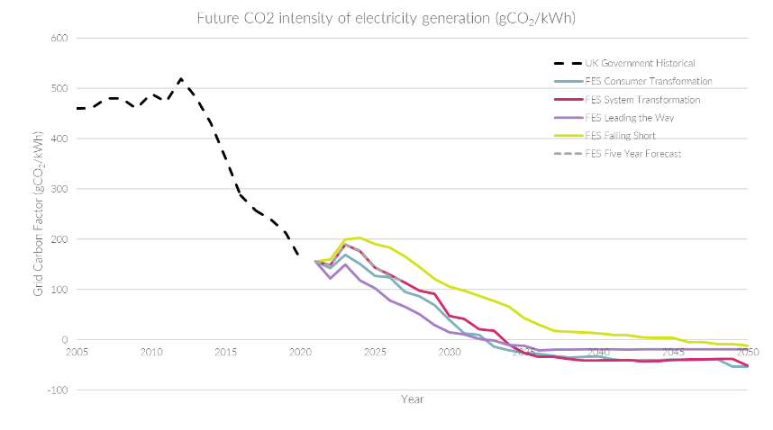

Figure : Future CO₂ intensity of electricity generation (gCO₂/kWh)

The distribution of electricity consumption between teaching and research buildings and university-owned halls of residence is as below. As depicted, most of the electricity is consumed by teaching and research facilities.

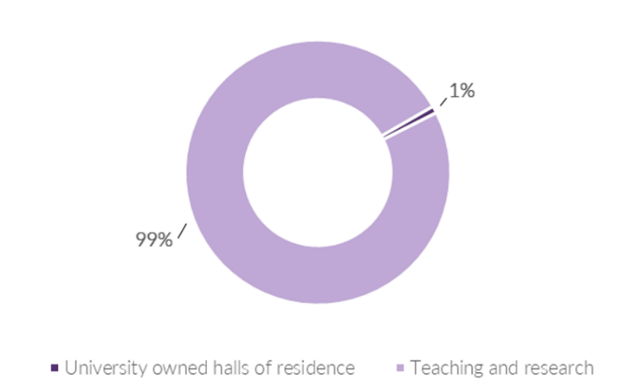

# Scope 3 emissions.

Scope 3 emissions encompass indirect greenhouse gas emissions that occur from sources outside of UoB’s direct operational control but are associated with its activities. These emissions arise from the entire value chain, including suppliers, contractors, customers, and other stakeholders. The emissions in Scope 3 account for 87% of UoB’s total emissions.

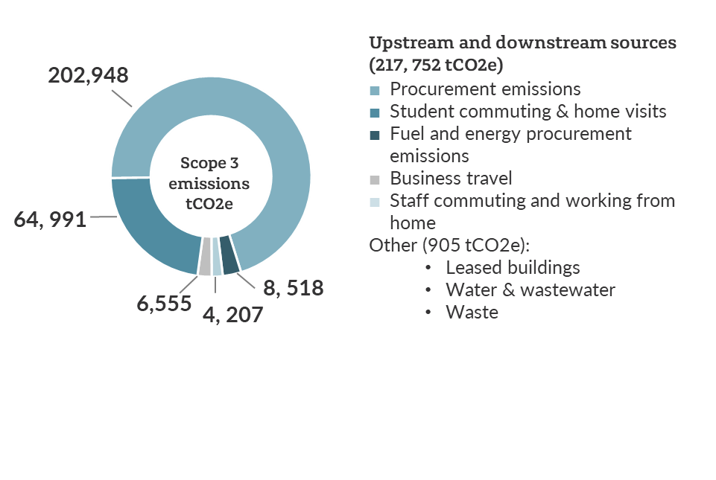

Figure : Split of overall spend calculation methodologies

Figure : Scope 3 emissions (tCO2e) for academic year 2021/22

## Procurement emissions

Procurement emissions, as in the baseline year, represent our most significant source of emissions, accounting for 61% of our total carbon footprint. Building upon recommendations from our baseline report, this year, our objective was to enhance the accuracy of emissions associated with our procurement practices. We contacted our primary suppliers, those with whom the University has the highest spending, and requested that they provide emission calculations for their operations. By understanding their emissions, as well as their turnover within the same period, we were able to create a bespoke conversion factor (tCO2e/£). For those suppliers where we were able to achieve this, we removed the spend and calculated emissions separately.

To inform the remaining emission calculations we used financial spend data and the Higher Education Supply Chain Emissions Tool (HESCET). For the Academic Year 2021/22, the total money spent against each of the HE procurement codes was mapped to a defined list of DEFRA categories for which conversion factors are available. This methodology is a blunt tool for calculating emissions and comes with a high degree of uncertainty. In future years we hope to engage more of our supply chain to provide primary emissions data. This approach will enable us to gain deeper insights into the sources of our emissions and, consequently, make more informed decisions regarding decarbonisation.

Using these two methodologies, the supplier specific method and the HESCET tool, a total of 202,948 tCO2e has been calculated for procurement related emissions. From the response of 51 suppliers, we were able to calculate 11% of our spend data using the supplier specific method, the remaining 89% used the HESCET tool. We also retrospectively applied this methodology to the baseline year for consistency. The difference between the two methodologies is shown in the tale below:

|  |  |  |
| --- | --- | --- |
|  | 2020/2021  tCO2e | 2021/2022  tCO2e |
| Supplier specific methodology | 13,328 | 9,304 |
| HESCET | 13,907 | 15,561 |
| % of total spend analysed | 5% | 11% |

We might infer from this that the HESCET tool significantly overestimates real emissions. However, it's essential to exercise caution and not rush to conclusions, as it's also possible that suppliers are *underestimating* their own emissions. The reality likely sits somewhere in between these two statements.

When comparing procurement emissions to the baseline year, there has been only a 6% increase in emissions despite an 18% increase in spend. It can be assumed that the additional spend is products and services with a lower carbon intensity.

The results of the HESCET tool show two primary emissions sources:

* Business services
* Medical and precision instruments

|  |  |
| --- | --- |
| *Category* | *Emissions (tCO2e)* |
| Business services | 76,867 |
| Medical and precision instruments | 76,095 |
| Information and communication technologies | 14,854 |
| Other manufactured products | 11,850 |
| Other procurement | 10,492 |
| Construction | 2,220 |
| Paper products | 824 |
| Manufactured fuels, chemicals and gasses | 330 |
| Food and catering | 114 |

## Student commuting and home visits

Student commuting and home visits includes those emissions associated with students commuting to and from University during term time as well as any visits home out of term time. It represents the second largest source of emissions for the University. This is attributed to the assumed frequency of flights for international students to visit their home countries outside of term time. Our calculations align with the SCEF recommendation, which assumes that each student makes two trips home annually. We also assumed that all international students fly economy (there are slightly higher emissions associated with flying in first or business class).

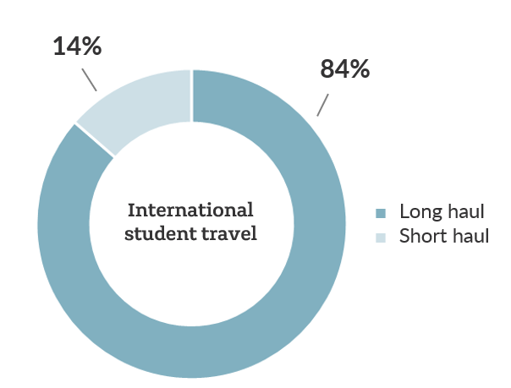Most flights taken consist of long-haul journeys, accounting for 84% of the total. The carbon factor for long-haul economy flights has seen a significant increase since the baseline year and is the prime reason for driving the rise in emissions within this category along with a small rise in the overall number of students.

Figure : Split of long-haul and short-haul flights for international students

Data for commuting during term time is based on a travel survey from 2022 which was sent to staff and students, the baseline year used a travel survey conducted in 2018. 14% of total recipients responded (over a third of staff and nearly 10% of students). During term time walking remains the most popular way to commute, with around half of students traveling this way. More students are relying on public transport than in 2018; 14% percent take the bus and 17% travel by train. The share of students taking solo car journeys to campus has seen a modest increase from 5% to 6% compared to previous travel survey conducted in 2018.

For the upcoming travel survey, it would be beneficial to expand the data collection to incorporate questions regarding the frequency of home visits and the mode of travel. This approach would eliminate the need for making as many assumptions in this category and lead to a more accurate reflection of emissions.

## Fuel and energy procurement.

Associated fuel and energy procurement accounts for 3% of UoB’s total footprint and refers to all the indirect emissions associated with UoB’s energy consumption not accounted for in Scope 1 and 2: the extraction, production, and transportation of fuels and the transmission and distribution of electricity. There is limited influence UoB can have on these emissions, other than reducing energy consumption in Scope 1 & 2.

## Business travel

Business Travel accounts for around 2% of total emissions and has seen a reduction of 33% compared to the baseline year despite the increasing carbon factor for long haul flights. The emissions for our business travel are calculated through a combination of data from our travel management company and other spend data. The figures below shows the breakdown of data from our travel management company. Grey Fleet refers to personal vehicles used for business use.

The reduction in emissions appears to be in the spend data; in the baseline year some double counting may have inflated the emissions, however, there was also around 25% more spend on relocation expenses.

Continuing to promote the use of the travel management company for booking business travel allows for a granular understanding of emissions withing this category. The below shows the information from our travel management company and any spend data we’ve been able to disaggregate into travel modes:

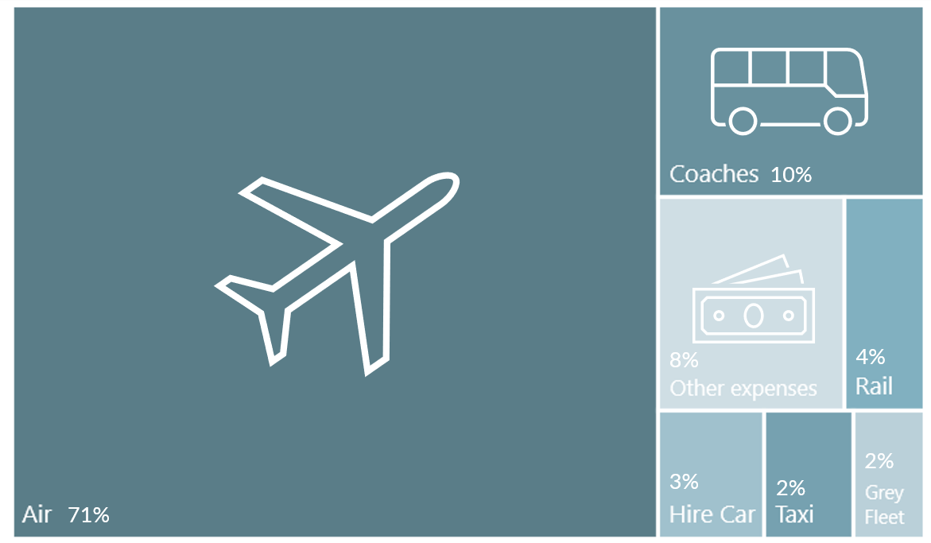

Figure : Split of travel modes included other expenses for business travel

\**other expense refers to travel incidentals such as hotel stays and meals*

## Staff Commuting & Working from Home

This category represents just over 1% of total emissions. As discussed previously commuting data is based on a travel survey from 2022. The number of staff commuting by solo car journeys has risen by over five percent since the 2018 survey to 40%, the highest share ever recorded. The remaining is split with 23% taking the train 11% cycling, 10% walking and 8% taking a bus and 7% car sharing.

Working from home emissions were calculated based on extrapolating the inverse of the commuting survey, in other words, if an individual reported commuting for three days a week, it was assumed that they were working from home on the remaining two days.

## Leased Buildings (downstream)

Leased buildings are buildings that are owned by the University but are operated by a third party. The emissions associated with our leased buildings are related to the gas and electric consumption used to heat and power these buildings. This category does not represent a significant source of emissions for the University. The proportion of those buildings that are leased for halls of residence is depicted below. It's worth mentioning that the electricity consumption within this category is primarily attributed to university-leased halls of residences.

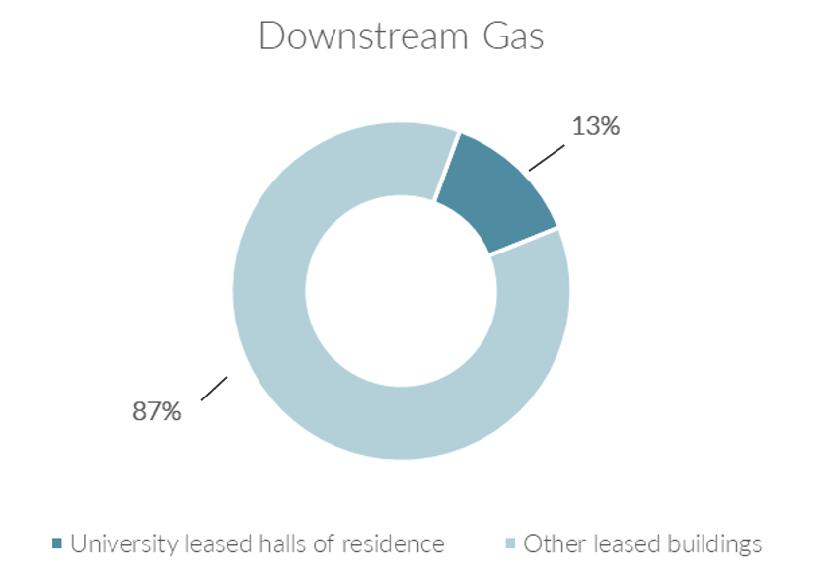

## Waste

Figure : Proportion split of gas/electric (kWh) in downstream leased assets between University leased halls of residence and other leased buildings

Waste accounts for less than 1% of the University’s total emissions. The calculations for our waste emissions comes from a combination of tonnage data from our main waste contractor and other specialist waste contractors. It has reduced significantly compared to the base year and there are a few reasons behind this. Firstly, the baseline year includes some spend data where tonnage data was not available, this will likely have inflated emissions. It also seems that the disposal route for general waste has changed from landfill to combustions (energy from waste), this reduced the carbon factor associated with general waste significantly.

The chart below illustrates the breakdown of waste in tonnes. General waste remains predominant at 56% and reducing this will be key to reducing overall emissions.

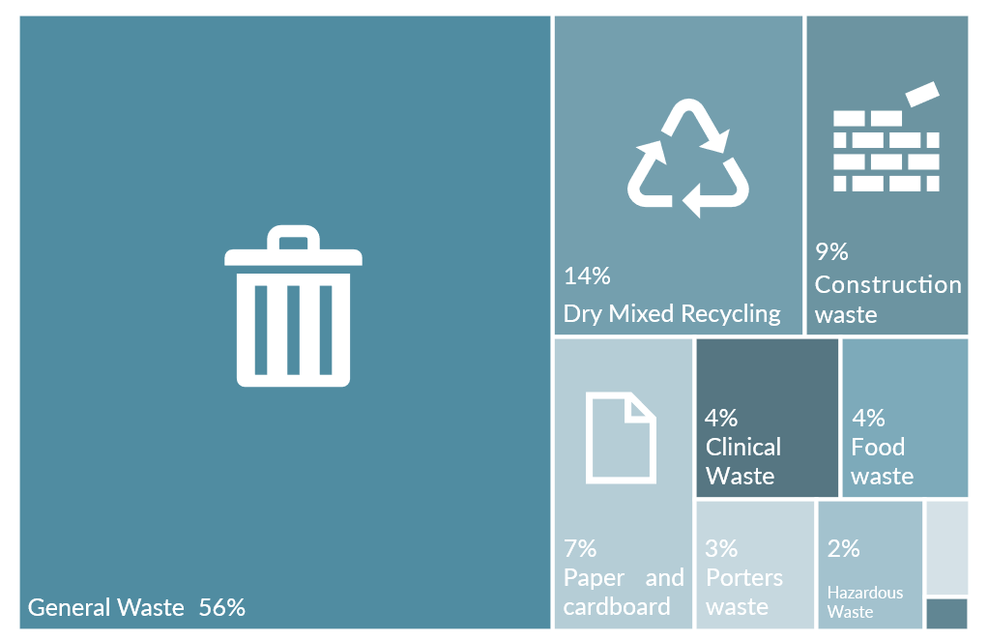

Figure : Split of waste generated (tonnes)

# Next Steps

**Scope 3 Summary**

**Carbon Hotspots:**

Scope 3 remains to be the highest source of the University emissions, accounting for 85% of total emissions.

Procurement emissions, as was in the baseline year, represent our most significant source of emissions, accounting for 61% of our total carbon footprint. The 6% increase is a key contributing factor to our emissions going up by 5% from our baseline.

The second highest emission source in Scope 3, as well as total emissions, is student commuting and home visits, which includes several assumptions on international students visiting their home country out of term time. 84% of those traveling internationally are travelling long-haul. The carbon factor for long-haul economy flights has seen a significant increase since the baseline year and is the prime reason for driving the rise in emissions within this category.

Flights continue to be the dominant source of emissions in business travel as well, however, the category as a whole has seen a reduction on last year.

The emissions related to the procurement of our energy in Scope 1 and 2 is proportionally similar to the baseline year and will reduce as Scope 1 and 2 consumption reduces.

**Reporting improvements:**

In future years we hope to engage more of our supply chain to provide primary emissions data. This approach will enable us to gain deeper insights into the sources of our emissions and, consequently, make more informed decisions regarding decarbonisation.

For the upcoming travel survey, it would be beneficial to expand the data collection to incorporate questions regarding the frequency of home visits and the mode of travel. This approach would eliminate the need for making as many assumptions as possible in this category and lead to a more accurate reflection of emissions.

Continuing to promote the use of the travel management company for booking business travel allows for a granular understanding of emissions withing this category.

We are currently working with a number of third parties to develop a decarbonisation pathway for all three emission Scopes. The successful delivery of the decarbonisation strategy requires active engagement across all the University and our wider stakeholders. Our strategy to create accountability, whilst simultaneously socialising the decarbonisation agenda, is being developed. This will involve embedding our strategy in both our policies and behaviours and ensuring that those with the most influence over carbon emissions have the right information, responsibility and tools to reduce it.

Our Sustainability Steering Group (SSG) has oversight of the direction and implementation of the strategy which will be reviewed yearly alongside the yearly carbon emissions report.

The annual carbon emissions report will be produced to allow us to monitor the success of our decarbonisation strategy and make revisions where appropriate and following advice from the SSG. Our data collection and calculation methodologies will be externally verified by a third-party auditor, to a certified international standard. By being transparent in our reporting, we will contribute to consistent emissions reporting across the HE sector.

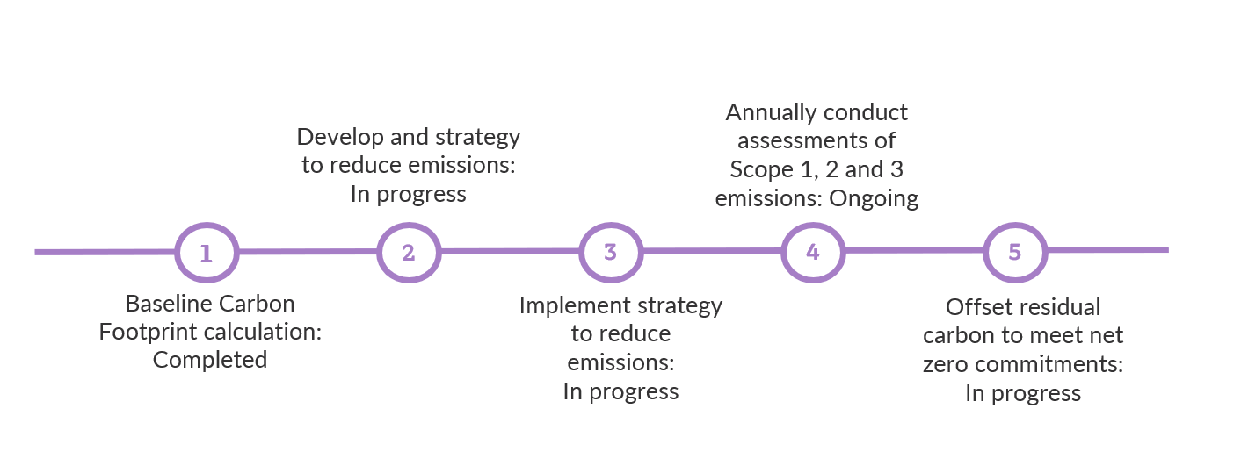

ANITA BARTON

ASSOCIATE

+44 113 380 1947

anitabarton@hoarelea.com

HOARELEA.COM

Western Transit Shed

12-13 Stable Street

London

N1C 4AB

England

