Asbestos

**POLICY UHSP/14/ASB/2022**

Health & Safety Policy

Table of Contents

1. Introduction 3

2. Scope 3

3. Definitions 4

4. Responsibilities 4

4.1 Director of Estates 4

4.2 Heads of School or Director of Professional Services 4

4.3 Staff with responsibility for arranging works to premises 5

4.4 Workplace Wellbeing (Occupational Health/ Safety Services) 5

4.5 Individuals 5

5. Implementation of Policy 6

5.1 Asbestos Register 6

5.2 Labelling of ACM’s 6

5.3 Inspection and maintenance 7

5.4 Removal and waste disposal 7

5.5 Training 7

5.6 Accidents and Incident Reporting 7

5.7 Department owned Equipment 8

6. Auditing and Monitoring 8

7. Review 8

8. References 9

APPENDIX 1: Definitions 10

APPENDIX 2: Emergency Procedures 11

APPENDIX 3: Department Owned Equipment 12

APPENDIX 4: Asbestos Labels 13

# Introduction

University of Birmingham (UoB) acknowledges the health hazards arising from exposure to Asbestos. The Control of Asbestos Regulations 2012 (CAR 2012) are intended to protect against risks arising from exposure to Asbestos, the University will comply with Regulation 4 of the CAR 2012 which sets out a legal duty to manage Asbestos in non-domestic premises. UoB will prevent the exposure to Asbestos fibres of any employee, visitor, student or contractor, where this is not possible UoB will reduce exposure to as low as reasonably practicable through the use of effective control measures and work methods supported by training of employees. The UoB intends to achieve this by:

* Identifying Asbestos Containing Materials (ACM) within relevant buildings. Where it is not reasonably practicable to identify ACM, for example ACM that may be located in inaccessible areas, then the University will presume that asbestos is present and manage accordingly.
* Risk assessing each identified ACM considering the likelihood, and the likely number of people that might be exposed, in the event of an uncontrolled release of Asbestos fibres.
* Implementing a system of monitoring of each remaining ACM at intervals determined by the risk assessment, including control measures to reduce the risk of exposure of people to Asbestos fibres from each ACM.
* Engaging with external expertise as appropriate where additional support, management and resource is required.
* Providing suitable and sufficient information, instruction, training and supervision to employees and contractors to reduce the risk of uncontrolled release of Asbestos fibres as low as is reasonably practicable.
* Devising and implementing emergency procedures to reduce the risk of exposure of people as low as is reasonably practicable in the event of an unplanned and/or uncontrolled release of Asbestos fibres.
* Reviewing this policy and any associated procedures at regular intervals, or following any uncontrolled release of Asbestos fibres, to ensure that it is working efficiently and effectively.

# Scope

The requirements within this policy apply to all University of Birmingham owned premises where Asbestos is, or may be present. The principles also apply to properties occupied or worked in by UoB staff and representatives in conjunction with the building owner’s responsibilities. The Asbestos Policy should be read in conjunction with the Asbestos Management Plan and the University’s Health & Safety Policy.

The majority of Asbestos will be associated with the University’s buildings and infrastructure, the Estate’s Department is responsible for managing this Asbestos.

Some Colleges may have equipment made of, or containing Asbestos e.g. gaskets and washers, heat resistant mats used under Bunsen burners, and gloves which may have Asbestos lining. The respective Schools are responsible for managing this Asbestos and notifying the Estates department of its presence if known.

As detailed in the [University Regulations](https://intranet.birmingham.ac.uk/as/registry/legislation/regulations/index.aspx), section 4, the University of Birmingham expressly forbids interference with any of the University engineering services or with the fabric of buildings without permission from the Director of Estates.

# Definitions

See APPENDIX 1: Definitions, for the list of Definitions.

# Responsibilities

The following responsibilities are in addition to those within the University’s Health & Safety Policy, and specifically relate to the arrangements for Asbestos.

## 4.1 Director of Estates

The Director of Estates is accountable for ensuring that their staff and contractors understand what they can do, and must not do, in relation to Asbestos Management and that staff who manage Asbestos are competent to do so. The Director of Estates will ensure that suitable resource is available to facilitate:

* No new asbestos or materials containing asbestos are used in the fabric of the University’s building or infrastructure;
* Identify and record Asbestos associated with the fabric of the University’s buildings and infrastructure;
* Have a procedure for formally identifying material that could be made of or contain asbestos and to take the appropriate action;
* Maintain an up to date record of the location and condition of the asbestos identified;
* Record the verified presence of Asbestos notified to the Estates Office by Head of School;
* Label as appropriate: Asbestos or potential Asbestos identified;
* Remove or make safe any Asbestos identified that is ***unsafe***;
* Regularly monitor the condition of any Asbestos that is considered safe to ensure it does not become ***unsafe*** and to remove or repair it if it does;
* Dispose of all Asbestos under their control in accordance with the Hazardous Waste Regulations 2005;
* Ensure staff are appropriately trained to identify possible Asbestos material, the possible locations of Asbestos and the action to take if it is found;
* Liaise with Heads of School and Directors of Professional Service departments who may need assistance with the identification of Asbestos and material containing Asbestos.

## 4.2 Heads of School or Director of Professional Services

* Ensure no new equipment containing Asbestos is purchased and/or used unless there is exceptional justification for doing so e.g. Museum artefact – Safety Services must be consulted before any purchase is made or any REACH (Registration, Evaluation, Authorisation and Restriction of Chemicals) application started. CAR 2012 must still be complied with;
* Identify, where possible, all equipment made of or containing Asbestos;
* Arrange through Estates, the removal of, wherever practicable, any Asbestos identified and dispose of it in accordance with the Hazardous Waste Regulations 2005;
* Ensure where it is not practicable to remove Asbestos that it is maintained in a condition that is ***safe*** and to notify the Estates Office of its presence and follow any guidance given;
* Ensure that relevant department staff are trained to identify possible Asbestos material, the possible locations of Asbestos and the action to take if it is found; support can be gained from the Estates Office if necessary.
* Seek the permission of the Estates Office before construction, alteration or maintenance is carried out on a building and in particular seek information from Asbestos register.

## 4.3 Staff with responsibility for arranging works to premises

Those responsible for arranging works to premises must ensure all Asbestos issues are dealt with prior to beginning any project. They are responsible for:

* Engaging with the Estates Office to ensure appropriate guidance is received and control measures put in place.

The Estates Office are then responsible for:

* Ensuring that projects which need to disturb Asbestos containing materials identify this within the project plan. The Asbestos must then be removed or encapsulated within the timescales and funding of the project.
* Carrying out more detailed survey work as necessary, where intrusive work is planned at any property.
* Employing, as necessary, a professional individual for co-ordinating and arranging removal and remediation work where there are insufficient in-house expertise, resources or knowledge.

## 4.4 Workplace Wellbeing (Occupational Health/ Safety Services)

Safety Services are responsible for:

* Providing advice to Heads of Schools or Directors of Professional Services if they are considering purchasing equipment containing Asbestos (refer to 3.2);
* Giving advice to individuals on matters relating to Asbestos;
* Managing the reporting process in the event of a RIDDOR (Reporting of Diseases Dangerous Occurrences Regulations 2013) reportable incident.

Occupational Health are responsible for:

* Maintaining appropriate health records;
* Providing advice to referred University staff or students about possible health risks of being exposed to Asbestos fibres or suspected of being exposed to Asbestos fibres and actions that may be required.

## 4.5 Individuals

Are responsible for:

* Co-operating in the implementation of this policy;
* Bringing to the attention of their Head of School or Director of Professional Services any known or potential locations of Asbestos;
* Reporting as soon as is reasonably practicable the accidental discovery of Asbestos.
* Not to interfere with any of the University engineering services or with the fabric of buildings without express permission from the Director of Estates.
* To ensure their GP maintains appropriate records in the event of a suspected or actual exposure to Asbestos fibres.

# Implementation of Policy

This Policy will work in conjunction with the Asbestos Management Plan, together with associated local policies, protocols and procedures. These documents will be available on the UOB intranet and will form the basis of the means for communication to building users/occupiers and staff of the methods employed by UoB to manage Asbestos.

## 5.1 Asbestos Register

The Asbestos Register can be accessed through an online portal with a valid log in using any web capable platform such as computer, iPad/tablet or phone. The link for the register is below, with access to be arranged through an Estates Sponsor.

<https://uob-prime.lmp.co.uk/>

The register is managed by Estates Office Technical Officers and updated by an external specialist Asbestos Contractor, who is responsible for any additions or alterations that may take place through work carried out on site.

Contractors can also be provided with access to the register, via an Estates Sponsor.

## 5.2 Labelling of ACM’s

In order to comply with Regulation 4 and 5 of the CAR 2012 the identification of Asbestos in the University’s Warning Labels or appropriate signage will be applied to ACMs considered to be a significant risk where this is deemed to help prevent accidental damage, and not cause undue concern.

Lower risk materials such as floor tiles, textured coatings, cement materials will not be routinely labelled but adequate steps will be undertaken to raise site awareness of their presence. If an Asbestos label is present, it must be assumed that ACMs are present. Conversely, depending on location, the absence of a label does not mean that ACMs are not present. If in doubt, **ASK**.

The use of local warning signs and labels can be beneficial in decreasing the chance of inadvertent damage and exposure however, labelling may not always be considered, particularly where they may cause anxiety to the building occupants. Examples of these can be seen in Appendix 4.

The labelling of Asbestos in the University’s buildings and infrastructure will be organised through the Estates Office.

## 5.3 Inspection and maintenance

The condition of all ACM’s or materials suspected of containing Asbestos will be inspected at agreed intervals within the management plan to ascertain if there has been any damage or deterioration, inspection intervals are determined based on a Priority Risk Score. Where damage or deterioration is found, the ACM will be reassessed and repaired or removed as appropriate.

A risk-based approach is taken with risk assessments being carried out using the algorithm in HSG 227, priority assessment and HSG 264 material assessment. Where ACM is assessed as being in good condition then this will generally be left in situ and managed, where ACM is assessed as posing a risk to health it will be, so far as is reasonably practicable, removed or encapsulated. Where removal or encapsulation is not reasonably practicable then access to the ACM will be managed to reduce the risk of exposure as low as is reasonably practicable.

Refurbishment and Demolition surveys are carried out as an integral part of the planning process for any project works carried out in University owned, managed or occupied premises. All work that could result in the release of Asbestos fibres is appropriately planned, managed, delivered and monitored. In the case of works that involve the removal or encapsulation or other activities that will lead to the release of Asbestos fibres, regardless of Asbestos type, these will only be carried out by organisations licensed to carry out such works by the Health and Safety Executive (HSE).

## 5.4 Removal and waste disposal

The removal and disposal of ACM’s is strictly controlled by legislation as defined in the CAR 2012.

All removal, repair and disposal of asbestos will be carried out under the control of the Estates Office.

Licensed contractors must carry out Asbestos stripping. Asbestos waste is classified as Hazardous Waste and must only be removed from University premises by licensed carriers and in accordance with the University Policy for Hazardous Waste and in full accordance with the CAR 2012.

## 5.5 Training

All employees who may encounter Asbestos during the course of their work will be given the necessary training to be able to identify the situations in which Asbestos may be present, to be able to recognise Asbestos or similar materials and to set out safe working practices to minimise risk to Health and Safety.

It is a statutory requirement that adequate information, instruction and training is given to employees who are, or who are liable to be, exposed to Asbestos, including those who supervise those employees, in accordance with Regulation 10 of the CAR 2012. Training shall be appropriate to the individual’s potential to be exposed to Asbestos and be given at regular intervals by a competent and experienced organisation/ person. The training will be proportionate to their needs and be refreshed at suitable intervals to maintain knowledge, this will be at intervals no greater than 3 years.

## 5.6 Accidents and Incident Reporting

The presence of Asbestos-Containing Materials in itself does not constitute a danger. However, there is a potential risk to health if such material is disturbed and fibres are released and become airborne. In any emergency the primary concern should always be the immediate safety of those that are affected as a result of an exposure. Emergency procedures are detailed in Appendix 2 of this policy.

When the immediate situation has been dealt with and people are no longer at risk, the incident must be reported locally, and to the Estates Health and Safety Officer who will inform Safety Services. Safety Services, in collaboration with the Estates Health and Safety Officer will inform the HSE if necessary under the Reportable Incidents, Diseases and Dangerous Occurrences (RIDDOR) Regulations 2013.

All incidents will be investigated with the aim of identifying lessons learned and preventing similar occurrences in future. Any remedial actions required must be implemented immediately where possible and lessons learnt communicated widely to all who can benefit. Where it is suspected that University staff or Students may have been exposed to Asbestos fibres they will be referred to Occupational Health for advice about possible health risks and actions that may be required. Copies of the incident report will be kept by Safety Services and in the Estates Office, and a copy provided to the person involved on request.

## 5.7 Department owned Equipment

Some items of equipment, particularly those found in laboratories may be made of or contain Asbestos. By experience and knowledge staff will know many pieces of equipment that do contain Asbestos. If there is any doubt the Estates Office should be contacted to arrange for material to be tested to verify its composition or advice sought from Safety Services.

It is advised that any equipment made wholly of Asbestos (e.g. gloves, mats etc.) is disposed of whether or not it is in good condition. Wherever possible, any equipment containing Asbestos (e.g. oven seals, furnaces etc.) should either have the Asbestos removed and replaced by another material, if practicable, or the equipment disposed of. Arrangements for the removal and disposal of Asbestos should be made through the Estates Office. The Asbestos Policy requires that any arrangements for disposal must be made in accordance with the University Policy for Hazardous Waste disposal.

In some cases, the removal of Asbestos may not be practicable. In such cases it may be left if it is in good condition or, if possible, repaired if damaged. It is advised that arrangements for repairs should be made through the Estates Office. Any equipment containing Asbestos should be clearly marked.

The Asbestos Policy requires Heads of Schools or Heads of Professional Services to notify the Estates Office of any material that they know or suspect is Asbestos or contains Asbestos. Initial queries concerning the identification and/or removal of Asbestos should be made through the Estates Office help desk, ext. 46406, email [repairs@contacts.bham.ac.uk](mailto:repairs@contacts.bham.ac.uk), or the buildings designated Maintenance Officer.

# Auditing and Monitoring

Independent audits, carried out both internally and externally may include the HSE and the University’s Internal Audit Service. Findings and action plans produced as a result of these audits will be monitored through the Estates Performance meeting and escalated if necessary.

# Review

This Policy will be reviewed three yearly or as circumstances dictate by changes in either Legislation or the University’s Organisational Structure who will also monitor its implementation and effectiveness.

# References

University of Birmingham is committed to meeting the requirements of the relevant guidance and complying with these procedures to manage the Asbestos risk in so far as is reasonably practicable. The following documentation has been used as the primary source of guidance:

* The Health and Safety at Work etc Act 1974
* The Management of Health and Safety at Work Regulations 1999
* The Workplace (Health, Safety and Welfare) Regulations 1992
* The Control of Asbestos Regulations 2012
* The Construction (Design & Management) Regulations 2015 (CDM)
* Approved Code of Practice (L143): Managing and Working with Asbestos
* Health and safety Guidance (HSG248) Asbestos: The analysts’ guide for sampling, analysis and clearance procedures
* Health and Safety Guidance (HSG264) Asbestos: The Survey Guide
* Health and Safety Guidance (HSG247) Asbestos: The Licensed Contractors Guide
* [The University of Birmingham Regulations](https://intranet.birmingham.ac.uk/as/registry/legislation/regulations/index.aspx)

# APPENDIX 1: Definitions

**Approved** - Approved for the time being in writing by the Executive.

**Asbestos** - The general term used for the fibrous silicates listed in regulation 2(1) of the CAR 2012. Any mixture containing one or more of these fibrous silicates at more than trace amounts.

**ACM** – Asbestos Containing Material: Any material containing more than 1% Asbestos.

**Asbestos products** -

Asbestos cement: A material which is predominantly a mixture of cement and chrysotile and which when in a dry state absorbs less than 30% water by weight;

Asbestos coating: A surface coating which contains Asbestos for fire protection, heat insulation or sound insulation but does not include textured decorative coatings;

Asbestos insulating board (AIB): Any flat sheet, tile or building board consisting of a mixture of Asbestos and other material except-

*(a) Asbestos cement, asbestos coating or asbestos insulating board; or*

*(b) any article of bitumen, plastic, resin or rubber which contains asbestos and the thermal and acoustic properties of that article are incidental to its main purpose;*

Asbestos insulation: Any material containing asbestos which is used for thermal, acoustic or other insulation purposes (including fire protection) except-

*(a) Asbestos cement, Asbestos coating or Asbestos insulating board; or*

*(b) any article of bitumen, plastic, resin or rubber which contains Asbestos and the thermal and acoustic properties of that article are incidental to its main purpose.*

**CAS** – Reference to CAS Registry Numbers assigned to chemicals by the Chemical Abstracts Service, a

division of the American Chemical Society.

**Competent –** Any reference to competence, competent persons or competent employees in relation to working with asbestos is a reference to a person or employee who has received adequate information, instruction and training for the task being done and can demonstrate an adequate and up-to-date understanding of the work, required control measures and appropriate law. They must also have enough experience to apply this knowledge effectively.

**Control measure -** A measure taken to prevent or reduce exposure to asbestos (including the provision of systems of work and supervision, the cleaning of workplaces, premises, plant and equipment, and the provision and use of engineering controls and personal protective equipment).

**New Asbestos -** That which is unknown to the University, or newly discovered**.**

**Reasonably Practicable** - This means balancing the level of risk against the measures needed to control the real risk in terms of money, time or trouble. However, you do not need to take action if it would be grossly disproportionate to the level of risk.

**Responsible Person** – Designated person who has a responsibility for the maintenance of the premises and the systems within it.

# APPENDIX 2: Emergency Procedures

Arrangements are in place to deal with emergencies and other unplanned events that may take

place for all areas where Asbestos is disturbed.

An Asbestos emergency is where:

* Suspected ACM’s are encountered;
* Known or suspected ACM’s are damaged, or discovered in a damaged state;
* Remedial works that result in the uncontrolled release of elevated airborne fibre levels
* Fire within or outside an asbestos enclosure
* Loss of negative pressure e.g. negative pressure unit fails
* Enclosure rupture/damage

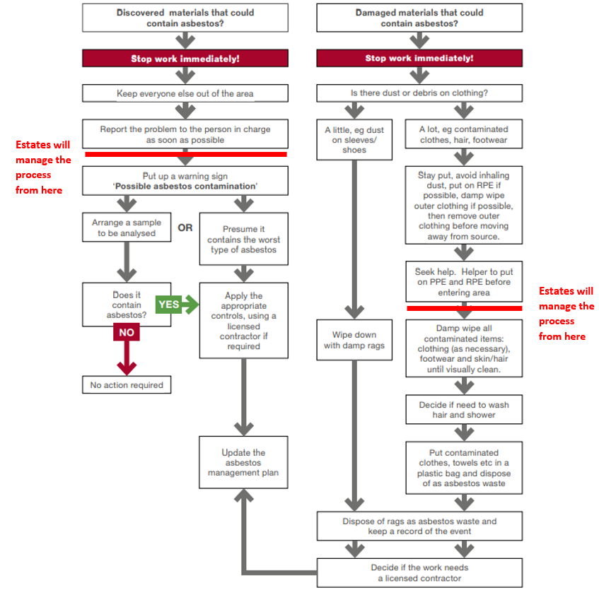**In all cases the Estates Office must be contacted immediately.**

Flowchart taken from HSE document EM1

<https://www.hse.gov.uk/pubns/guidance/em1.pdf>

# APPENDIX 3: Department Owned Equipment

|  |  |  |  |  |
| --- | --- | --- | --- | --- |
| Item or piece of equipment that may be made of or contain Asbestos. |  |  |  |  |
| 🡻 |  |  |  |  |
| Can the Asbestos item or the equipment containing Asbestos be disposed of? | **Yes**  🡺 | Arrange disposal via the Estates department |  |  |
| **No**  🡻 |  |  |  |  |
| Can the Asbestos be replaced? | **Yes**  🡺 | Arrange disposal in accordance with University Policy for Hazardous Waste | 🡺 | Replace with other material |
| **No**  🡻 |  |  |  |  |
| Is the Asbestos in good condition and safe? | **Yes**  🡺 | Appropriately mark.  Notify the Estates Office so records can be updated. | 🡺 | Monitor condition regularly.  Notify the Estates Office if condition, location change. |
| **No**  🡻 |  |  |  |  |
| Can the Asbestos be repaired and made safe? | **Yes**  🡺 | Appropriately mark.  Notify the Estates Office so records can be updated.  Arrange repair with the Estates Office. | 🡺 | Monitor condition regularly.  Notify the Office of Estate Management if condition, location change. |
| **No**  🡻 |  |  |  |  |
| The removal and disposal of the Asbestos **must** be arranged via the Estates Department, which will be carried out in accordance with the University’s Hazardous Waste Policy |  |  |  |  |

**Note Initial** queries concerning the identification and/or removal of Asbestos should be made through the Estates Office Help desk, ext. 46406.

# APPENDIX 4: Asbestos Labels

Infrastructure Disturbance Notice

An Infrastructure Disturbance caution notice may be place in some rooms, offices and other areas within buildings at the University. A typical location will be on a wall at sight level adjacent to the opening of the main entrance door. The notice provides a warning for everyone that they MUST NOT carry out work which is likely to disturb walls, ceiling, floors or services without specific authority from the Estates Office.

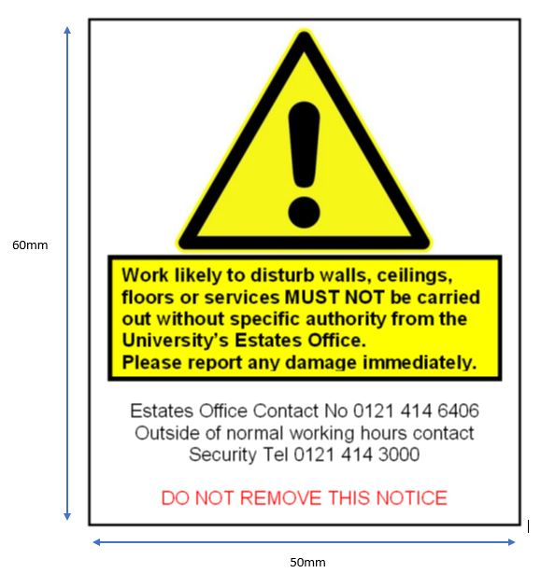

Asbestos warning label

This label is used within concealed/maintenance areas such as substations, plant rooms, distribution boards, and dry risers.

