# Carbon Management Plan

## Executive summary

This Carbon Management Plan summarises the University’s approach to achieving Net Zero Carbon (NZC) by 2045 and how carbon accounting will be carried out annually to track progress.

This will see not only the University reducing its environmental impact but that of our suppliers, partners, and contractors alike, demonstrating responsibility in line with our civic responsibilities towards the health of the city and the region’s business, communities and citizens.

This plan has been reviewed and approved by the Sustainability Steering Group.

## Introduction

As a university founded on social responsibility, we deliver sustainability through pioneering research and innovative education, the behaviour and actions of our students and staff, and engagement with our local communities. This is reflected by the [sustainability pillar](https://university-of-birmingham.foleon.com/bham2030/strategic-framework/sustainability/) of our 2030 Strategic Framework. The University of Birmingham has [committed to reaching Net Zero Carbon (NZC)](https://www.birmingham.ac.uk/university/social-responsibility/energy-and-carbon.aspx#:~:text=The%20University%20of%20Birmingham%20is,against%20a%2020%2F21%20baseline.) by 2045. ￼

## Student Involvement

The University’s Guild of Students were involved in shaping the 2030 Strategic Framework and setting our NZC targets. The [NUS Carbon Targets](https://www.carbontargets.uk/unipage/university-of-birmingham) initiative has ranked us as “Leading the Way” on commitments to reduce carbon emissions and taking action against the climate emergency.

To deliver on our net zero target, we have embarked upon an ambitious plan that includes and engages our students, colleagues, and other stakeholders. This Carbon Management Plan (CMP) outlines our approach to achieving NZC targets, through reduction of demand, production of cleaner energy, and offsetting of emissions.

## Carbon accounting and emission scopes

The Greenhouse Gas (GHG) Protocol is the recognised global standard for carbon accounting. This categorises emissions into three ‘Scopes’ so that responsibility for them can be accurately allocated. Essentially, Scope 1 and 2 are those emissions that are owned or controlled by an organisation, whereas Scope 3 emissions are a consequence of the activities of the organisation but occur from sources not owned or controlled by it.

We have recently changed the methodology to calculate our carbon emissions to realign with best practice set out in the Environmental Association of University and Colleges’ (EAUC) Standardised Carbon Emissions [*Framework*](https://www.eauc.org.uk/scef) (SCEF). The SCEF encourages improvement of data quality and robustness over time. Notably, we have adopted the assumptions set out within the SCEF for calculating carbon emissions associated with the international student commute (at two return flights per year).

Given the significance of the SCEF methodology to our carbon accounting we have re-calculated our original baseline period of 2020-21. This has seen the baseline increase from 280,504 tCO2e to 316,239 tCO2e for 2020-21. The main reasons for this were the inclusion of the international student commute (see above) and working from home emissions. In addition, we have improved the quality of our Scope 3 data by using invoices, rather than purchase orders, to calculate the emissions associated with our procurement spend for both the baseline year, and for 2021-22. The graphic below, depicts the changes between the original and revised baselines:

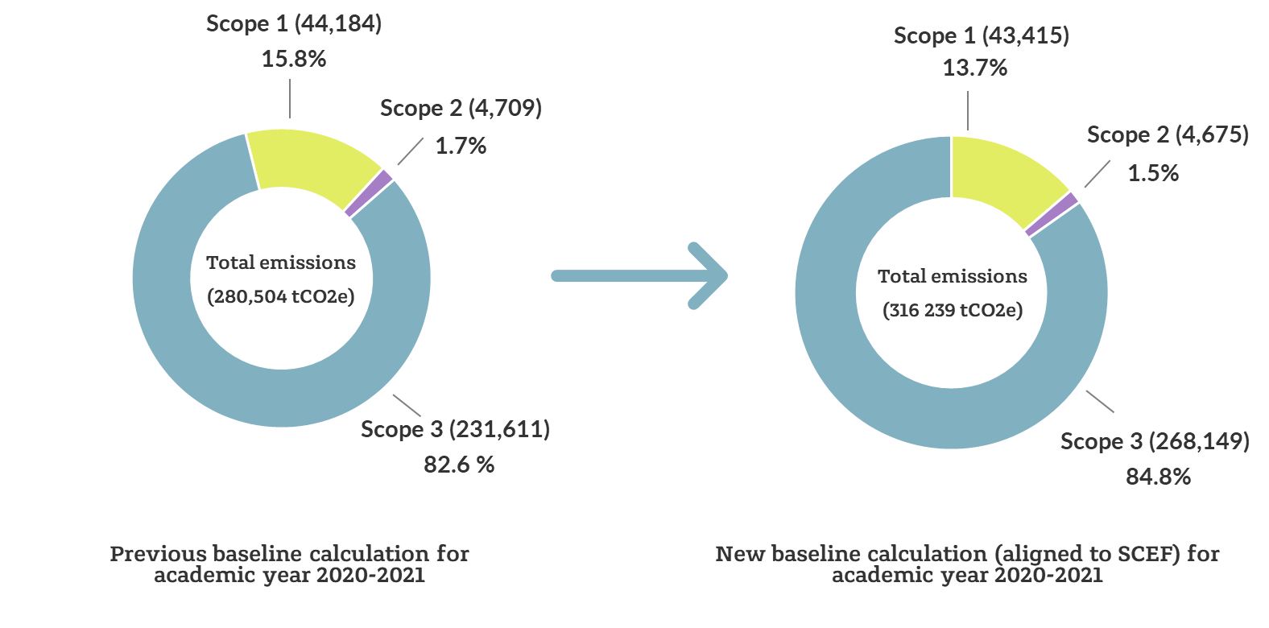

*Figure 1 – Comparison between the original baseline calculation for total emissions against the new baseline calculation (aligned to SCEF) for 2020-21.*

Emissions for 2021-22 increased by 5% over the revised 2020/21 baseline, which is an overall increase of 14,752 tCO2e. The changes are illustrated below:

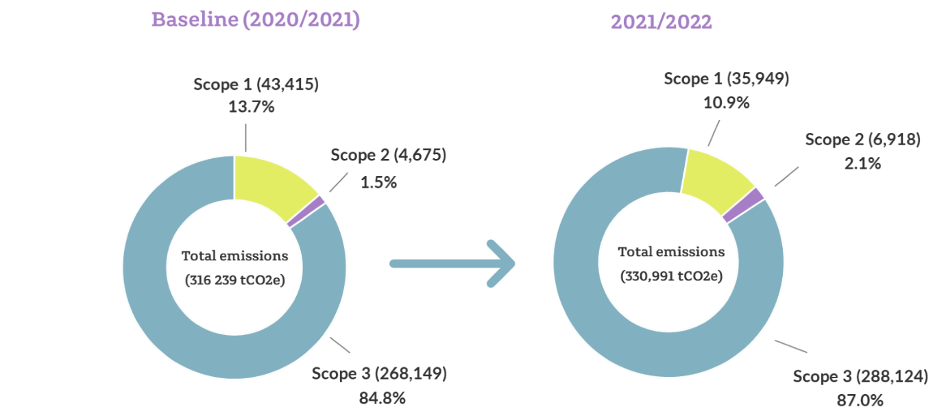*Figure 2 – Comparison between the baseline total emissions for 2020-21 against the total emissions for 2021-22.*

The significant changes are summarised below.

* Scopes 1 and 2: This reflects an 18% decrease in natural gas and 47% increase in purchased electricity. The reduction in gas consumption was caused by reduced utilisation of our Combined Heat and Power system, resulting in increased reliance on electricity imported from the grid.

Scope 3: This reflects a 6% increase in supply chain emissions, due to an increase in spend; and 34% increase in the international student commute as international students returned in greater numbers post-pandemic.

## Baselines

The table below shows the breakdown of the University’s carbon footprint across each scope for the baseline year. This provides context for the number of areas where emissions reduction will need to be targeted.

|  |  |  |  |
| --- | --- | --- | --- |
| **Scope** | **Source** | **Baseline emissions**  **(tCO2e)** | **Contribution to total**  **(%)** |
| 1 | Natural Gas | 42,923 | 13.57% |
|  | Fleet (owned / operated) | 75 | 0.02% |
|  | Refrigerants | 225 | 0.07% |
|  | Other fuels | 192 | 0.06% |
| 2 | Purchased electricity | 4,652 | 1.47% |
|  | Heat & steam | 24 | 0.01% |
| 3 | Procurement emissions | 191,866 | 60.67% |
|  | Fuel & energy procurement emissions | 9,145 | 2.89% |
|  | Waste | 628 | 0.20% |
|  | Business travel | 9,767 | 3.09% |
|  | Staff commuting & working from home | 6,962 | 2.20% |
|  | Student commuting (during university terms time and home visits) | 48,565 | 15.36% |
|  | Leased buildings (downstream) | 1,031 | 0.33% |
|  | Water and wastewater | 185 | 0.06% |
|  | **Total** | **316,240** | 100% |

*Figure 3 – Carbon Emissions Baseline Table*

## Targeting carbon reduction

The University of Birmingham has a long history of carbon management, reduction and reporting dating back to 2006, with the publication of our first carbon management plan (CMP) in the first phase of the Carbon Trust’s *Higher Education Carbon Management Programme.* We achieved our 2020 target to reduce our Scope 1 & 2 carbon emissions by 20% in absolute terms against a backdrop of increasing student numbers, construction of new buildings and increasing turnover.

This CMP outlines our approach towards the University’s institutional Measure of Success (or KPI) for achieving NZC emissions across all scopes by 2045, 5-years ahead of the [UK Government’s 2050 legally binding target](https://www.gov.uk/government/publications/net-zero-strategy).

## Milestones

The University will continue to work towards our absolute reduction targets, whilst also adopting relative metrics to support the progression of our carbon management program. To ensure that we remain on track toward our decarbonisation targets, an evolving plan of projects and initiatives that will contribute to the reduction of carbon emissions is currently being established. This will be developed and maintained in accordance with progress.

The NZC overall and interim targets for absolute emissions reduction will support delivery of the UK’s legally binding target and aligns with the COP21 Paris Agreement, which seeks to limit the increase in global temperature to 1.5°C above pre-industrial levels. The University’s strategic and interim targets are set out here:

* Milestone 1 (interim target) – By 2027, 18% carbon reduction, for Scopes 1 & 2 (against 2020/21 baseline)
* Milestone 2 – By 2035, to deliver NZC for Scopes 1 & 2
* Milestone 3 – By 2045, to achieve NZC for Scope 3

## Monitoring and Reporting

Our Milestone 1 interim target will remain under review pending the proposed development of [sector specific guidance](https://www.eauc.org.uk/eauc-led_science-based_target_guidance_and_veri). This approach is consistent with our position as a [global leader in climate change research](https://www.birmingham.ac.uk/research/climate/index.aspx) and will ensure our continuing alignment the COP21 Paris Agreement.

Carbon emissions will be calculated annually, allowing the monitoring and adjustment of our pathway to NZC with increasing accuracy. We intend to take a transparent approach to reporting, holding ourselves accountable to our NZC commitments by publishing our progress in annual updates to the CMP.

## Implementing Carbon Reduction

A range of activities have been co-created through our Sustainability Steering Group and sustainability action groups, with SMART targets established where appropriate with the aim of reducing our environmental impact and enhancing the positive contributions we can make to tackling the climate crisis (see Appendix A). Activities have been collaboratively developed and will be regularly updated to maintain relevance and ambition. Focus of this activity will be in five parts and are explored in further detail below:

* Scopes 1 and 2
* Scope 3
* Community Involvement
* Biodiversity
* Offsetting

### Scopes 1 and 2

As noted above, the University has set a target to deliver Net Zero Carbon for Scopes 1 and 2 by 2035, with an interim target of 18% carbon reduction for Scopes 1 and 2 by 2027. A number of key actions will be required to deliver our decarbonisation target for scope 1 & 2. As natural gas accounts for 89% of scope 1 and 2 emissions, the priority for decarbonising will be to move away from using gas to produce heat and power, to become an electrically powered campus (i.e. installation of heat pumps to decarbonise our Energy Centre). To facilitate this, initial activity will focus on reducing energy demand, such as LED lighting upgrades and heating, ventilation, and air conditioning controls optimisation as these are enabling measures for the electrification of buildings. Alongside this, fabric upgrades will be aligned to our Estates strategy, focusing on buildings that will remain on the decarbonised district heat network. We are in the process of installing additional rooftop Solar PV at our Sport and Fitness Centre and National Buried Infrastructure Facility.

Scope 3

Scope 3 emissions relate to emissions that are not under our direct control such as the procurement of goods and services, business travel, and student and staff commuting. Our scope 3 emissions account for 87% of our total emissions, and as such, we will need to ensure that robust targets are set to ensure we achieve our Scope 3 goal of net zero carbon by 2045. A baseline for the University’s scope 3 emissions has been developed (as shown in the table above), and over the next 12 months systems and processes for capturing this data will be improved to ensure the accuracy and reliability of this data. This will then help inform meaningful targets for carbon reduction. To support our net zero objectives, the University will develop an in-depth net zero carbon implementation plan by 2025, outlining the workstreams needed to achieve net zero carbon by 2045, including the following scope 3 target areas:

* Business Travel
* Staff and Student Commuting
* Waste
* Water
* Procurement

### Business Travel

Over the next 12 months, the University will introduce updated business travel guidance (which will be supported by accurate reporting) that aims to reduce carbon emissions resulting from business travel by encouraging the following:

* Encourage use of Travel Management Company (Clarity) wherever possible for bookings
* Use of travel hierarchy principle

1. Don’t travel
2. Reduce travel
3. Travel without flying. Where there is a choice, avoid flying.
4. Fly better. It is important that those who do need to fly are considering cabin class, direct flying and using the booking tool. Economy travel generates lower emissions per person than business class. First class generates the most carbon emissions.

* Promote the use of sustainable commuter travel options by staff and students to and from campus.

### Staff and student Commuting

We have also set targets to reduce our student and staff commuting to and from campus, which will be measured via our yearly travel survey. Key milestones include a plan to reduce single occupant car journeys (currently at 40%) by 2% by the end of the 2024/25 academic year, and by 5% by 2026.

*Waste*

While waste is a small contributor to our overall carbon emissions, we recognise our responsibility to reduce waste and increase recycling rates. By the end of 2024, a recycling target of 40% (currently 35%) is to be achieved, with a further target to reach 50% by the end of 2026/27. These assumptions are reliant on engagement and behaviour change. It is anticipated that changes in UK waste legislation in 2025, as well as introduction of the following interventions will further drive changes in behaviour:

* Expansion of food waste collections focussing on building kitchens and areas of high footfall.
* Streamlining waste streams following audit and in anticipation of future compliance changes which will expand segregations further.
* Behaviour change campaign, aiming to increase recycling rate by introducing coffee cup schemes; utilising the sustainable champions network to educate and develop targeted campaigns.

### Water

As part of our work to reduce emissions across our Estate and mitigate our environmental impact, the University is committed to reducing water usage, both on campus and within our residential accommodation stock. As such, the University has set a 10% water reduction target for absolute consumption by the end of the 2024/2025 academic year. We recognise that engagement with both staff and students across the campus will be needed to ensure that our water consumption reduction targets are met; engaging staff and students around the topic of water reduction forms part of our community engagement plan as set out within our sustainability priorities.

### Procurement

Our suppliers are at a mixed level of carbon maturity from industry leaders to those having taken no action. Of our top 43 suppliers by spend, 37% have set either public or internal NZC targets for their scope 1 and 2 emissions. To meet our NZC targets, we will need to engage with our supply chain to decarbonise at a faster rate. We have taken the following steps to respond to these challenges:

1. Measuring and mapping our supply chain
2. Setting supply chain targets
3. Influencing our suppliers’ emissions through the creation of ‘action pathways’ based on carbon maturity of each supplier.

During the next 12 months our focus, supported by our Sustainable Procurement Projects Manager, will be as follows:

1. Sharing decarbonisation targets with suppliers.
2. Expanding the NZC Supplier Tool rollout across our supply chain.
3. Introducing decarbonisation criteria into our procurement pre-qualification phase.
4. Developing a 5-year supply chain engagement plan.

### Community Involvement

While a significant component of achieving NZC will involve activities beyond the control of the individual (e.g. upgrades to buildings, changes to the energy centre), having a focus on behaviour change will ensure that staff and students are educated and supported to take personal action in a way that is aligned to our NZC targets. Various workstreams are already underway to engage staff and students across the University, and drive increases in energy efficiency through behaviour change. The Engagement Action Group is working to drive actions that will result in embedding sustainability and NZC action across the community and has identified various priorities for how to [Get Involved](https://www.birmingham.ac.uk/university/social-responsibility/get-involved).

We have already launched schemes such as Green Impact, green weeks and a sustainability champions network to help progress these goals. Over the next 12 months, we will seek to increase membership of our sustainability champions network to 400 members, as well as maintain our goal of holding two sustainability themed green weeks per academic year. We are also in the process of initiating a scheme for student Sustainability Ambassadors at College level and student Sustainability Reps at School level. In addition, a College Sustainability Leads group has been established, to align and engage the Colleges with the Sustainability Priorities, including NZC.

The University also acknowledges the importance of reputation-related factors in regards to supporting our carbon management aims. We closely monitor league table positions and benchmarks, such as the QS and People and Planet Sustainability league tables. We will seek to improve our standing relative to our peers in the higher education sector, measuring our progress and performance year on year.

### Biodiversity

Increasing biodiversity at the University is an important consideration in the management of our decarbonisation plan. The University has already completed an exercise to baseline its natural capital undertaken by consultant partners Buro Happold in May 2024. Over the next 12 months, we will begin to implement our Biodiversity action plan as set out in our sustainability priorities, which include the following targets:

* Develop and publish a biodiversity policy
* Set targets for enhancing biodiversity for the 2024/2025 academic year and beyond
* Achieve Nature Positive Universities accreditation
* Maintain Hedgehogs Friendly Campus Gold Accreditation

### Offsetting

Whilst our current focus is on reducing our absolute emissions as far as is practicably possible, we recognise that to meet our Net Zero Carbon targets, it will be necessary to offset any remaining “residual” emissions. At this stage, it is anticipated that any offsetting would be steered through the [EAUC Carbon Coalition](https://www.eauc.org.uk/carbon_coalition) initiative to ensure maximum value for money and confidence in the projects being invested in.

Governance, Authority and Reporting NZC

There is a strong governance model in place for ensuring the Net Zero Carbon targets are met. This has been developed to drive action linked to strategy​ by providing a mechanism for effective reporting into senior leadership​ and optimising engagement with key stakeholders. The governance model is set out below.

Sustainability Oversight Board (SOB)

The SOB is chaired by the Vice-Chancellor and is responsible for:

* Holding the Sustainability Steering Group to account for progress against the University’s sustainability ambitions, as set out in the Strategic Framework;
* Reviewing and approving plans that deliver against the University’s sustainability ambitions;
* Reviewing the effectiveness of management processes and controls over delivery against the sustainability ambitions;
* Overseeing the resource profile for delivery of the University’s sustainability plans;
* Ensuring connectivity between Sustainability and other key strategic initiatives.

Sustainability Steering Group (SSG)

The SSG provides strategic oversight and co-ordination of the University’s approach to sustainability and achieving NZC, and ensure alignment with other strategic goals such as Smart Campus and Capital Master Planning. Specific key tasks carried out by the SSG are as follows:

* Overseeing the development and work of various action groups (see below) which are responsible for delivery against key areas of the strategy.
* Checking on progress, monitoring performance and examining all business cases for proposed projects and additional resourcing.
* Reporting progress towards NZC to the SOB and University Executive Board.

Roles and responsibilities of SSG group members*:*

* Executive Sponsor of NZC - Professor David Hannah – Deputy PVC Sustainability and Director of the Birmingham Institute for Sustainability & Climate Action (BISCA).
* University Lead of NZC - Head of Sustainability (University Business Lead for Scopes 1, 2 & 3).
* Mark Senior – Chief of Staff
* Accountable Lead for scope 1 & 2 - Trevor Payne – Director of Estates
* Accountable Lead for scope 3 - Simon Bray – Director of Campus Services
* Professor Julia Myatt – Director of Sustainability Education
* Danielle Edwards – Deputy Director of Finance (Projects)
* Matthew Home – Head of Procurement
* Monica Guise – Director of Facility Services
* Rebecca Lambert – Director of Planning and Performance Insight
* Kathryn Hobbs – Head of Communications and Engagement
* Alison Lundy – Sustainability Project Officer and EA
* Tara Lamplough – Head of Business Partnering, IT Services
* Dr Laura Graham – Biodiversity Action Group Lead
* Paula Mitchell – Director of Communications and Reputation
* Emily Prestwood – Energy Development Manager, Birmingham Energy Institute
* James Sharman – Carbon and Sustainability Manager
* Max Williams - Guild Sustainability Officer

Action groups

To rationalise the variety and scale of the challenge, a number of groups have been established that currently report into the SSG. A brief description of each group is provided below:

* Net Zero Carbon Action Group - To develop a clear plan for achieving the University’s Net Zero ambitions and to communicate this plan to key audiences
* Engagement Action Group - To develop a clear plan for how staff and students engage with Sustainability, increase localised activity and initiatives in a coordinated manner across all communities.
* Data & Benchmarking Action Group - To improve the efficiency and effectiveness with which sustainability data can be used
* Communications Action Group - Drawing together the communications strategy and delivery of the communications strategy, based on the other workstreams​
* Biodiversity Action Group – To nurture and protecting the University's natural capital and green spaces for the benefit of the community, now and in the future

Membership of each working group has been purposefully designed to promote cross functional working. Similarly, there is expected to be a high degree of overlap between the activity of the groups, to be managed through shared membership, clarity of ownership and joint working​.

The above action groups are developing detailed action plans to deliver carbon reductions in line with NZC targets. They will also assess resource requirements to ensure priority is given to projects and initiatives that deliver the best return on carbon saving (e.g. £ invested / tonne saved). The actions are summarised below:

1. Publish progress on action plan development and related actions in annual updates of the CMP.
2. Identify projects / initiatives, rank and prioritise based on key criteria e.g. carbon saving, cost, technical risk, etc with methods of prioritisation to be used or developed as needed.
3. Publish a rolling programme of deliverable projects and initiatives in the annual update of the CMP.

Other groups

The following groups also report into SSG.

* Research / BISCA – This group will ensure that major University initiatives are developed and that they share our research and impact on sustainability​ and that we contribute to sustainability through collaboration with the city and region​. As BISCA shifts from transformative to distributed leadership, a management and advisory group will be formed, and these will report into SSG.
* Academic Steering Group for Smart Campus Research & Education – To provide strategic oversight and co-ordination of the University’s approach to maximise the smart campus as a research and innovation asset.

The Governance structure will be reviewed annually, to ensure it is fit for purpose in supporting the University in achieving its sustainability ambitions. Other work in progress includes:

* Establishment of a College Leads Group – bring together academic Sustainability Leads in each College alongside other sustainability professionals. The College Leads have been engaged and the approach reviewed, with the conclusion that it remains important to continue engagement through the College Lead model.
* Development of a Sustainability education strategy -Using UN Sustainable Development Goals to develop educational material for each discipline. Governance will be developed by the recently appointed to Director of Sustainability Education.

Appendix A – SMART Targets Table

|  |  |  |  |
| --- | --- | --- | --- |
| Impact Area | Objective | Target | KPI |
| Procurement | Reduce procurement related emissions and improve the sustainability of our supply chain | 1. Expand the NZC Supplier Tool rollout across our supply chain | Uptake of NZC supplier tool across supply chain |
| Water | Reduce water consumption across Campus | 1. Reduce absolute water consumption by 10% by end of 2024/25 academic year 2. Improve awareness of water consumption through community engagement plan | % reduction in water consumption |
| Waste | Reduce waste and increase recycling rates across campus | Recycle 40% of waste by end of 2024, and 50% of waste by the end of 2026/27 academic year | % of waste going to recycling |
| Business Travel | Minimise the environmental impact of University related business travel | 1. Develop and maintain adherence to sustainable travel guidance. 2. 2% reduction in flights. | Availability of travel guidance |
| Staff Commuting | Minimise the environmental impact of staff commuting | Target to reduce single occupant car journeys by 2% by end of academic year 2024/2025, 5% by 2026 | % of staff utilising car sharing (measured through annual travel survey) |
| Student Commuting | Minimise the environmental impact of student commuting | Increase public transport usage across student body through subsidies funded by car parking charges | % of students using public transport (measured through annual travel survey) |
| Student: Travel from Home to University | Minimise the environmental impact of student travel from home to University | Increase activities outside of term time to encourage student retention on campus, thus reducing travel. | Numbers of outside of term time activities held |
| Community Involvement | Increase awareness and engagement of students and staff around climate and sustainability issues | 1. 400 sustainability champions. 2. Maintain two Green Weeks per year 3. Increase our standing from 87th place in the People and Planet Sustainability League Table | No. of sustainability champions  No. of Green Weeks held  People and Planet League Table Standing |
| Biodiversity | Increase biodiversity across our campus | 1. Develop and publish a biodiversity policy 2. Maintain Hedgehogs Friendly Campus Gold Accreditation 3. Become a nature positive University | Availability of policy  Achievement of Hedgehog Friendly Accreditation  Achievement of Nature Positives University Accreditation |
| Construction and refurbishment | Ensure sustainability and climate resilience are built into construction and refurbishment projects | 1. Introduce decarbonisation criteria into the procurement pre-qualification phase 2. Embed sustainability targets and objectives within our master planning and estates capital projects governance process. 3. Develop a net zero carbon implementation plan by 2025 | Availability of implementation plan |