

**Allotments and Well-Being**

Findings from a Birmingham Study

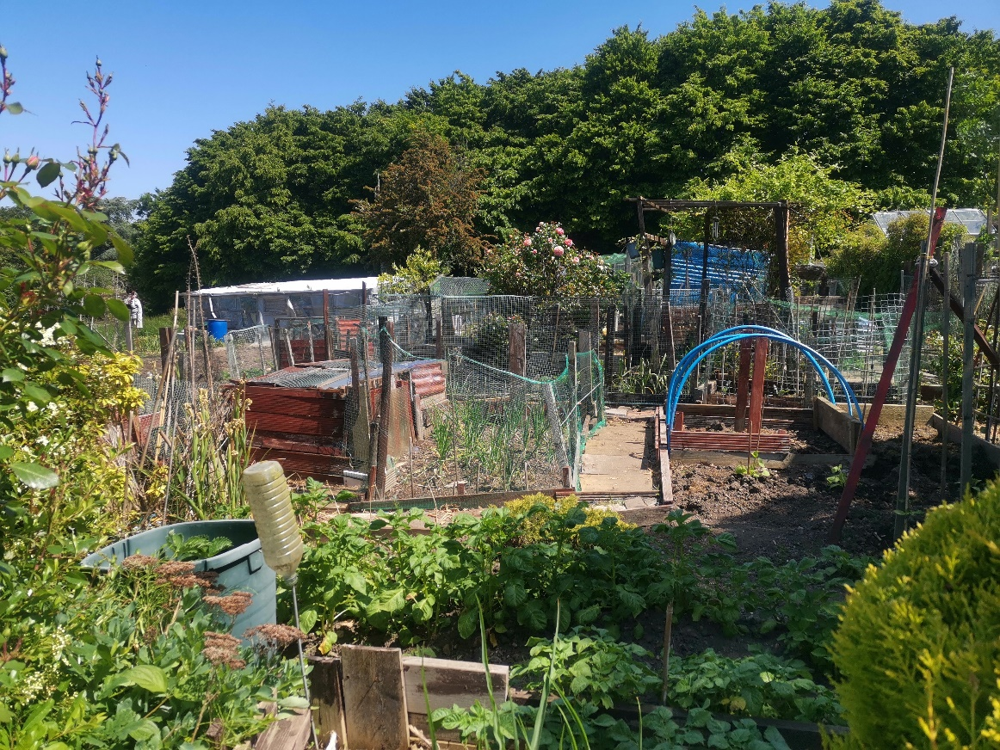

Dr. Jon Bloomfield and David Draycott

June 2024



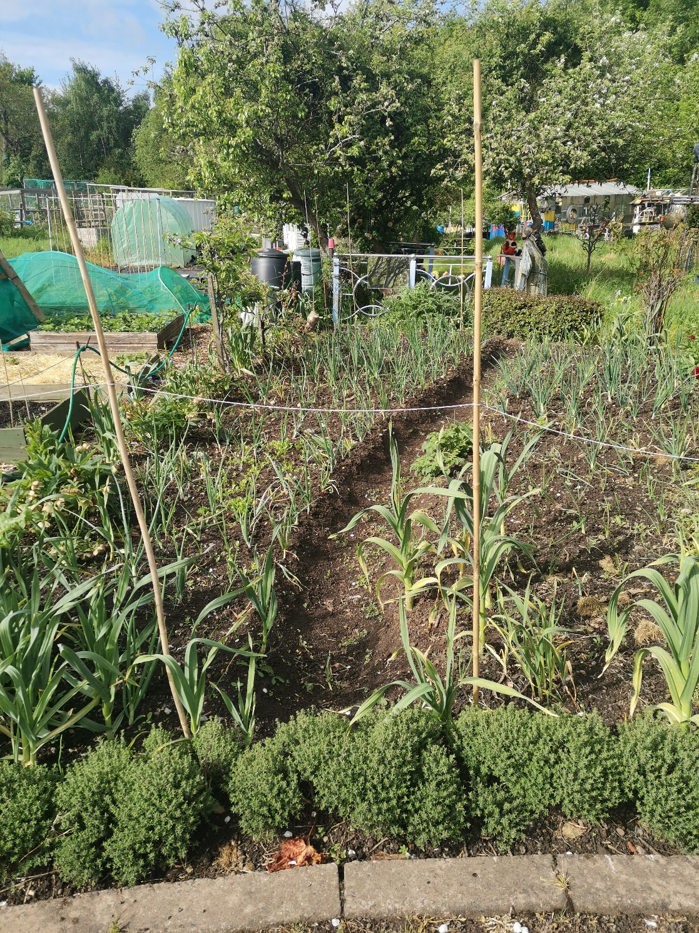

Allotments have been an under-stated feature of Britain’s urban life for many decades. After years of slow decline there are now signs of growth across the UK. Waiting lists for plots are rising as the climate crisis and a growing recognition of the importance of the environment and nature sparks a revival of interest. Yet little research on current plot-holders has been undertaken.

To rectify this, the Institute of Local Government Studies (Inlogov) at the University of Birmingham organised a study that collected information directly from allotment users and site secretaries in partnership with the Birmingham District Allotments Confederation (BDAC). The study focused on the Birmingham allotment estate that provides plots across 113 sites in the city. Hosted on the BDAC website and open to all plot-holders in the city, 876 valid forms were completed, which represented 14% of current plot-holders. Along with secretaries’ returns from fifty sites and a range of interviews the study enabled the authors to compile a wide-ranging picture of allotment life in today’s Birmingham.

## What did we find?

### The Changing Face of Plot-holders

The standard image of allotment holders has been of a stable, elderly male population. Yet this Birmingham study shows that allotments are in a process of profound change. Firstly, allotments are no longer a man’s world. On our returns, women have edged marginally ahead of men with more tenancies now held by women, 50%:49%. Secondly, there is a growing spread of ages. While 50% of plot-holders are 65 years or older, a fifth are between 30-49 years old with almost 30% aged between 50 -64. The only category with negligible involvement is the under 30s at 2%. Also, more people with office jobs or a professional background are involved along with growing ethnic diversity.

There is also a clear shift away from the operation of the standard size 250 sq. metre plot. Many sites encourage new tenants to take up half rather than full plots or have introduced more flexible plot sizes. On the latest figures there are now 1851 half-plot tenancies in the city nearly 30% of the total, while in addition there are now 278 mini-plots and 60 raised beds particularly suited to people with disabilities. As one branch secretary explained, “there is no longer a one size fits all policy. We’re becoming much more flexible.” This flexibility helps older plot-holders too.

|  |
| --- |
| “I really love growing vegetables and spuds. But after thirty years a whole plot is getting too much for me. My back’s going and I can’t take it. So, I’m cutting out the spuds and last autumn I went down to a half plot. That’ll be enough for me now.”  Dave. |

#### Crops Harvested

Most plot-holders see their allotment as a serious commitment. It’s a substantial leisure activity. During the main growing months - spring, summer, and early autumn - three-quarters of plot-holders go to their plot at least 3-4 times a week and grow a wide variety of crops.

**Figure 1: How often do you go to the plot in summer?**

|  |  |  |  |  |  |  |  |  |
| --- | --- | --- | --- | --- | --- | --- | --- | --- |
| |  | | --- | |  | |  |  |  |  |  |  |  |
|  |  |  |  |  |  |  |  |
|  |  |  |  |  |  |  |  |
|  |  |  |  |  |  |  |  |

The survey suggests that 88% of plot-holders grow potatoes. The most popular other vegetables are onions and shallots, brassicas, tomatoes, and courgettes with more than three-quarters of plot-holders cultivating these crops, while a similar proportion grow at least ten different vegetables on their plot. Rather less fruit than vegetables is grown but fruit growing is still very popular with over three quarters of plot-holders engaged. The most popular fruits are strawberries, rhubarb, and raspberries with more than two-thirds of all fruit-growing plot-holders cultivating these fruits.

Taken as a whole and excluding those who were unable to record any figures, our sample indicates that on average 100 kg. of fresh produce was harvested on each plot in the city.

|  |  |  |  |  |
| --- | --- | --- | --- | --- |
|  | **Table 1: Estimated weight of produce harvested in 2023 (kg)** | | | |
|  | Potatoes grown | Vegetables grown | Fruit grown | Total produce |
| Overall weight | 21,924 | 35,985 | 13,927 | 71,836 |
| Average per plot | 30 | 49 | 21 | 100 |

Our sample of those recording weights of crops harvested covered nearly one-ninth of the total allotment population. This suggests that more than **630,000 kg or 630 tonnes of food** are being grown on allotments each year across the city. This is fresh food, mostly produced organically and consumed within the locality where it is grown. **It represents by far and away the most significant and consistent element of urban agriculture within the city.**

People take up allotments for a variety of reasons and with a range of intentions. As well as those determined to grow a high volume of food crops, there are those looking to grow a variety of fresh food, along with those who enjoy the relaxation and exercise that allotments bring and the friendship that allotments can offer. So, there are large differences among plot-holders.

Broadly, we found that plot-holders fall into one of three types: serious cultivators; keen gardeners; and leisure gardeners. Those producing above 150 kg of produce a year can best be described as serious cultivators. Just over one-sixth of plot-holders (18%) meet this category. Over two fifths (44%) grow between 50 -150 kg of food a year. This category we term keen gardeners. Those producing up to 50 kg of produce a year can best be categorised as leisure gardeners and these accounted for 38% of plot-holders.

#### The Benefits of Allotment Life

All studies of allotments refer to their contribution to the well-being of plot-holders. Our survey questions on the benefits of allotments very much reflected that view. The survey outlined six potential benefits. Scores of over 90% were recorded for those stating as a benefit regular physical exercise, peace of mind and relaxation as well as a supply of fresh vegetables. In the survey’s most significant finding, when asked to identify the most important benefit of being an allotment tenant, peace of mind and relaxation emerged at the top of the poll. It was the main priority for 32% followed by 31% for supply of fresh vegetables and 17% for regular physical exercise.

**Figure 2: Which of these benefits is most important to you?**

|  |
| --- |
| “I love it down here. I grow a variety of crops. I used to suffer from anxiety. The GP gave me pills. But I just find it so relaxing down here, away from it all that I don’t take them now.”  Zahora. Asian housewife, East Birmingham |

#### The Community Dimension

Many allotment tenants just want to tend their plot and grow their crops. Others enjoy the company of fellow plot-holders and the haven of peace and quiet that the allotment provides. Yet allotments can’t run on autopilot. They are public assets and need regular care and repair.

The vast majority of allotments are owned and managed by local authorities. Since 2010, all UK councils have had to deal with the austerity policies of national government and a huge loss of revenue. This has had a knock-on effect on allotment support, as in every other service area. In Birmingham there is now only 0.6 of an officer within the council responsible for managing the 7,000 plus plots compared with five officers with area responsibilities up to 2015. Allotments have become a neglected part of the City Council’s estate.

The smooth operation and management of allotments depends on the energy and enthusiasm of the volunteers who run the sites. They embody the philosophy and culture of self-help. Yet, the reality is that David Cameron’s vision of ‘the big society’ can’t work without solid institutional support. This can take a variety of organisational forms. The Birmingham Confederation is discussing various options with the council, but the basic fact is that whoever takes the lead, there needs to be active stewardship of the allotment estate.

The more focused use of allotment rental income could offer that stewardship. But it needs to be combined with a community engagement strategy by allotments themselves. This requires allotments to see themselves as community assets open to their neighbourhood and wanting to attract onto their patch local families, schools and youngsters interested in nature and environmental issues.

This approach requires a shift in allotment culture. The more active sites are showing the way with external fundraising to maintain and modernise their sites. Their outward-going profile not only helps sites to attract funds but also makes sites more of a community hub.

|  |
| --- |
| “Access to our sites should be for the local community. Applications for additional funds must include a community dimension so that families and children will use the sites.”  BDAC Secretary Hester Blewitt |

## Recommendations

The report draws on these findings to suggest a number of practical recommendations.

* With some basic publicity and a drive to shorten existing waiting lists, occupancy rates could quickly rise to over 90%;
* maximising the use of allotments should be a priority for the city’s public health and GP services;
* they should feature more prominently in the council’s green spaces and planning proposals;
* BDAC should be helped in its fund-raising and other initiatives.

## Conclusions

Allotments are essentially a low-cost public investment, which currently goes under the radar. At a time when there is much talk about the importance of well-being, allotments represent a key, but often neglected, element of urban life. This report shows the rich and important contribution they make to the life and health of the city. The National Allotment Society is looking to extend this survey to other regions across the country as part of a drive to increase the recognition of the allotment’s role. They deserve a higher profile and more attention from all decision-makers across Birmingham and beyond.

## Authors and Acknowledgements.

This report was prepared and written by **Dr Jon Bloomfield,** Honorary Research Fellow, Department of Public Administration and Policy, University of Birmingham and **David Draycott,** Secretary of the Moor Green Allotments Association. The study was only possible with the help of many people active within the Birmingham allotment community, in particular, Hester Blewitt, BDAC Secretary and Clive Fenn; while Jason Lowther, Director - Institute of Local Government Studies (Inlogov) at the University of Birmingham facilitated the use of the Qualtrics system; ensured the smooth operation of the two surveys and helped with his considerable policy insight.

A copy of the full report is available on the BDAC website. [Home - Birmingham & District Allotment Confederation (bdacallotments.co.uk)](https://bdacallotments.co.uk/)

For further information contact Jon Bloomfield at [j.bloomfield@bham.ac.uk](mailto:j.bloomfield@bham.ac.uk).

