Randomised controlled trial of

EArly transjugular intrahepatiC porTosystemic stent-shunt in

Acute Variceal Bleeding REACT-AVB trial.

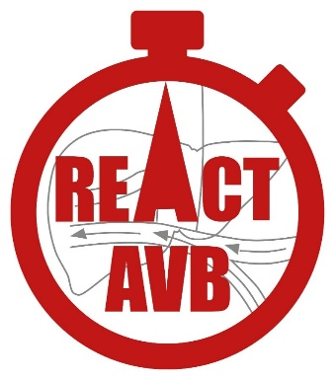

PARTICIPANT INFORMATION SHEET
Welfare Attorney/Welfare Guardian/Nearest Relative

Trial Summary:
- Variceal bleeding is a serious complication of liver cirrhosis.
- Patients with variceal bleeding need treatment with medicines and endoscopic treatment to stop the bleeding and prevent further bleeding. This is known as standard of care (SOC).
- For patients at high risk of bleeding again, an “early” Transjugular Intrahepatic Portosystemic Stent-Shunt (TIPSS) is offered to reduce the risk of further bleeding.
- We do not know which treatment is better and this trial is being conducted to find out if early TIPSS is better than SOC.
- This trial will randomly assign patients to either SOC or early TIPSS.
- We aim to improve the care of patients with liver cirrhosis and oesophageal variceal bleeding.

What is this information sheet for?
You have been provided with this information sheet by the REACT-AVB research team for one of the following reasons:
- To invite you to consider giving your permission for the person you are consenting for, to take part in a research study called REACT-AVB.
or

- For you to consider if the person you are consenting for, should continue in the trial, even though consent was obtained from them before.

Normally we would ask the patient directly if they wish to take part in the trial, or if they agree to continue in the trial. However, as the patient is very unwell, they currently lack the capacity to make an informed decision themselves about this. We are therefore asking you as their Welfare Attorney/Welfare Guardian/Nearest Relative, if you will give consent on their behalf. This is permissible under the Adults with Incapacity (Scotland) Act 2000.
We ask that you put your own views about the research aside and to consider and take into account, the past and present wishes and feelings of the person you are consenting for, had they been able to consent for themselves.
Before you decide it is important for you to understand why the research is being done and what it will involve. This Information Sheet tells you the purpose of the trial and what will happen if they do take part. A member of the research team will go through this information sheet with you. Please do take the opportunity to ask any questions and request more information if anything is unclear. Feel free to talk to others about the trial if you wish.

Why have they been invited?
The person you are consenting for has been invited to take part because they have liver cirrhosis and have been admitted to hospital with bleeding from varices.

Do I have to give consent?
No. Giving consent is entirely voluntary and your decision will not affect the usual care of the person you are consenting for in any way.
If you decide they would have no objection to taking part or continuing in the trial, we will ask you to read and sign a Legal Representative Consent Form. A copy will be provided for you to keep. Throughout the trial, you can let us know any concerns or if you think they should be withdrawn. As soon as they are feeling better and capable of making independent choices, we will ask them if they wish to continue taking part in the trial. They can stop being part of the trial at any time and their usual care will not be affected. We will keep and use the data collected up to the point of them withdrawing from the trial.
If you feel that you are unable to decide whether or not to give consent, please let us know. We will understand if you do not want to take on this responsibility.

What is the purpose of the trial?

Cirrhosis (scarring of the liver) can lead to varices (abnormally enlarged veins) developing in the lower gullet (food pipe) or stomach. There’s a 1 in 20 chance of varices bleeding while, 1 in 7 patients may not survive. In those who do survive, further bleeding is common. We must therefore offer the best treatment to improve survival by preventing further bleeding. We check for these varices with a device called an endoscope (a bendy tube incorporating light and a tiny video camera).

The currently accepted treatment for patients who bleed from varices is known as standard of care (SOC) and includes the following:
Endoscopic treatment
During an endoscopy procedure, using the endoscope, we can:
- Tie off an enlarged vein with a rubber ring (variceal banding) or;
- Inject a drug, with a needle, directly into the swollen vein, to cause that vein to clot which stops bleeding.
We need to do this every few weeks or months.
Medication
We may use antibiotics as well as other drugs. Once a patient is stable they are offered drugs called beta-blockers which slow down the heart and lower pressure in the enlarged veins, this reduces the risk of further bleeding.
TIPSS
For some patients, we use a device called a Transjugular Intrahepatic Portosystemic Stent-Shunt (TIPSS). The TIPSS procedure involves inserting a small metal tube, roughly 10mm in diameter (about the length of a grain of rice), inside the liver using a wire passed through a vein in the neck and down into the organ (through the liver). The procedure is done under sedation (so the patient will be sleepy) or general anaesthetic (so the patient will be asleep). The procedure is done with X-ray imaging guidance.

TIPSS may be used to treat severe variceal bleeding (bleed from the varices) in:
- An emergency to stop bleeding where SOC has not worked. This is known as ‘rescue’ TIPSS
or;
- Patients that are at high risk of bleeding again after satisfactory stabilisation with SOC. This is called “early” TIPSS.
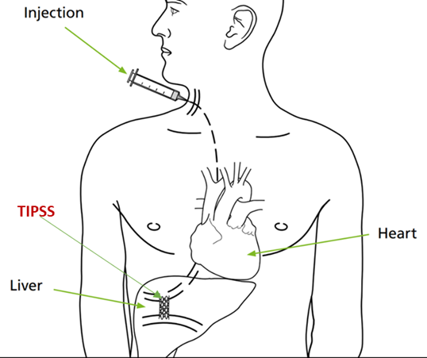

Our trial on early TIPSS – the plan
There have only been a few clinical trials of early TIPSS in a small number of patients. Trial results so far have not clear as to which patients benefit from early TIPSS or whether it is better for the patient overall. Current guidelines recommend further research. Nobody so far has compared early TIPSS with SOC in a large clinical trial and obtained clear results.
Our team has a lot of experience running clinical trials involving people with liver disease. Our team includes two patient collaborators and a Trustee of Liver4Life charity (https://www.liver4life.org.uk/). We will regularly involve them and other public contributors in all parts of the research.
We want to do a trial to compare early TIPSS with SOC in severe variceal bleeding to see if early TIPSS is better than SOC in improving the survival of patients. Patients will get early TIPSS or SOC at random.
The trial will seek to recruit just under 300 patients nationally over 4 years. It includes a 12-month pilot trial to address any problems early. We will also compare cost-effectiveness and quality of life for the patients for both treatments. If we conclude that early TIPSS is more effective in terms of survival, cost, and quality of life than SOC, this could lead to a major change in clinical practice.

Are there any benefits to taking part?
We cannot guarantee that there will be any direct benefit to the person you are consenting for by taking part in this trial. However, they may feel empowered knowing that their contribution to the results of the trial should in the future, lead to the best treatment for variceal bleeding in patients with liver cirrhosis.

What would taking part involve?
After providing consent, on behalf of the person you are consenting for, they will be selected to one of the treatment groups randomly by a computer. They will have a one in two chance of either treatment (like flipping a coin). Once the treatment group (either SOC or early TIPSS) is assigned, their doctor will be informed which treatment they have been given.
The treatment will continue for at least one year (unless any problems arise or you/patient themselves decide to withdraw from the trial).
During the trial, at 3 separate time points, we will ask the person you are consenting for to complete a health questionnaire form. (EQ5D-5L). This may be carried out face to face with the research staff or remotely over the telephone. With your permission, a copy of the form will also be sent to the REACT-AVB Trial Office.
All patients who take part in this trial will be seen as is usual clinical practice either in the clinic or via telephone and/or/ video conference, every few months to assess their well-being.
All patients will have an ultrasound at 6 monthly intervals as part of their normal care. Patients in the early TIPSS group will also have an ultrasound to check that the TIPSS is working well at 2-7 days. These patients do not require further endoscopies or beta-blockers.
Patients in the SOC group will be prescribed regular beta-blockers and have endoscopies to treat the varices every few weeks to months depending on how well the varices respond to treatment. The GP of the person you are consenting for, will be kept informed of their participation in the trial.

A summary of the trial schedule is illustrated below: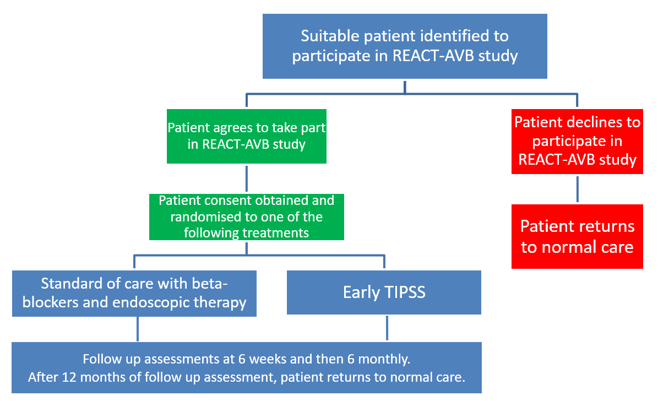

Pregnancy

The TIPSS procedure and beta-blockers can harm the unborn child. Neither pregnant women nor women who plan to become pregnant during the course of this trial should not participate in this trial. Women who could become pregnant must use barrier contraception during the trial. If you are aware that the person you are consenting for is pregnant, please inform us immediately. We will need to follow up the person you are consenting for, during their pregnancy and information about the outcome of their pregnancy will be collected from their and their baby’s medical notes. There is no risk to children born to fathers taking this medicine.

How many visits are there and how long will it take?
All patients who take part in this trial will be seen as is usual clinical practice either in the clinic or via telephone and/or/ video conference, every few months to assess well-being and to look for untoward effects. This appointment will take approximately 30 minutes.
Patients in the early TIPSS group will have an ultrasound to check that the TIPSS is working well at 2-7 days. These patients do not require further endoscopies or beta-blockers. This procedure will take approximately 30 minutes.
Patients in the SOC group will be prescribed regular beta-blockers and have endoscopies to treat the varices every few weeks to months depending on how well the varices respond to treatment.

Are the treatments and tests safe?

TIPSS has been in use for over 30 years and carries few complications.
If the person you are consenting for takes part in this trial they may have a TIPSS procedure. This will be in addition to what they would receive if they did not take part. During the procedure, 1 in 10 patients may experience fever or minor bleeding which normally gets better without additional treatment. Fewer than 1 in 20 patients may have more severe bleeding, infection, liver, kidney or heart failure requiring additional treatments. 1 in 3 to a half of all patients may experience confusion after/following a TIPSS. This is due to the unwanted build-up of toxic substances in the body such as ammonia, which can lead to a brain condition known as hepatic encephalopathy, although this normally improves with medical treatments and other measures. In previous studies, the likelihood of experiencing this was no higher with TIPSS than SOC.
The TIPSS procedure involves exposure to x-rays. This procedure uses ionising radiation to form images of the person you are consenting for’s, body, and provide their doctor with other clinical information to inform treatment. Ionising radiation may cause cancer many years or decades after the exposure. We are all at risk of developing cancer in our lifetime. 50% of the population is likely to develop one of the many forms of cancer at some point in their lifetime. Taking part and being in the TIPSS arm will increase the lifetime risk of cancer by 0.18% compared to the general population.
Variceal banding has been used for over 30 years and is generally considered very safe. Around 1 in 10 patients may experience discomfort and find it difficult to tolerate the procedure. Infrequent complications may include bleeding which affects about 1 in 20 patients, and a very small risk of causing narrowing of the gullet, making it difficult to swallow or causing a tear in the gullet (perforation).
Beta-blockers were initially developed to treat high blood pressure and some forms of heart disease. As with any drug, there are potential minor side effects that affect around half of patients, but serious complications are very rare. The side effects of beta-blockers which can be difficult to tolerate in about 1 in 10 patients include shortness of breath, low blood pressure causing dizziness, and upset stomach. Other less common side effects include abnormal vision, bradycardia (slow heart rate), asthenia (fatigue), and impotence. The doctor will carefully monitor any side effects and make changes where required, for the person you are consenting for.
There will be an independent safety committee to oversee the trial.

What happens when the research trial stops?
After the trial finishes, the clinical care for the person you are consenting for, will revert to the current standard care for patients with cirrhosis and previous variceal bleeding.

What if new information becomes available?
Sometimes we get new information about the treatments being studied. If this happens, the Research Doctor will tell you and discuss whether the person you are consenting for, should continue in the trial.
If the trial is stopped for any other reason, we will inform you and arrange for the person you are consenting for’s, continuous care.

What if there is a problem?
If you have a concern about any aspect of this trial, you should ask to speak to the Researcher Team who will do their best to answer your questions (see contact details on the last page). If you remain unhappy and wish to complain formally, you can contact your local hospital’s Patient Experience Team.
Contact details are: << INSERT LOCAL DETAILS HERE>>.
In the unlikely event that something does go wrong and the person you are consenting for, is harmed during the trial due to someone’s negligence, then they may have grounds for legal action and compensation against the sponsor (the University of Birmingham) but they may have to pay your legal costs. The normal NHS complaints mechanisms will still be available to them, if appropriate.

Will there be any financial reimbursement offered for taking part in this study?
There will not be any financial reimbursements offered for taking part in this study.

Will their details be kept confidential?
All information collected, for this trial about the person you are consenting for, will be subject to the General Data Protection Regulation (GDPR) and Data Protection Act 2018 for health and care research and will be kept strictly confidential.
The University of Birmingham is the Sponsor for this trial. They will be using information from the medical records of the person you are consenting for, to undertake this trial and will act as the data controller. This means that the University of Birmingham is responsible for looking after their information and using it properly. For this trial, we will collect their name, date of birth, sex, contact details, address, NHS number/Community Health Index (CHI) or Health & Care Number (H&C), ethnicity, brief demographic data, medical history and health conditions.
All information collected by the Research Team will be safely and securely stored in the REACT-AVB Trial Office at the University of Birmingham, on paper and electronically and will only be accessible by authorised personnel. People who do not need to know who they are will not be able to see their name or contact details. The only people at the University of Birmingham who will have access to information that identifies them, will be people who manage the trial or audit the data collection process. In routine communication between their hospital and the Trial Office, they will be identified by their unique trial number and partial date of birth.
By giving your permission for the person you are consenting for, to take part in the trial, you will be agreeing to allow staff from the REACT-AVB Trial Office to look at the trial records, including their medical records. It may be necessary to allow authorised personnel from government regulatory agencies (e.g. the Sponsor and/or NHS bodies) to have access to their medical and research records. This is to ensure that the trial is being conducted to the highest possible standards.
With your permission, a copy of your signed Legal Representative Consent Form will also be sent to the University of Birmingham for this trial.
From time to time we may be asked to share the trial information (data) we have collected with researchers running other studies in this organisation and other organisations so that they can perform analysis on the data to answer other important questions about liver disease. These organisations may be universities, NHS organisations or companies involved in health research and maybe in this country or abroad. Any such request will be carefully considered by the trial researchers and will only be granted if the necessary procedures and approvals are in place. This information will not identify the person you are consenting for and will not be combined with other information in a way that could identify them. The information will only be used for health research, and cannot be used to contact them or to affect their care. It will not be used to make decisions about future services available to them, such as insurance. Under no circumstances will they be identified in any way in any report, presentation or publication arising from this or any other trial.
To allow accurate follow up of all our patients, it may be necessary for the REACT-AVB Trial Office to contact other UK NHS bodies to provide information about their health or to collect their data for other related research. This would mean that the REACT-AVB Trial Office will use some of their personal identifiers (date of birth, NHS number/ Community Health Index (CHI) or Health & Care Number (H&C), trial number, age, sex and address) to link information that these organisations hold. Their information will be held and maintained by central UK NHS bodies such as NHS digital.
Your partner, relative or close friend (or the person you are representing) can find out more about how we use their information:
- At www.hra.nhs.uk/information-about-patients/
- By asking one of the Research Team
- By sending an email to the University’s Data Protection Officer at dataprotection@contacts.bham.ac.uk.
There is an open-access REACT-AVB trial website www.birmingham.ac.uk/react-avb that contains information about the trial. No identifiable information about your partner, relative or close friend (or the person you are representing) will be available on this website.

You are able to withdraw your partner, relative or close friend (or the person you are representing) from the processing of their data at any time. The rights to access change or move their information will be limited, as we need to manage their information in specific ways for the research to be reliable and accurate. To safeguard their rights, we will use the minimum personally identifiable information possible.

How long will their personal data be kept?
The University of Birmingham and the NHS will keep identifiable information about the person you are consenting for at least 10 years after the trial has finished, to allow the results of the trial to be verified if needed.
If you withdraw them from the trial, we will keep the information we have already obtained about them but, to safeguard their rights, we will use the minimum personally-identifiable information possible.

Involvement of their family doctor.
The GP of the person you are consenting for, will be kept informed of their participation in the trial. By providing your consent for them to take part, you agree to us sharing their progress in the trial with their GP, as needed for their clinical care.

What will happen to the results of the research?
At the end of the trial, we will report results to the funder of the research and publish them in appropriate academic and professional journals and at conferences. We will write our reports in a way that no-one can work out that the person you are consenting for, took part in the study. The Research Team will contact the person you are consenting for, with the results of the trial once it is finished. The publications are made available to the general public on websites for the specialist societies, University of Birmingham, and NIHR should you be interested. You can also access the trial website to follow its progress and see the results when available.
No personally identifiable information will be included in publications from this trial.

Who is organising, insuring, and funding the research?
REACT-AVB is funded by the National Institute for Health Research (NIHR) Health Technology Assessment (HTA) Programme (Reference Number: 13083). It is sponsored by the University of Birmingham and is being organised and run on their behalf by the Birmingham Clinical Trials Unit.
No member of the Research Team is being paid for including you in this trial.
The University has in place Clinical Trials indemnity coverage for this trial, which provides cover for harm which comes about through the University’s, or its staff’s, negligence in relation to the design or management of the trial and may alternatively, and at the discretion of the University provide cover for non-negligent harm to participants.
The NHS Trust has a duty of care to its patients, in the event of clinical negligence being proven, compensation will be available via the NHS indemnity.

Who has reviewed the trial?
All research in the NHS is looked at by an independent group of people, called a Research Ethics Committee, to protect the patients interests. This trial has been reviewed and given favourable opinion by the Research Ethics Service (Reference: 23/WM/0085 and 23/SS/0050).

Have patients and the public been involved in this trial?
A group consisting of patients and members of the public helped to develop this research topic and the research questions that should be asked. Potential participants described the inclusion and exclusion criteria for people taking part in this trial, patient visits, and the tests.
The two patient collaborators mentioned earlier helped to develop and review this Patient Information Sheet. They will continue to be involved in the trial.
Thank you for taking the time to read this information leaflet.
If you wish to seek advice about the trial from a healthcare professional who is not involved in the trial you can contact <INSERT CONTACT DETAILS HERE> through the switchboard on the following number: <INSERT NUMBER HERE>
If you have any questions, about the trial, please contact the Research Team on <INSERT CONTACT DETAILS HERE>
Alternatively, you can contact the Chief Investigator for the research trial:
Professor. Dhiraj Tripathi
Consultant Hepatologist and Liver Transplant Physician
University Hospitals Birmingham NHS Trust
Queen Elizabeth Hospital
Edgbaston
Birmingham
B15 2WB
Dhiraj.Tripathi@uhb.nhs.uk

