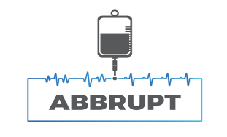

<Insert GP name and address>

Dear Dr. <insert > ,

Short trial title: ABBRUPT

Full trial title: A randomised controlled trial to investigate clinical and cost effectiveness of Amiodarone vs Beta Blockade for new onset atrial fibRillation in icU - a Pragmatic sTudy (ABBRUPT)

Patient Name: <insert > | DoB: <insert > | NHS No.: <insert >

Our hospital is participating in a research study called ABBRUPT to investigate the clinical and cost-effectiveness of two commonly used treatments, Amiodarone vs Beta Blockade, for new onset atrial fibrillation in intensive care. The trial is funded by the National Institute for Health Research Health Technology Assessment programme (reference: NIHR150027) and is sponsored by the Birmingham Clinical Trials Unit based at the University of Birmingham.

At the time of their admission, your patient was assessed for eligibility and randomised into the trial. They (or their legal representative) have provided written informed consent to participate having had time to read the Patient Information Sheet and discuss the trial with the research team.

Your patient has been allocated to receive: Amiodarone ☐ Beta Blockade ☐

We will follow the patient’s progress of recovery for 90 days. To provide robust follow up, we may contact you/your surgery to ascertain any changes in the patient’s circumstances. You can find more detailed information about the trial on the website www.birmingham.ac.uk/ABBRUPT.

If you have any concerns, questions or would like any further information regarding the research, please contact us.

Yours sincerely,

<Insert local contact name>  <insert phone number, email> | <insert PI name>  <Insert phone number, email>

