<<INSERT TRUST LETTER HEAD>>

The SLEEP T2D Study
The Impact of Sleep Disorders in Patients with Type 2 Diabetes: A Cohort Study and Feasibility RCT
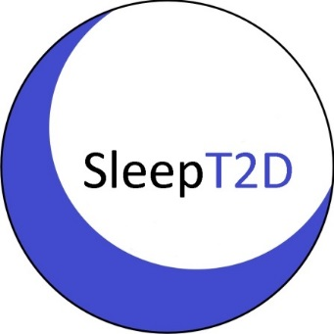

PATIENT INFORMATION SHEET

We would like to invite you to take part in our research study
Before you decide, we would like you to understand why we are doing this research and what it involves.

A member of our team will go through this leaflet with you and answer any questions. You can talk to others about the study if you wish, like friends and family, or your GP. You can also contact <<Patient Advice and Liaison Services (PALS) or local equivalent on INSERT DETAILS>> for advice on taking part in trials. Please ask us if there is anything that is not clear.

Why are we doing this study?
Around two in three patients with type 2 diabetes also have sleep apnoea (OSA).

OSA is a condition where there are moments of blockage to the windpipe during sleep. This reduces breathing for a short time. This can cause disturbed sleep, snoring, sleepiness, increased blood pressure and increased heart rate.

Often, patients don’t know that they have OSA. Many feel better after receiving treatment, because they can sleep better.

Patients with type 2 diabetes and OSA may be more likely to develop diabetes-related eye, kidney and nerve problems than diabetes patients without OSA.

We want to look at whether OSA affects glucose levels, blood pressure, diabetes-related problems, and quality of life.

If you take part in SLEEP T2D, we will perform some tests and ask you to complete some questionnaires at the start and end of the study (more information is below).

Depending on what we find out from these, we may ask you to join another part of the study, comparing treatment with continuous positive airway pressure (a CPAP mask) to no treatment for OSA.

In this case, we will tell you what this means for you, and explain what CPAP is.

Why have I been invited?
We have invited you to join this study because you have type 2 diabetes.

Can I say no?
Participation is voluntary so it is up to you to decide whether to take part or not. If you decide not to, your care will not be affected.
If you decide that you want to take part, you can withdraw at any time, without giving a reason and without it affecting your care.

What will happen to me if I take part?
We will ask you to attend a visit at your hospital (figure 1, next page). This will last about two hours and we can refund your travel.
A member of the research team will explain the study to you and answer any questions.
If you agree to take part, you will be asked to sign a consent form. You should only do this if you are happy that you understand the study and want to take part.
Once you have agreed to take part and have signed the consent form, we will perform some tests and collect the information described in the next section of this leaflet.
We will also ask you to take home a sleep monitor, to record what happens in your sleep for one night.
We will phone you to check on your health at 6, 12, and 18 months. We will ask you to repeat the first visit in two years and do another sleep test.
We will send the information (including personal details) we collect about you to the SLEEP T2D Study Office at the University of Birmingham.

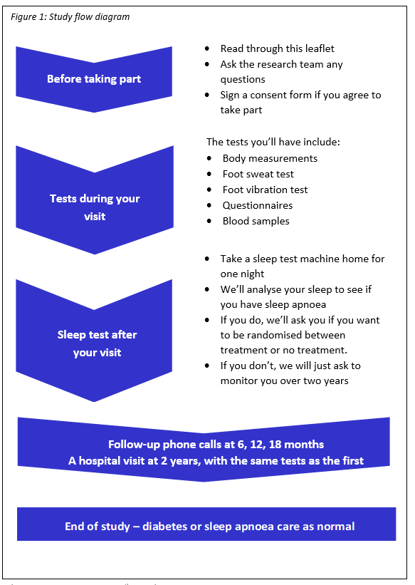

The tests and information we will collect
Personal:
We will collect your name, phone number, NHS number, date of birth, gender, medications history, medical history, smoking status, and alcohol intake.
You should let us know if you become pregnant during the study and we will also ask you in phone calls at 6, 12 and 18 months after you join.
Body measurements:
We will measure your height, weight, and waist, hip, and neck circumferences.
Metabolic and kidney measurements:
We will measure your blood pressure, cholesterol and glucose levels, and your kidney function.
Cholesterol and glucose levels and kidney function are usually taken during routine care, so we will use the results from your records.
If these are not available then we will take a blood sample. This will be up to 16mL of blood, about 3 teaspoons. The blood samples will be taken like in standard care, with a needle. You will feel a sharp scratch as the needle goes in and there is a small chance of bleeding, bruising or infection. We may ask for a morning urine sample.
Eyes:
We will review pictures of your retina (back of the eye) taken for your usual diabetes care.
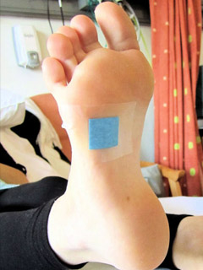
Neuropad test
Nerve function in feet:
We will examine your feet and give you two nerve tests, which shouldn’t cause any discomfort:
- Neuropad test - a plaster is put on the sole of the foot for 10 minutes and sweat production is measured by how it changes colour.

- Vibration test - a small vibrating tube will be pressed against your toe and you will be asked whether you can feel it.
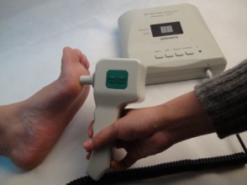Vibration test

Sleep duration, quality and preferences, and nerve function:
There are four questionnaires about your sleep, and two about how your nerves work. Each should take about five minutes.
Quality of life:
We will ask you to complete a questionnaire about your general wellbeing. Again, this should take about 5 minutes.
This information will not be used to inform your clinical care; so it is important you let your GP, nurse or consultant know if you have any concerns about your wellbeing. Support can also be found from <<Please add appropriate support info e.g. PALS>>.
Research blood samples:
We will take four tubes of blood (32mL, less than four tablespoons) for research samples. This is so we can look at biological signs of diabetes, kidney function, and OSA. Altogether we will take up to 48mL of blood at both visits (under 5 tablespoons).
Any blood samples we take will all be taken at the same time.
Saliva samples:
We will ask you to give two saliva samples. You will be given two collection tubes with an instruction leaflet. We will ask for one sample before bed and another the next morning. There is a pre-paid envelope to return these samples.

Sleep apnoea (OSA):
We will ask you to do a one night sleep test at home, using a device that tests if you have OSA. The device is about the size of a hand and you wear it overnight, whilst you are asleep for at least four hours. It records breathing, chest movements, snoring, oxygen levels, heart rate and body position.
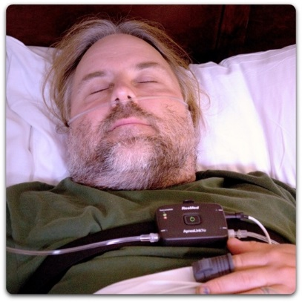
Sleep study device

At your study visit, we will tell you how to use the device. After the sleep test, you will return the device to us either in person (we will pay your transport costs), or by taxi (arranged by the study team). When the sleep test has been checked, we will discuss the results with you.

Based on the sleep test results, you will go into one of two groups:
1 - Normal overnight sleep test or less than 10 breath holds per hour of sleep:
You will have visits as below, and no further treatment unless you need it later.

2- Patients who have 10 or more breath holds per hour of sleep:
You will have visits as below, and you will be given further information about the study. If you are happy to carry on we will ask you to sign another consent form. If you consent to join this part of the study, you will be randomly allocated to either:
- CPAP treatment
- No treatment

This means there is a 50:50 chance (like tossing a coin) that you may or may not be given CPAP treatment.

All patients will be followed up in the study for two years:
We will contact you by telephone at 6, 12, and 18 months to ask some questions about your health. We will ask you to attend a final study visit after two years. This will be the same as your first visit. We will ask you to do another sleep test.

Expenses and payments
Although you will not be paid to take part in the study, we will cover your expenses to attend study visits.

What are the advantages of taking part?
Everyone in the study will get an in-depth check of their diabetes, in more detail than normal NHS care. You (and your GP, with your permission) will be given feedback on any relevant results.
Patients with diabetes are not always tested for OSA although it is very common. OSA is associated with increased risk of road traffic accidents and increased risk of high blood pressure and heart disease.
So, patients participating in this study could benefit from being screened for OSA where otherwise you might not.
If you have moderate to severe OSA you may be eligible for the further stage of the study, and then you could receive treatment where otherwise you might not.

What are the possible disadvantages of taking part?
There are no painful procedures in this study, but patients will have to visit the study centre so we can get your information. Patients with excessive daytime sleepiness will be referred to a sleep physician who will advise if the patient should inform the DVLA (Driver and Vehicle Licencing Agency) after assessing them. The DVLA website says that patients must inform the DVLA if OSA affects their ability to drive safely or if they have daytime sleepiness.
Treatment with CPAP usually improves sleepiness and if patients adhere to the CPAP treatment and do not suffer from excessive sleepiness, the DVLA is unlikely to revoke the license because of OSA.

What happens when the research study stops?
Your diabetes care will continue as normal.

What if new information becomes available?
Sometimes we get new information about the treatment being studied. If this happens, your research doctor will tell you and discuss whether you should continue in the study.
If the study is stopped for any reason, we will tell you and arrange your continuing care.

What will happen if I don’t want to carry on?
You can withdraw from the study at any time without giving a reason and this will not affect your care.
Information collected until your withdrawal may still be used. Any stored samples that can still be identified as yours can be destroyed if you wish.

Will my details be kept confidential?
All of the information that we collect about you, including from your medical records, will be kept strictly confidential, and any information about you will be stored separately from your name and address so that you cannot be recognised. We will take all reasonable steps to protect your privacy. Full details of how your data will be handled follow at the end of this information sheet.

Involvement of your family doctor
With your permission, your GP will be kept informed of your participation in the study.

What will happen to any blood samples I give?
Samples will be used to develop new tests that may help doctors choose the right treatment for patients in the future.
Your research blood samples will be anonymised (labelled with a study number instead of your name) so they can only be linked back to you by key people in the research team. These samples will first be kept in a freezer in a secure room at your hospital. They will then be sent out of this NHS Trust to the University of Birmingham Human Biomaterials Resource Centre where they will be kept for 10 years after the study and might be used for other future, ethically approved studies. Some of your samples will also be analysed by a UK-based life sciences company, Mologic.
Saliva samples will also be anonymised, and will be sent to be analysed by Mologic.

Are there any more ways I can help?
We are planning future studies in patients with type 2 diabetes and OSA. You can give consent for us to contact you about future research.

What will happen to the results of the research?
At the end of the study, we will publish the study findings in a medical journal. You will not be identified in any publication. After this, we will send a summary to you.

Who is organising and funding the research?
The study is sponsored by the University of Birmingham. No member of the research team is being paid for including you in this study.
The study is funded by the National Institute for Health Research Clinician Scientist programme (project reference NIHR-CS-2013-13-029). The views expressed in this information sheet are those of the authors and not necessarily those of the NIHR, NHS, or the Department of Health.

What if there is a problem?
If you have a concern about any aspect of this study, you should speak to the researchers who will do their best to answer your questions (see contact details on the last page). If you remain unhappy and wish to complain formally, you can do this by contacting <<Patient Advice and Liaison Services (PALS) or local equivalent on INSERT DETAILS>>.
We do not envisage any problems as a result of taking part in the trial. However, all patients are covered for negligent harm according to NHS indemnity guidelines.
The University of Birmingham has Clinical Trials indemnity coverage for this study that provides cover to the University for harm due to the University’s, or its staff’s, negligence in relation to the design or management of the study and may provide cover for non-negligent harm to participants. With respect to the conduct of the study at your hospital and other clinical care, responsibility for patient care remains with your NHS Trust and is therefore indemnified through the NHS Litigation Authority.

Who has reviewed the study?
All research in the NHS is looked at by an independent group of people, called a Research Ethics Committee, to protect your interests. This study has been reviewed and given a favourable opinion by the West Midlands - Solihull Research Ethics Committee.

Who else is taking part?
We want to include up to 500 patients with type 2 diabetes in this study.

How will my information be handled?
Your doctors will send your personal information to the Sleep T2D study office at the University of Birmingham Clinical Trials Unit, on paper and electronically, where it will be securely stored under the provisions of the EU General Data Protection Regulation 2018 and the Data Protection Act 2018.
If you consent to it, the researchers involved in Sleep T2D may, in the future, access electronic data from your central NHS records, for example through NHS Digital. This will give researchers information that is routinely collected during your visits to your GP and hospital, and lets us find out about your health after the study has ended without contacting you further. To do this, we would send your name, gender, date of birth and NHS number with any request for information.
Regulatory bodies, who monitor the conduct of research in the UK, may need to access your personal data to check this research is being run correctly.
Personal identifiable information and research data will be stored for 25 years after the study ends by the University of Birmingham and in your NHS Trust’s archive. You will not be identifiable in any articles we publish about the research.
The University of Birmingham is the sponsor for this study. The University of Birmingham will be using information from you and your medical records in order to undertake this study and will act as the data controller for this study. This means that the University is responsible for looking after your information and using it properly.
Your rights to access, change or move your information are limited, as we need to manage your information in specific ways in order for the research to be reliable and accurate. If you withdraw from the study, we will keep the information about you that we have already obtained. To safeguard your rights, we will use and store the minimum personally identifiable information possible.
You can find out more about how we use your information at www.birmingham.ac.uk/SleepT2D.
<<INSERT TRUST NAME>> will collect information from you and your medical records for this research study in accordance with our instructions.
The people who analyse the information will not be able to identify you and will not be able to find out your name, NHS number or contact details.
The information that will be provided to the Sponsor and other organisations involved in this research is specified in this information sheet on page 5.
When you agree to take part in a research study, the information about your health and care may be provided to researchers running other research studies in this organisation and in other organisations. These organisations may be universities, NHS organisations or companies involved in health and care research in this country or abroad. Your information will only be used by organisations and researchers to conduct research in accordance with the UK Policy Framework for Health and Social Care Research.
Your information could be used for research in any aspect of health or care, and could be combined with information about you from other sources held by researchers, the NHS or government.
Where this information could identify you, the information will be held securely with strict arrangements about who can access the information. The information will only be used for the purpose of health and care research, or to contact you about future opportunities to participate in research. It will not be used to make decisions about future services available to you, such as insurance.
Where there is a risk that you can be identified your data will only be used in research that has been independently reviewed by an ethics committee.

What happens to my sleep test data?
As part of this study, we are using an online application called Airview which lets us analyse and store your sleep test.
AirView is operated by a provider specialised in handling health data (currently Informatique de Securité SAS, Montceau-les-Mines, France), who ensure compliance with the EU General Data Protection Regulation 2018.
Data collected by AirView are used for our research and include the sleep apnoea measurements. This is uploaded to AirView in encrypted form. The equipment manufacturer will not have access to your data.

Thank you for taking the time to read this information sheet and for considering taking part in this research project.
Should you require further information please do not hesitate to contact us using the contact details set out below. You can also contact us to find out what information we hold about you, to be informed at any time how your data is being processed, to rectify any data held about you, to erase the data in certain circumstances, and to object to its being used in certain circumstances.
If you have any questions, please contact <<INSERT LOCAL CONTACT DETAILS>> on:
Phone: <<INSERT LOCAL CONTACT DETAILS>>.
Email: <<INSERT LOCAL CONTACT DETAILS>>.
Sleep technician: <<INSERT SLEEP TECHNICIAN DETAILS>>.

The study is funded by the National Institute for Health Research Clinician Scientist programme (project reference NIHR-CS-2013-13-029). The views expressed in this publication are those of the authors and not necessarily those of the NIHR, NHS, or the Department of Health.

