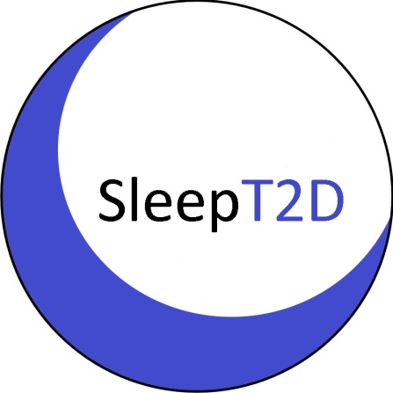

SLEEP T2D PARTICIPANT SUPPLEMENT CONSENT FORM
(Consent to participate in an additional part of the SLEEP T2D Study)

SLEEP T2D: The Impact of Sleep Disorders in Patients with Type 2 Diabetes: A Cohort Study and Feasibility RCT

 |  | Please initial each box to confirm consent ↓
1. | I confirm that I have read and understood the Supplement Information Leaflet for the SLEEP T2D study (version _______ dated _______________). I have had the opportunity to think about the information, ask questions and have had these answered to my satisfaction.
2. | I understand that my participation in this additional part of the study is voluntary and that I am free to withdraw at any time, from either this part of the study alone or the entire study, without giving a reason and without my medical care or legal rights being affected. I understand that data collected up to my time of withdrawal may be used.
3. | I understand that relevant sections of my medical notes or information related directly to my participation in this study may be looked at by individuals from the SLEEP T2D research team, representatives of the sponsor, from regulatory authorities, or from the NHS Trust where it is relevant to my taking part in this research. I give permission for these individuals to have direct access to my records.
4. | I understand that my General Practitioner will be informed of my participation in this research.
5. | I understand that my research doctor will provide a copy of this consent form and personal information about my progress, in confidence, to the central organisers at BCTU for use in the SLEEP T2D Study, where it will be stored. This personal information will include name, address, date of birth, telephone number and NHS number as well as medical information and will be held securely and confidentially at the University of Birmingham. I give permission of the transfer and storage of this data.
6. | I agree to my name and address being sent to ResMed UK so that I can be supplied with a continuous positive airway pressure device if I am allocated to this treatment.
7. | I agree to my address being sent to the central organisers at BCTU to help arrange supply of a continuous positive airway pressure device if I am allocated to this treatment.
8. | I agree to participate in this additional part of the SLEEP T2D Study.
To participate in this additional part of the SLEEP T2D study you MUST consent to points 1-8 above and initial the corresponding boxes.

Name of participant |  | Date |  | Signature
Name of person receiving consent  Consent has been taken: |  | Date  By post |  | Signature  Face to face

Original to be filed in the Investigator’s Site File; 1 copy for patient; 1 copy to be kept with patient’s hospital record; 1 copy to be sent to BCTU

