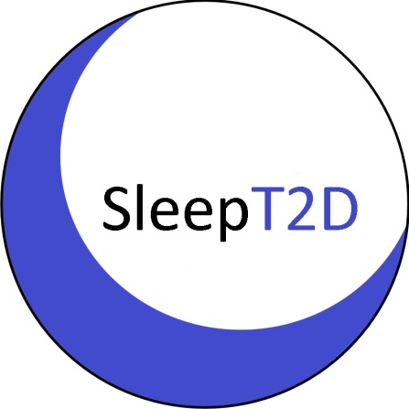

SLEEP T2D PARTICIPANT CONSENT FORM
SLEEP T2D: The Impact of Sleep Disorders in Patients with Type 2 Diabetes: A Cohort Study and Feasibility RCT
 |  | Please initial each box to confirm consent ↓
1. | I confirm that I have read and understood the Information Leaflet for the SLEEP T2D study (version _______ dated _______________). I have had the opportunity to think about the information, ask questions and have had these answered to my satisfaction.
2. | I understand that my participation in this study is voluntary and that I am free to withdraw at any time, without giving a reason and without my medical care or legal rights being affected. I understand that data collected up to my time of withdrawal may be used.
3. | I understand that relevant sections of my medical notes or information related directly to my participation in this study may be looked at by individuals from the SLEEP T2D research team, representatives of the sponsor, from regulatory authorities, or from the NHS Trust where it is relevant to my taking part in this research. I give permission for these individuals to have direct access to my records.
4. | I understand that my General Practitioner will be informed of my participation in this research.
5. | I understand that my research doctor will provide a copy of this consent form and personal information about my progress, in confidence, to the central organisers at Birmingham Clinical Trials Unit for use in the SLEEP T2D Study, where it will be stored. This personal information will include name, gender, date of birth, telephone number and NHS number as well as medical information and will be held securely and confidentially at the University of Birmingham. I give permission for the transfer and storage of this data.
6. | I understand that my name and telephone number will be used to contact me for study information (6 monthly telephone calls).
7. | I agree to donate blood and urine samples for routine biochemistry tests if these results are not available from my medical notes.
8. | I agree to my sleep data being transmitted, processed, and used for research purposes in the online application AirView as described in the Sleep T2D Information Leaflet referred to in point 1 above.
9. | I agree to participate in the SLEEP T2D Study.
To participate in the SLEEP T2D study you MUST consent to points 1-9 above and initial the corresponding boxes. Points 10-16 overleaf are OPTIONAL; please initial these boxes if you agree to these.

10. | I understand that the information held and maintained by NHS Digital and other central UK NHS bodies may be used to help contact me or provide information about my health status in the future. To do this, I agree that my name, gender, date of birth and NHS number may be shared with these central bodies. These central bodies will link my details to their data and send this information back to the SLEEP T2D study team.
11. | I am happy to be contacted in the future about further studies.
12. | I agree to my saliva kits being sent out of this NHS Trust for storage and analysis at Mologic, National Agri-Food Innovation Campus, Sand Hutton, York, YO41 1LZ.
13. | I agree to donate additional blood samples for the measurement of cystatin C and other additional biomarkers.
14. | I agree that samples of my blood that have been donated by me may be stored, at the University of Birmingham, for future biochemical tests to help understand effects of type 2 diabetes and obstructive sleep apnoea. The investigations will be for medical research only and my results will be kept confidential.
15. | I agree to the transfer of my samples outside of this NHS Trust to be stored and analysed in research laboratories at University of Birmingham and Mologic.
16. | I agree that my samples which remain at the end of the study can be stored, at the University of Birmingham and at Mologic, for use in future ethically and scientifically approved research to help understand effects of type 2 diabetes and obstructive sleep apnoea, in the UK or overseas. The research may involve private or commercial companies, genetic studies, and the use of animal or in vitro models.

Name of participant |  | Date |  | Signature
Name of person receiving consent |  | Date |  | Signature

Original to be filed in the Investigator’s Site File; 1 copy for patient; 1 copy to be kept with patient’s hospital record; 1 copy to be sent to BCTU

