# Guide for Inclusive Research

## Background

Research should benefit everyone. However, there is growing understanding that there are groups of people who are less likely to be involved in research; experience challenges not currently addressed by research; or are not considered when research interventions are assessed. These groups are “[underserved by research](https://www.nihr.ac.uk/documents/improving-inclusion-of-under-served-groups-in-clinical-research-guidance-from-include-project/25435)”. There are many ways that researchers can make sure that their work is inclusive and does not overlook people in these ways. This is a guide to support researchers in their work with groups underserved by research.

This guide supports researchers during the lifetime of their research projects so they can undertake their work inclusively. The guide covers all stages of research, including when they are developing an idea into a research proposal, applying for funding, setting up a project (which includes governance and ethics), project management, and what to do at the end of a project.

## Inclusive Research Lifecycle

Figure 1 describes the guide to inclusive research, showing the points in the research lifecycle where actions can be taken to work with underserved groups. A [video](https://youtu.be/GliUsyBg5mw) accompanies this image and guide.

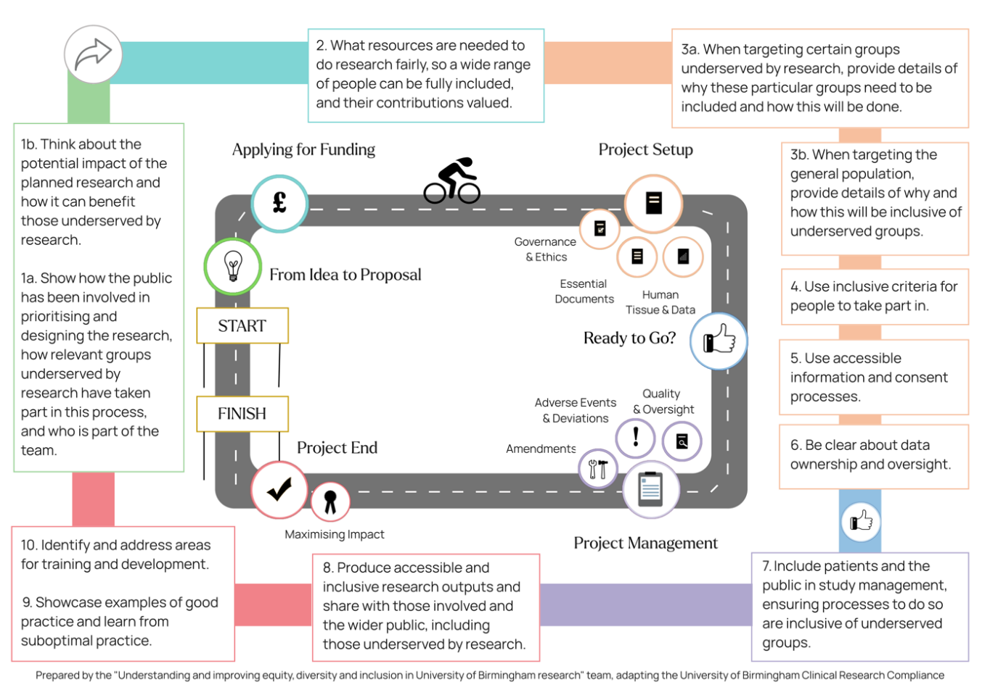Figure 1 – Guide to inclusive research

## From Idea to Proposal

### 1a. Show how the public has been involved in prioritising and designing the research, how relevant groups underserved by research have taken part in this process, and who is part of the team.

1. **Identify Key Stakeholders**: This step lays the foundation for collaborative partnerships (e.g. with patient groups, members of the public, charities, community interest organisations, community leaders and representatives from underserved groups). By reaching out to key stakeholders, researchers can ensure that the voices and perspectives of underserved communities are central to the research prioritisation and conceptualisation process.
2. **Facilitate Dialogue**: Organising meetings or focus groups using inclusive and appropriate formats where researchers and community stakeholders can engage in open discussions is essential for understanding the needs, priorities and challenges faced by underserved groups. Facilitating such dialogue allows for the exchange of ideas and insights, fostering mutual understanding and collaboration.
3. **Co-Design Research Initiatives**: Collaboratively co-designing research projects ensures that methodologies are culturally sensitive, ethical and inclusive of diverse perspectives. By involving relevant underserved groups in the research design process through public involvement and engagement, researchers can address the specific needs and priorities of these communities, leading to more meaningful and impactful research outcomes.
4. **Research team composition**: If research focuses on groups underserved by research, consider whether the research team includes people with those characteristics, if there are gaps in knowledge, and how these can be addressed.

### 1b. Think about the potential impact of the planned research and how it can benefit those underserved by research.

1. **Changes due to research:** Research can change the economy, society, culture, public policy and services, health, the environment and quality of life in the UK and beyond. Consider *who* will benefit and if anyone is left behind, particularly those underserved by research.

## Applying for Funding

### 2. What resources are needed to do research fairly, so a wide range of people can be fully included, and their contributions valued

1. **Identify Funding Sources**: Proactively explore and identify funding opportunities that prioritise equity and accessibility in research. This foundational step can involve seeking out grants, fellowships or funding streams specifically tailored to support projects focused on relevant underserved communities or mainstream funders for whom this is a stated priority (e.g. those with an equality, diversity and inclusion research strategy). By targeting opportunities aligned with the research objectives, researchers promote the feasibility of their funding strategy and can cost the resource required to undertake inclusive research.
2. **Engage with Funding Bodies**: Once potential funding sources are identified, researchers can engage with relevant funding bodies. This entails reaching out through various channels including direct email communication, virtual meetings and participation in networking events focused on community engagement and research funding. By establishing connections with funding bodies, researchers gain insights into their priorities, application processes and expectations, and work with funders to promote consideration of funding for inclusive research. Building relationships and understanding the structure of funders may increase the likelihood of securing funding.
3. **Highlight Community Connections**: In writing funding applications, researchers can demonstrate their existing community connections and collaborations and the roles these partners have had in bid development. By demonstrating active involvement and partnerships with underserved communities, researchers demonstrate the relevance and potential impact of the proposed research e.g., by articulating how community input has shaped the research objectives and methodologies, thus illustrating a commitment to co-creating solutions that address community needs and priorities. Funding bodies increasingly require demonstration of strong community engagement, making it essential for researchers to highlight these connections to enhance their competitiveness in securing funding.

## Project Setup

### 3a. When targeting certain groups underserved by research, provide details of *why* these particular groups need to be included and *how* this will be done

1. **Use the existing evidence:** Consider how the existing evidence supports the targeting of certain groups and use this to structure the rationale for doing so. Understanding the demographics, needs, challenges and preferences of the underserved groups is crucial for effective engagement. These can be identified through the available evidence and engaging with public contributors identifying with the groups in question. This step lays the foundation for developing appropriate strategies and ensuring that the research approach is tailored to the specific context of the target population.
2. **Engage with the community:** Those in the community have reported being inundated with requests to support/participate in research. When planning how to make contact, consider using existing links established by colleagues, the institution, or agencies/organisations working to broker relationships between researchers and communities. Building relationships with community leaders and seeking input from trusted individuals helps in gaining insight into community dynamics and expectations.
3. **Communicate purpose and benefits/risks:** Clear and transparent communication about the purpose and potential benefits/risks of participation is essential for gaining trust and underpins informed consent. Emphasising the value of their perspectives and contributions centres their role in shaping the research outcomes or community initiatives. Be clear about expectations and outcomes of the research.

### 3b. When targeting the general population, provide details of *why* and *how* this will be inclusive of underserved groups

1. **Use the existing evidence:** Consider how the existing evidence supports the targeting of the general population and use this to structure the rationale for doing so. Describe how the research design will allow diverse and inclusive participation, ensuring that all members of the community benefit from the research.
2. **Recognise underserved groups as part of the general population:** Consider how the research design can facilitate participation from underserved groups. This may involve use of alternative recruitment and retention strategies, including partnerships with community-based organisations that serve underserved populations. Attend their meetings or events to build relationships and understand the needs and concerns of the communities they represent. Collaborate on outreach efforts to ensure that research opportunities reach those who may otherwise be overlooked. This step ensures that researchers directly engage with the communities they aim to include, tapping existing networks and understanding community dynamics.

### 4. Use inclusive criteria for people to take part in research

1. **Scrutinise what criteria are needed to take part in research**: Often criteria for research participation is used without consideration for who it unintentionally excludes (e.g. upper age limits, fluency in particular languages). Consider inclusion and exclusion criteria to assess whether they are needed.
2. **Use the existing evidence**: Consider how the existing evidence supports the use of criteria for participation and use this to structure the rationale for doing so. When there is insufficient evidence, consider whether the criteria are needed.
3. **Inclusive study design**: When using new criteria for taking part in research, it may be that the research design will need to be changed to accommodate a different range of participants. For example, removal of language-related criteria may mean translation of materials into different languages. Consider feasibility of making necessary changes. Transparently report study limitations on basis of participation criteria and study design.

### 5. Use accessible information and consent processes

1. **Develop Accessible Consent Materials**: Creating consent forms and informational materials in accessible formats ensures that participants can understand and engage with the content regardless of their literacy levels, language backgrounds, familiarity with research. This step directly addresses the accessibility of consent processes.
2. **Explain and Inform**: Providing information about the research project, its purpose, objectives and potential benefits is crucial for ensuring informed consent. This step enables participants to make informed decisions about their involvement in the research.
3. **Facilitating Informed Consent**: Administering consent forms using preferred formats (e.g. written or verbal consent) and languages, ensuring participants understand the content and allowing them to ask questions or seek clarification before signing the consent form are essential components of obtaining informed consent. This step ensures that participants fully understand the implications of their participation.

### 6. Be clear about data ownership and oversight

1. **Establish Transparent Data Ownership Models**: Clearly defining data ownership clarifies the rights of participants and the public, ensuring that everyone understands the roles, responsibilities, and conditions regarding data ownership and oversight.
2. **Facilitate Public and Community Involvement in Data Governance**: Engaging community organisations and leaders in discussions about data ownership and oversight is essential for ensuring that the models put in place reflect the needs and values of underserved groups. This step promotes inclusivity and equity in decision-making processes.
3. **Inform Participants and the Public on Data Ownership**: Providing comprehensive information for participants and the public empowers them to understand their rights and responsibilities regarding data ownership and oversight. Clear communication and information foster trust and cooperation throughout the research process.

## Project Management

### 7. Include patients and the public in study management, ensuring processes to do so are inclusive of underserved groups

1. **Use Diverse Engagement Methods**: Reach out to underserved communities through a variety of engagement methods, including face-to-face, online platforms, community organisations, social media, local events and direct email contact. This multi-faceted approach ensures that the invitation to participate reaches individuals through channels they are comfortable with and have access to.
2. **Establish Community Connections**: Foster strong connections with community organisations and groups that represent relevant underserved populations. Collaborate with these organisations to identify potential participants, build trust and codesign study management processes that meet the needs and preferences of the community.
3. **Involve in planning**: Involve representatives from relevant underserved communities to gather insights, feedback and input on study management processes. Ensure that the involvement methods are inclusive, welcoming and conducted in culturally sensitive ways to encourage participation from all segments of the community.

## Project End

### 8. Produce accessible and inclusive research outputs and share with those involved and the wider public, including those underserved by research

1. **Use a Range of Communication Methods:** Employ a variety of communication methods to share research outputs with diverse audiences, including social media, community events and local media outlets. This approach helps to ensure that research findings are accessible to underserved communities who may not have access to traditional academic publications. Develop a strategy in partnership with public contributors. *“Go to them, do not expect them to come to you.”*
2. **Prioritise Accessible and Inclusive Research Outputs:** Prioritise plain language summaries and other accessible formats, adhering to established best practice standards? when disseminating research findings. This approach promotes inclusivity and ensures that research outputs are comprehensible and relevant to diverse audiences.

### 9. Showcase examples of good practice and learn from suboptimal practice

1. **Reflect on practice:** Reflect on the strategies used to promote inclusion of those from relevant underserved groups, considering what has worked and what hasn’t. Seek feedback from those involved where possible.
2. **Share experiences:** When possible, engage in opportunities to share experiences of engaging underserved groups in research with others in the research community. This enables opportunities to learn and continually improve practice. This also minimises duplication of efforts.
3. **Showcasing best practice and addressing knowledge/practice gaps:** Institutions can take opportunities to showcase when there is good practice in engaging underserved groups in research to promote opportunities for others to learn. This also allows for gaps in knowledge and practice to be considered and addressed through training.

### 10. Identify and address areas for training and development

1. **Identify Challenges and Solutions:** Examine the challenges faced when engaging and retaining underserved groups and identify recurring issues/specific areas where researchers may need additional support, training or resources. For instance, using community engagement hubs or cultural humility training.
2. **Understanding of Community Engagement and Building Relationships:** Researchers’ awareness of the principles and practices of community engagement helps build relationships with community organisations. It promotes sustained interaction, mutual respect and understanding of community needs and priorities which are crucial for effective collaboration.
3. **Understanding of Patient and Public Involvement:** Patient and public involvement is integral to conducting ethical and impactful research with underserved groups. Providing comprehensive training sessions for researchers on patient and public involvement promotes understanding of its importance and potential applications.

## Funding statement and acknowledgements

Funded by Research England under the Enhancing Research Culture funding stream, the National Institute for Health and Care Research (NIHR) Applied Research Collaboration West Midlands and the NIHR Midlands Patient Safety Research Collaboration. We thank our patient and public team members and those who have supported and taken part in this work. The Inclusive Research Lifecycle (Figure 1) was prepared by the "Understanding and improving equity, diversity and inclusion in University of Birmingham research" team, adapting the University of Birmingham Clinical Research e-Pathway.