NIHR Global Health Research Group on Atrial Fibrillation management

Newsletter March 2021
Atrial fibrillation (AF) is the most common heart rhythm disorder globally and is a major cause of morbidity and mortality - 25% of strokes are due to AF and adults have a 1 in 4 lifetime risk of developing AF. The NIHR Global Health Research Group on Atrial Fibrillation Management is led by Professors Gregory Lip and Neil Thomas and they have formed partnerships with three LMICs –
Brazil, China and Sri Lanka. Using their knowledge and previous experience they plan to support the partners in these countries to develop tailored research to improve AF management with the aim of reducing AF-associated stroke which is common, yet under-diagnosed /treated in these settings.

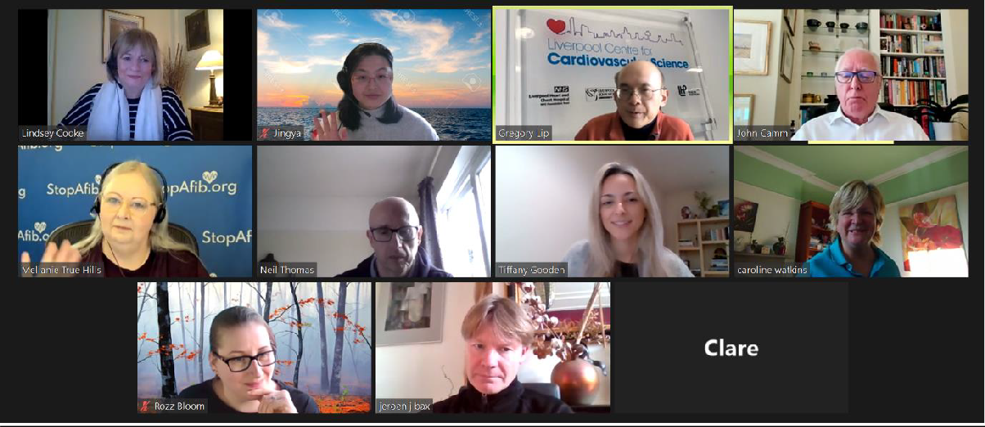

We met with the International Scientific Advisory Committee (ISAC) and NIHR in early March to discuss finances, training, impact and progress and next steps of all projects across the three countries. ISAC and NIHR were delighted and impressed with the progress made on the projects despite the COVID-19 pandemic, and with the various research outputs each country has produced over the last several months. It was an informative and productive meeting and we will meet again in September2021.

Research news
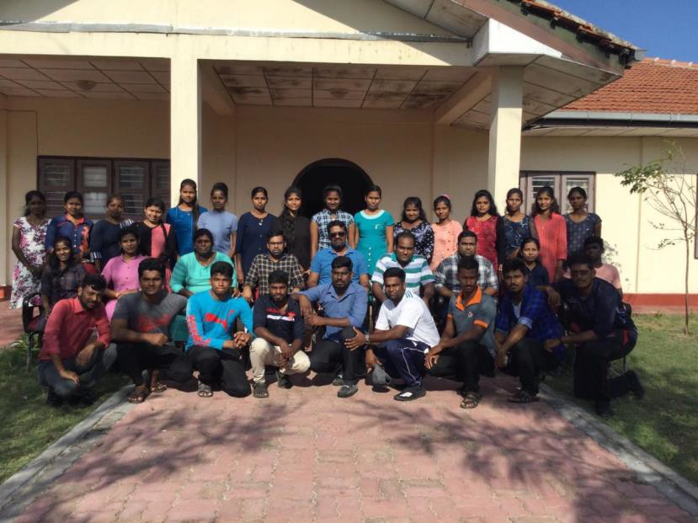
FIGURE 1. THE SRI LANKA TEAM
FIGURE 2. COLLECTING DATA DESPITE FLOODS
We have moved funds around to support the Sri Lanka team with identifying the prevalence of AF using a prospective cohort study design. Additionally, they have received support from Roche to expand on this work to determine the prevalence of other cardiovascular disease and identify associated risk factors and biomarkers for bleeding events, including those caused from AF. They have already recruited more than half of their community-based cohort in Northern Provence, and they expect to have 10,000 people recruited within the next 6 months – a task they have gone through great measures to complete (see photo below). The team is also nearly done with collecting baseline data from AF patients for a better understanding of the patient pathway of AF. Two research fellows within the Sri Lanka team are finalising the protocols for two systematic reviews on AF with help from Dr David Moore, the systematic review expert at the University of Birmingham.

FIGURE 3. COLLEAGUES FROM BRAZIL

COVID-19 has unfortunately caused much disruption to the work and lives of the Brazil team, leading to a hold on all patient-facing research until the vaccination programme is more complete. However, they have been busy working on secondary analyses and drafting manuscripts for publication. They have also been able to continue collecting data from patients for the patient pathway research via telephone calls.
FIGURE 4. RECRUITING PATIENTS FOR THE PATIENT CARE PATHWAY STUDY
The China team has successfully recruited 230 patients for the patients care pathway study, which was to identify the potential barriers that may exist to accessing care and management for AF. The China team transferred all information in the paper-based questionnaire to electronic records in a timely fashion. The recruitment work is expected to be completed by early April. Once they completed all the recruitment work, all data at baseline would be available for analysis. After that, the follow-up questionnaire will be administered to patients by the end of April.

Qualitative Research
The Brazilian team have completed the analysis of 164 transcripts from interviews with healthcare professionals (HCPs) to identify barriers to optimal management of AF. They have drafted a manuscript and is preparing for submission to a peer reviewed journal. The article will discuss topics such as AF education for patients and HCPs and lack of confidence from HCPs in how to handle AF.
The China team have completed the analysis of three focus groups with general practitioners to have a better understanding on the existing problems of management of AF and to identify barriers to optimal management of AF. They have drafted a manuscript and are preparing for submission to a peer-reviewed journal. In addition to this, they have also successfully conducted four patient focus groups in Beijing and are planning for another three focus groups in Shanxi. The UK team and the China team are currently working on analysing all transcripts from the first four patient focus groups.
The Sri Lanka team has completed three patient focus groups and have been meeting regularly with the qualitative experts in the AF group from the UK to discuss analysis. They are in the final stages of mapping the themes and sub-themes that emerged from the research and have started drafting a manuscript for publication. They plan to highlight interesting findings on barriers to AF diagnosis and what AF patients believe with regards to what they must eat and what they can and cannot do because of their AF diagnosis.

Research Outputs
The Brazilian team have been successful in publishing two articles in the last couple of months. Their review on AF in low- and middle-income countries was published in the European Heart Journal in December 2020, and their paper on the impact of AF and long-term oral anticoagulant use on all-cause and cardiovascular mortality was published in the International Journal of Stroke in February 2021. In addition, their paper on using ECG records and self-report in the community to diagnose AF has been accepted in the Brazilian Journal of Cardiology. They have submitted a report on ‘Ideal cardiovascular health and atrial fibrillation or flutter’ to the International Journal of Cardiology and are awaiting a response from the editor.

Links to the Brazilian team’s publications:
Atrial fibrillation in low- and middle-income countries: a narrative review
The impact of atrial fibrillation and long-term oral anticoagulant use on all-cause and cardiovascular mortality: A 12-year evaluation of the prospective Brazilian Study of Stroke Mortality and Morbidity
The Sri Lanka team have been very active in reaching out to and involving individuals in the local communities. They released a local press release on the AF research they are conducting in January 2021 and plan to speak to the local media in March about the progress of the project. The team are also in the process of writing a small booklet on public and patient involvement in a low-income country. Furthermore, they have launched their AF website, Twitter account and are working on their second newsletter to be published in March.

Links to the Sri Lankan’s social media accounts:
Website: Global AF Reach in Sri Lanka Twitter account: Global AF Reach Sri Lanka
Follow us at - https://twitter.com/af_reach
