Dear COPE-WM participant,
You have received this dried blood spot (DBS) test kit as you are currently taking part in the COPE-West Midlands research project. The kit contains:

- This instruction leaflet
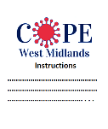

- Dried blood spot card
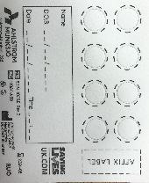

- A lancet
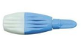

- Cotton wool
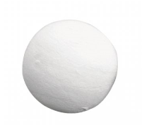

- Alcohol wipe

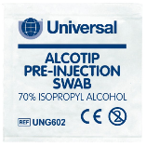

- A desiccant (small white sachet that helps with keeping the blood sample dry)
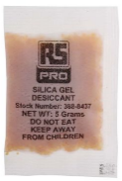
- A re-sealable polythene bag
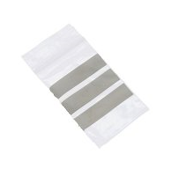
- A prepaid envelope

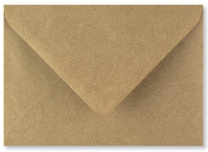
Before emptying the contents of this pack, be sure all items are placed on a clean and flat surface. Please note: do not touch the middle of the DBS card, and only the sides. The DBS test must be returned to the study team within 3 days of you receiving the kit.
The following steps below explain what you need to do. If you have any problems, please contact the study team: cope-wm@contacts.bham.ac.uk

Dried blood spot test instructions
- Use a pen to complete information on the dried blood spot card, noting
  - your first and last name,
  - date of birth (month and year only)
  - date and time of the blood collection

- Wash hands thoroughly with soap and warm water. Warm hands will allow the best blood sample. Dry your hands afterwards.

- Choose the area for the finger puncture. Best place is on the side of the middle or ring finger (e.g. shaded area of finger pad).
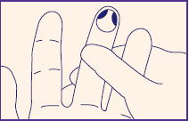

- Hold the lancet against the side of your chosen finger, as illustrated below
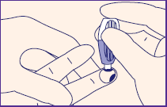

- To activate, press the lancet firmly against the puncture site. Do not remove until a click is heard.

- Lightly massage the punctured finger, and allow a blood drop to form

- Allow the blood drop to fall into the first circle on the blood spot card. Ensure the blood spot is filled up to the dotted line.

- Complete all FOUR circles on the card

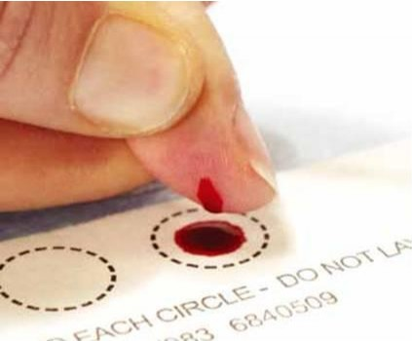

If you find that blood flow is poor/slow, lower the arm of the finger you have selected. This will help to increase blood flow. If possible, please avoid excessive squeezing of the finger.
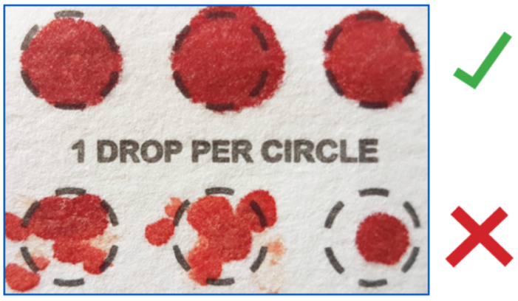
- Once complete, using the cotton wool, wipe off the blood from your punctured finger and cover with a plaster
- Allow the card to dry for 30 minutes, at room temperature
- Put the desiccant into the polythene bag, along with dry blood spot card and used lancet. Please make sure you have closed the bag properly.
- Place the closed polythene bag in the prepaid return envelope (Department of Clinical Immunology Service, Institute of Immunology and Immunotherapy, College of Medical and Dental Sciences, P.O Box 1894, Vincent Drive, Birmingham. B15 2TT), and post back to the study team within 3 days of receiving this kit.
Thank you!

