# Birmingham Institute for Sustainability & Climate Action (BISCA) Affiliates: role and application process (September 2024)

The Birmingham Institute for Sustainability & Climate Action (BISCA) is seeking applications for Affiliate membership.

This document provides details on the role expectations, the benefits to the individual, their School and College and the application process.

**Closing date:** 15 November 2024.

## About BISCA

With society’s awareness of sustainability matters at a peak, the University is leveraging its influence and assets to make a powerful statement on how we can lead action to tackle the global climate emergency, aligned with the UN Sustainable Development Goals (SDGs). [The Birmingham Institute for Sustainability & Climate Action](https://www.birmingham.ac.uk/research/bisca/home-page.aspx) (BISCA) facilitates, connects and delivers world-leading, transdisciplinary research on sustainability and foster climate action through our research community, students, policy and decision makers, and wider society – leading to better livelihoods and a more sustainable environment in a rapidly changing world.

At BISCA, we bring together researchers from across the University with expertise in sustainability and climate action. This University wide research community forms a dedicated network of Affiliates that connect to deliver on interdisciplinary and transdisciplinary research challenges with impact.

## About BISCA Affiliation

Affiliates act as supporters and advocates for BISCA while gaining benefits of our exciting research environment, inclusive and diverse culture, and facilities and assets. Affiliates reach beyond the University to industry, policymakers and wider society to drive impactful research for sustainability and climate action. Affiliation operates as a flexible, mutually beneficial and committed arrangement to deliver targeted activities with clear outcomes towards BISCA’s objectives, available below:

* [BISCA’s objectives](https://www.birmingham.ac.uk/research/bisca/goals-and-objectives)

### Who we are looking for

We are seeking a diverse range of Affiliates to provide a mix of experience, expertise, backgrounds, perspectives and ideas, and to embody BISCA’s Equality, Diversity and Inclusion values and actions.

### Enquiries

Informal enquiries are welcome, please contact:

* David Hannah, BISCA Director: [d.m.hannah@bham.ac.uk](mailto:d.m.hannah@bham.ac.uk)
* Liza Jabbour, Deputy Director: [l.jabbour@bham.ac.uk](mailto:l.jabbour@bham.ac.uk)
* Helen Onyeaka, Deputy Director: [h.onyeaka@bham.ac.uk](mailto:h.onyeaka@bham.ac.uk)

## Affiliate benefits for individual, School and College

* The following diagram (and list below) summarises the mutual benefits of Affiliation for individual, School and College as well as BISCA.
* Importantly, all resources gained by Affiliates (e.g. grant awards, impact) flow back through their associated School and College

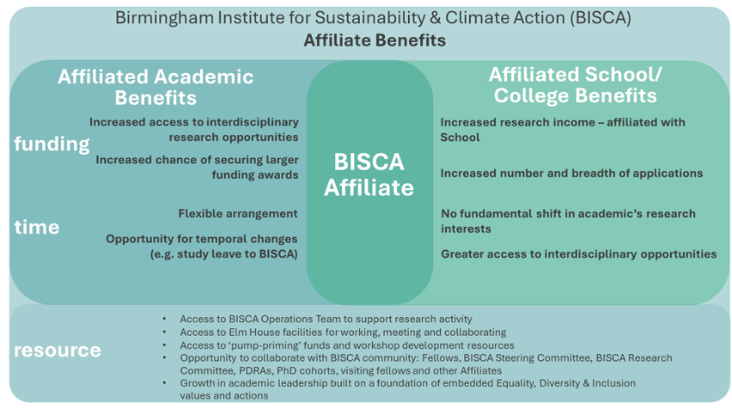

### Affiliate individual benefits

* Increased access to interdisciplinary research opportunities; engaging with existing and emerging networks, collaborations and partnerships across campus, with other institution, industry and government bodies
* Opportunity to collaborate with BISCA community: Fellows, BISCA Steering Committee, BISCA Research Committee, PDRAs, PhD cohorts, visiting fellows and other Affiliates
* Increased chance of securing larger funding awards; systems which support the proactive and rapid development of bids through the research committee, the network of BISCA Affiliates, close working relationships with RSSD colleagues and operational support
* Focused time and space to pursue sustainability research within and through BISCA
* Part of a growing cohort and network of new and previous BISCA Affiliates
* Growth in academic leadership built on a foundation of embedded Equality, Diversity & Inclusion values and actions
* Access to BISCA Operations Team to support research activity
* Access to Elm House facilities for working, meeting and collaborating
* Access to ‘pump-priming’ funds and workshop development resources

### School and College Benefits

* Increased research income - awards remain with the school
* Increase in number and breadth of awards - increasing interdisciplinarity
* The Affiliate’s research interests will remain aligned with their core discipline and the school
* Greater access to interdisciplinary opportunities for the School through the Affiliate and the College and School’s connection with BISCA

### BISCA Affiliate (0% FTE) Expectations

* A flexible arrangement agreed between the Affiliate and BISCA targeted with clear activities and outcomes (see application form)
* Importantly, no formal workload allocation (that is 0% FTE role) with time taken from discretionary research time (as acknowledge by Head of School - see application form)
* Research interests, profile, expertise and experience that align with, and furthers BISCA’s strategic objectives and research themes (see application form).
* Alongside their research, the Affiliate will be expected to support key BISCA activities and initiatives, for example:
  + Participate in and contribute to funding calls, projects and initiatives (including engaging with BISCA Research Management Committee).
  + Act as a point of contact, and advocate for, BISCA within their School and College, and more broadly across the University
  + Provide expert advice internally and externally regarding sustainability and climate action research, as relevant to their project and area of specialism
  + Support BISCA, BISCA Director and Deputy Directors, Committees or working groups to respond to sustainability and climate action related external opportunities.
  + Deliver internal and external engagement initiatives (e.g. workshops, seminars/talks, and creating communications content for a range of audiences including researchers, students, business, policymakers and wider society)
* The BISCA Affiliation scheme will embody BISCA’s Equality, Diversity and Inclusion values and actions by encouraging applications from a diverse population of academics
* Applications encouraged from all career levels

## Appointment Term and Applications

* Please use the online application form available here: [online application form.](https://forms.office.com/e/G9QzxXcQqv)
* Affiliation applications will be considered by the BISCA Senior Leadership Team and the BISCA Steering Committee.
* Appointment duration is 2 years in the first instance – reviewed against delivery of agreed outcomes at the end of first year of Affiliate’s activity.
* If activity is not delivering mutual benefits, the Affiliate status will be withdrawn.
* Closing date 15 November.

Becoming an Affiliate of BISCA is an opportunity to lead impactful research in sustainability and climate action, collaborate across disciplines, and grow your academic profile. We encourage applications from all career levels, with a particular emphasis on diversity and inclusivity.

Apply by 15 November 2024 to join our vibrant network of sustainability researchers and contribute to meaningful action on the most pressing grand challenges for society and our planet.