CLiC – Corpus Linguistics in Context

An Activity Book

Supporting the teaching of literature
at GCSE and AS/A-level

Version 1, November 2017

Michaela Mahlberg, Peter Stockwell, Viola Wiegand
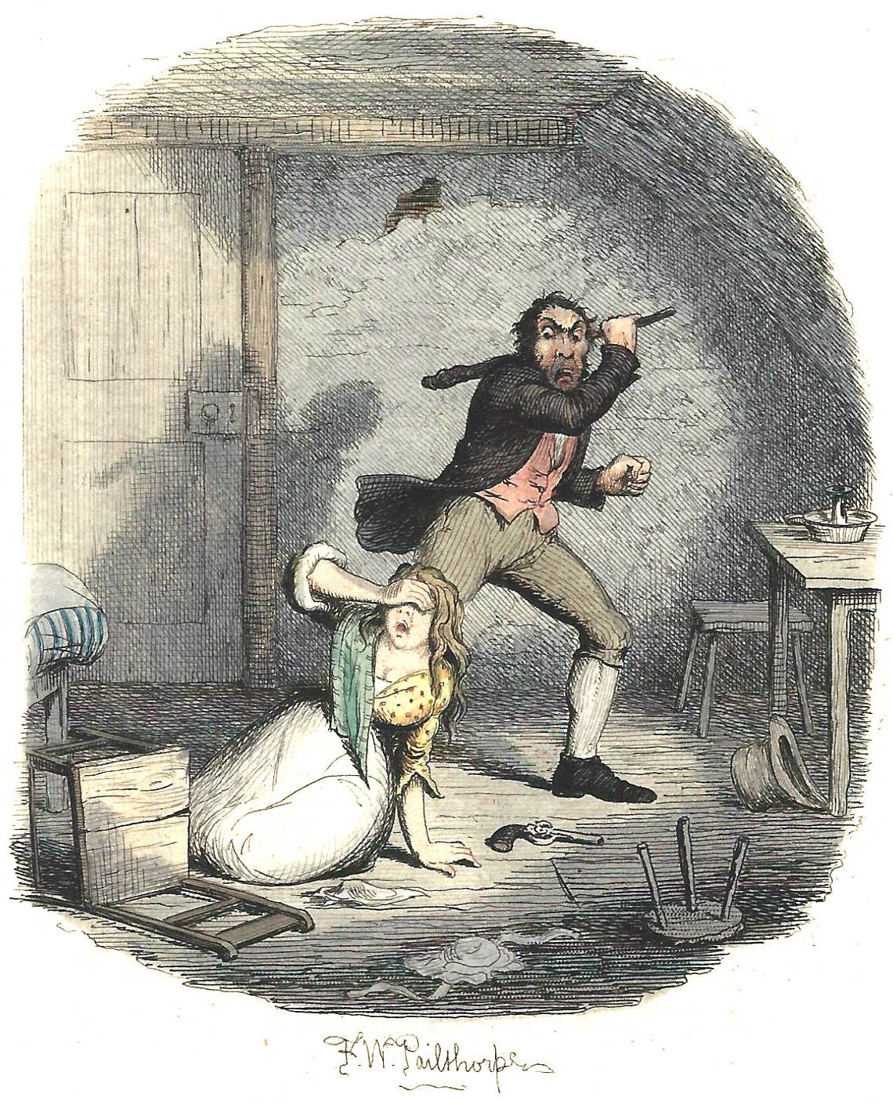

CLiC is funded by the Arts and Humanities Research Council
Grant reference AH/P504634/1

This work is licensed under a Creative Commons Attribution-NonCommercial-ShareAlike 4.0 International License.
© 2017, Michaela Mahlberg, Peter Stockwell, Viola Wiegand

Table of contents
1. Introduction 2
Part I – Corpus methods and CLiC 4
2. Corpus linguistic basics for the study of literature 4
3. The CLiC corpora: books you can read with CLiC 7
4. Concordancing and KWICgrouping: exploring patterns in the text 10
5. Keywords: indicating what the text is about 15
6. Clusters – repeated sequences of words 19
7. User-defined tags – adding information to your text 20
Part II – Thematic Activities 22
8. The creation of fictional characters 22
9. Body language and characterisation 25
10. Setting and atmosphere in novels 28
11. Exploring theme in The Sign of the Four 30
12. Character and structure in A Christmas Carol 33
13. The fireplace pose – texts and cultural context 37
14. Social protest writing: Hard Times and Oliver Twist 39
15. Education, women and governesses in the 19th century 41
16. Growing up in Great Expectations 45
17. Fictional and real speech in Jane Austen and the 19C 48
Resources and references 53
Appendix 1: Overview of CLiC texts listed in AQA, Edexcel and OCR A-Level / GCSE specifications 54
Appendix 2: Corpus tools 55
Appendix 3: Handouts for photocopying 56

Introduction
This book has been written for teachers and the exploration of literature in the classroom. Language and literature can be taught as separate subjects, but recent developments of language and literature specifications illustrate how both can and need to be integrated. For example, Marcello Giovanelli and colleagues have created resources supporting the teaching of the AQA English Language and Literature Specification. For more information see their blog The Definite Article and their AQA student book for English Language and Literature A/AS Level teaching (Giovanelli et al. 2015).
The CLiC – Activity Book makes suggestions for this integration. It provides examples of activities that teachers can adapt to or incorporate into their classes. It also includes activities that can inspire ideas for student projects for the NEA. However, even if you are looking for materials solely for language or literature this book provides relevant concepts and methods, as it is fundamentally concerned with how we derive meanings from texts – and especially how we ‘read’ literary texts. Any reading experience will be shaped by the format or the materiality of the text. In the digital age, new forms of texts have emerged and new methods of reading have become possible. We can still read a hard copy of Great Expecations and may want to treat the experience as a solitary one. But we can also read the text in electronic format and experience it in novel and creative ways. An example are the ‘readalongs’ of Dickens’s novels. The Great Expectations Readalong Project approaches the text in different forms and makes it a shared experience: participants read the text in its original weekly instalments on Dickens Journals Online, discuss it on a blog and live-tweet the story in such a way that volunteers tweet as characters.

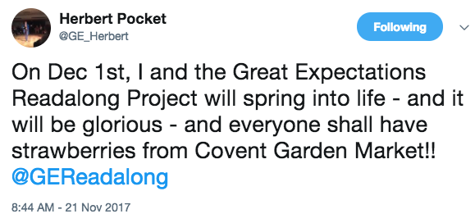
Figure 1: Tweet from the Great Expecations Readalong Project

The CLiC – Activity Book makes a contribution to thinking about teaching in the digital age. It illustrates ‘corpus linguistic’ methods that support the analysis of literary texts. Corpus linguistics refers to an area of linguistics that uses computer-assisted methods or specific software to find patterns, count frequencies and display texts in a number of ways. However, the CLiC – Activity Book is not intended to be a full-blown introduction to corpus linguistics. Its focus is on activities to study language and explore literary texts in the classroom. So corpus linguistics is only introduced to the extent to which it can usefully support the development of teaching materials and be employed by students. The acronym ‘CLiC’ – Corpus Linguistics in Context – reflects this focus on the contextualisation of methods and approaches.
The main corpus tool we will introduce is the CLiC web application. CLiC is freely available online at http://clic.bham.ac.uk. The web app has been developed as part of a research project that focused on Dickens’s fiction. Hence a large component of CLiC is made up of Dickens’s novels. But there is also a variety of other literary texts available in CLiC – some of these texts have explicitly been added in response to feedback by teachers. Appendix 1 provides an overview table that refers to several GCSE and A/AS-level specifications (both Literature and Language and Literature) and lists the texts in CLiC that are particularly relevant to these specifications. Because CLiC is free and lets you read novels in their entirety, the CLiC corpora can only contain texts that are out of copyright.

How to use this book?

The CLiC – Activity Book is structured into two main parts – a methodological section that introduces the functionality of the CLiC app and a thematic section that illustrates specific thematic activities. However, you do not have to go through the book chronologically. The main advantage of the structure is that it introduces basic concepts in a systematic way – almost like an extended glossary – so that an overview of methods is provided that enables you to apply these methods to texts of your choice. The first part introduces, for instance, how you can run concordances and it provides an example to illustrate the kind of information that concordances can provide. The second part then starts the other way round, from topics and questions you might want to address. In the activity on A Christmas Carol we are interested in the social importance of the fireplace, and concordances will be one way of investigating the topic. As a result of this structure, some of the activities in Part II also bring in other online materials that can be usefully combined with findings from CLiC .

Availability and further development of the CLiC Activity Book

The CLiC Activity Book is available both as a pdf and as a word document from our project resources web site.

While the pdf will be easier to print, we also make the word document available so you can adjust and adapt activities in the way that best fits your teaching activities. We publish the CLiC Activity Book online so that we can update it continuously.

We are very interested in feedback from teachers who use our activities and will also aim to incorporate feedback and suggestions into future versions of the activity book. If you have ideas for specific CLiC activities or want to share your experience of using CLiC in the classroom it would be fantastic if you wanted to write a guest blog for us. We can then also refer to your blog post in a future version of the CLiC Activity Book.

Please do get in touch with us!


email: clic@contacts.bham.ac.uk
Twitter: @CLiC_Dickens
project website: http://www.birmingham.ac.uk/clic
project blog: https://blog.bham.ac.uk/clic-dickens/

Part I – Corpus methods and CLiC

Part 1 takes you through the different functionalities of CLiC and illustrates with simple examples what each of the CLiC tools can do. The CLiC interface is designed in such a way that its use is as intuitive as possible, so you will probably be able to work out a lot for yourself. Even so, this part of the CLiC Activity Book can give you some examples of how to familiarize your students with CLiC. Most of the CLiC functionalities (concordance, keywords, clusters) illustrate common corpus tools, so Part 1 also offers tranferrable skills. (In Appendix 2 we give examples of other corpus software that you will find easy to use once you have a first experience with CLiC). Beyond the common corpus approaches, CLiC offers some functionalities that are either novel or specifically helpful to the study of literary texts. For even more detail on practical questions, please also see the CLiC user guide. The guide can also be accessed from the ‘Help’ button in the top-right corner of the CLiC web app.

Corpus linguistic basics for the study of literature

Corpus linguistics is an area of linguistics that has become possible with the arrival of computers. Corpus linguists use electronic copies of texts as well as linguistic data that is born-digital (blogs, twitter data, etc.) to study a language. Corpus linguistics is a good example to show how research methods develop and enable new perspectives and insights. This is the same in other disciplines. Consider, for instance, how the invention of the miscroscope has had an impact on biology. As corpus linguistics is part of our rapidly developing digital world, it occasionally gets mentioned in the press. Such topical articles might be useful materials to discuss with your students and reflect on how digital innovation changes our world (see the resources in the ‘further reading’ box on page 6).
Crucially, corpus linguistics draws attention to the importance of frequency of usage for the description of language. Frequency information is relevant when new words enter the language and we notice how specific usages become increasingly frequent. It also comes into play when we describe how words and phrases change their meanings over time (see Part II, Section 12, where we look at the phrase once upon a time). It seems, however, that speakers of a language are not always aware of the very frequent words and the patterns of usage that account for naturally occurring language. Would you have known that words like time, place and world are among the most frequent nouns in general English? The meanings of these words are very general and their frequency is linked to the fact that these words occur in phrases such as the first time, last time, every time, take place, a good way of –ing, the best X in the world. Directly linked to studying frequencies of words and phrases is the need to compare quantitative information across different data sets, e.g. the language used in textbooks will be rather different from the language of casual conversations in the staff room.
Insights from corpus linguistic research have a particular impact on teaching English as a foreign language. For instance, dictionaries now tend to focus on the most frequent meanings of the most frequent words. Also the ability to use phrases in the way they most commonly occur in the language supports the learning of a second language. However, even to native speakers, corpus linguistics has a lot to offer. Studying the ways in which we talk about global warming, immigrants, women, obesity, smoking, educaction etc. provides us with insights into societal and cultural patterns. At an even more basic level, especially concordance methods can support the close reading of a text and have the potential to support students who might not find it easy to read long texts such as novels.
The CLiC Activity Book focuses particularly on how corpus linguistic methods can support the study of literary texts. The way in which we are aware of the language we encounter is directly relevant to the reading of novels. When we read Pride and Prejudice, we are able to talk about the character Elizabeth Bennet, but we might not be able to recall every detail we read about her. We might not even have noticed specific linguistic patterns that created the impression we have of the character. Characterisation is a process that takes place in the mind of the reader. Everyone brings their own background knowledge to their reading of a novel – that is why each student in your class will have a different picture of Jane Eyre. But at the same time, textual cues in the text direct the reader in a specific way and trigger enagement with specific background knowledge. Hence everyone’s mental representation of Jane Eyre will be text-driven. The creation of fictional characters is one type of meaning that is created in literary texts. However, the creation of meaning in the reader’s mind is much wider than characterisation and extends to settings, atmosphere, etc. basically every kind of meaning triggered by a literary text. The methods we illustrate in the activity book enable you – and your students – to focus on linguistic signals in the text that are relevant to this process. In the most basic sense, you can you view corpus linguistic methods as supporting close reading.
A single novel is a relatively small data set in corpus linguistic terms though. It is therefore important to note that not all corpus linguistic methods will be equally useful when studying a particular text. Sometimes, running concordances to simply find occurrences of a word across the text might be the most useful approach. Sometimes, a comparison with other texts might be what is most helpful. The activities we present in the CLiC Activity Book are examples and are intended to give you some ideas as to how you can explore literary texts with corpus linguistic methods.
As the CLiC Activity Book has directly arisen from our research into cognitive corpus stylistics and the study of Dickens and 19th century fiction, we have included references to some of our relevant research publications – especially when they are freely downloadable.
Further Reading

Characterisation and CLiC

Mahlberg, M., Stockwell, P., Joode, J. de, Smith, C., & O’Donnell, M. B. (2016). CLiC Dickens: novel uses of concordances for the integration of corpus stylistics and cognitive poetics. Corpora, 11(3), 433–463. (PDF available from https://doi.org/10.3366/cor.2016.0102)
Stockwell, P & Mahlberg, M. (2015). Mind-modelling with corpus stylistics in David Copperfield, Language and Literature, 24 (2), 129–147. http://journals.sagepub.com/doi/abs/10.1177/0963947015576168
2) General Textbooks on Corpus Linguistics
Cheng, W. (2012). Exploring Corpus Linguistics. Language in Action. London: Routledge.
Flowerdew, L. (2012). Corpora and Language Education. Basingstoke: Palgrave Macmillan.
Lindquist, H. (2009). Corpus Linguistics and the Description of English. Edinburgh: EUP.
McEnery, T. & A. Hardie, (2012). Corpus Linguistics. Cambridge: CUP.
3) Example articles from newspapers / magazines
‘What the Enron emails say about us - Scholars have spent years analyzing the corporation’s vast digital archive. What have they discovered?’ by Nathan Heller, The New Yorker, 24 July 2017 https://www.newyorker.com/magazine/2017/07/24/what-the-enron-e-mails-say-about-us

‘The decline of the gradable adverb: 'quite', 'rather' and 'fairly' are becoming a relic of the past’, by Camilla Turner, The Telegraph, 11 November 2017 http://www.telegraph.co.uk/education/2017/11/11/decline-gradable-adverb-quite-rather-fairly-becoming-relic-past/

The CLiC corpora: books you can read with CLiC
The CLiC web app allows you to access four corpora:

DNov - Dickens's Novels
19C - 19th Century Reference Corpus
ChiLit - 19th Century Children's Literature Corpus
ArTs - Additional Requested Texts

1) DNov - Dickens's Novels
DNov contains Dickens’s 15 novels.

2) 19C - 19th Century Reference Corpus
19C is a corpus of 29 novels by other authors published in the 19th century. The corpus does not contain any Dickens texts. It includes a maximum of three texts by the same author. 19C was created as reference corpus for the research reported in Mahlberg (2013).

3) ChiLit - 19th Century Children's Literature Corpus
ChiLit contains 71 British children’s books published in the 19th century. The 19th century is also known as the ‘Golden age’ of English children’s literature. The corpus has been compiled as part of the GLARE project. A description of the ChiLit corpus is available from our CLiC Dickens blog (https://blog.bham.ac.uk/clic-dickens/); Figure 2 is a preview of the blog post.

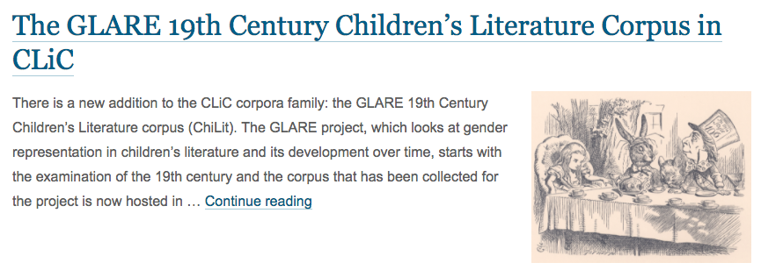
Figure 2: Preview of the blog post describing the books in the 19th Century Children’s Literature corpus

4) ArTs - Additional Requested Texts
There are no systematic design criteria for this corpus. It contains books that users of CLiC asked us to include, as well as a number of other books listed by GCSE and AS/A-level specifications that are not included in any of the above corpora – some GCSE / AS/A-level texts are already part of the other corpora. For an overview of all the texts in CLiC that are relevant to English Literature and English Language and Literature teaching specifications see Appendix 1. All texts in CLiC are based on e-books from Project Gutenberg.

Table 1: Number of texts and number of words in CLiC corpora
Corpus | Number of texts | Number of words
DNov | 15 | 3,835,807
19C | 29 | 4,513,070
ChiLit | 71 | 4,443,542
ArTs | 23 | 2,259,103
Total | 138 | 15,051,522

Selecting corpora in CLiC

Sometimes using a whole corpus can be useful, for instance, when we want to search all of Dickens’s novels. But sometimes you might want to select only an individual text. Each functionality of CLiC lets you choose the texts from the corpora in any way you like. Auto-complete for the text names in the search box can support you in making your selection. Figure 3 shows how “Auste” will show all books written by Jane Austen so that you can then easily select your own Austen corpus for a concordance search.

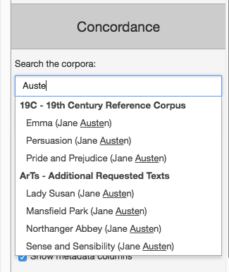
Figure 3: Using auto-complete to select texts

The CLiC start page lists all the corpora and the texts in them broken down into chapters, as shown by Figure 4 for Persuasion, so that by clicking on a chapter number you will see the full text of the chapter. The overview on the start page also provides information on word counts for each book.

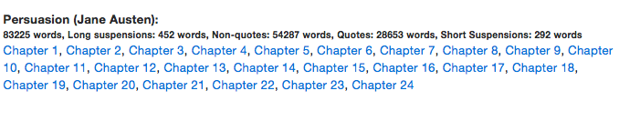
Figure 4: Chapter overview of Persuasion on CLiC start page

Text sections (subsets) – speech and narration

All texts in CLiC have been marked up in such a way that it is possible to focus searches on the direct speech of the fictional characters, or other specific sections of the text. In the example below, text within quotation marks is indicated in red. We refer to such text as ‘quotes’. Most of the time, quotes are the direct speech of charaters – in some cases direct thought, or very rarely direct writing. Text that appears outside of quotation marks, indicated in blue, is referred to as ‘non-quotes’. There are two specific subtypes of non-quotes: ‘long suspensions’ and ‘short suspensions’. Long suspensions are interruptions of a character’s speech by a stretch of narrator text of five words or more. Short suspensions are interruptions of narrator text that are shorter than five words. Note that returned Miss Tox is not a suspension, it ends with a full stop (which is not possible for suspensions) and it is not followed by speech either. (We use the term ‘suspensions’ following Lambert’s (1981) definition of the ‘suspended quotation.)

'You are so kind, Lucretia,' returned Mrs Chick, a little softened, 'as to say so, and to think so, I
believe. I hope neither of us may ever have any cause to lessen our opinion of the other, Lucretia.'

'I am sure of it,' returned Miss Tox.

Mrs Chick coughed as before, and drew lines on the carpet with the ivory end of her parasol. Miss Tox, who had experience of her fair friend, and knew that under thepressure of any slight fatigue or
vexation she was prone to a discursive kind of irritability, availed herself of the pause, to change
the subject.

'Pardon me, my dear Louisa,' said Miss Tox, 'but have I caught sight of the manly form of Mr Chick in the carriage?'

(Dombey and Son, Charles Dickens, Chapter 29)

Concordancing and KWICgrouping: exploring patterns in the text
The concordance is the basic display format in corpus linguistics. It finds all occurrences of a particular word or phrase in a corpus and lists them vertically with the search term in the middle.

In this section we use the example of the word chin, a body part noun, to illustrate the value of concordancing when looking for patterns in the text. Body part nouns are useful starting points to find descriptions of body language in novels. Figure 5 shows a concordance sample of chin in Dickens’s novels; the sample contains the first 10 concordance lines of the altogether 317 lines containing chin.

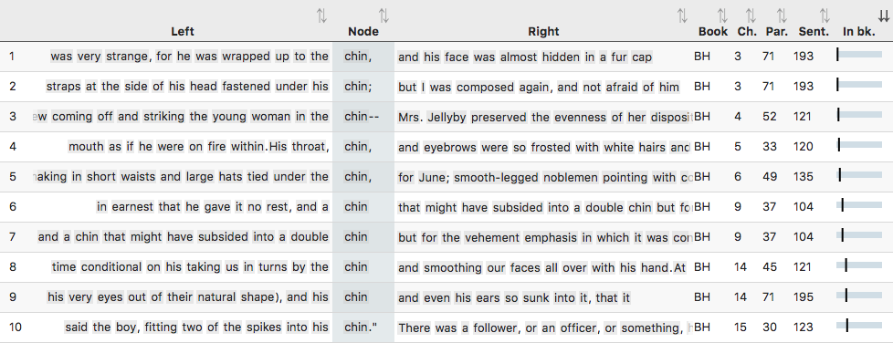
Figure 5: Sample of concordance lines of chin in DNov
As a concordance is by default ordered according to book, all lines at the top of the concordance are from Bleak House (BH). However, concordances can be easily resorted so that patterns become visible. In order to sort by the first word on the left (L1 position), click on the header ‘Left’. Similarly, click on ‘Right’ to sort by the first word on the right.
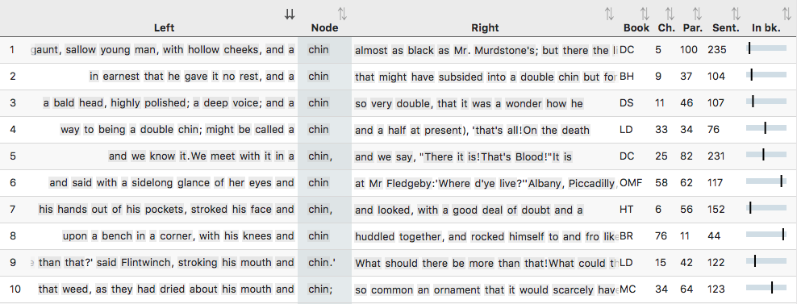
Figure 6: The first 10 lines of chin in DNov, ordered by the first word on the left

Figure 6 shows the first 10 lines when the concordance is sorted by ‘L1’ position, the first word on the left. We can now see examples from a variety of novels (as shown in the ‘Book’ column), and they all start with a. When scrolling down in the concordance view, we can spot patterns such as the compound noun double chin, of which there are several instances, shown in Figure 7.

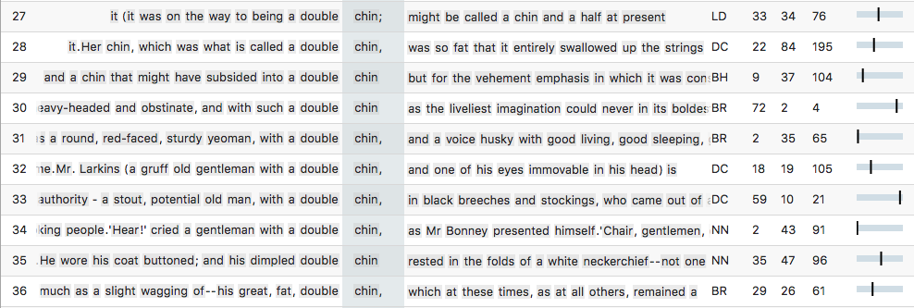
Figure 7: Sample of concordance lines of chin in DNov ordered by the first word on the left

KWICGrouping

The words and phrases around the search term can be explored in more fine-grained detail by using the CLiC KWICGrouper. This feature allows you to look for shared patterns across concordance lines by searching for words in the context.

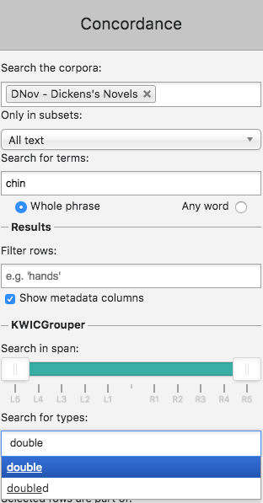
Figure 8: Using the KWICGrouper to search for double in the concordance of chin
In order to check whether there are more instances of double surrounding chin, we can use the KWICGrouper menu, which is located in the sidebar under the basic concordance options. Figure 8 illustrates how this is done: we simply type the word double into the box (“Search for types”) and then select it from the list. The dropdown will also suggest words with similar forms, but for this example we stick to the one form, double. Once we have selected a word in the KWICGrouper, the concordance will be automatically rearranged: all matching lines will move to the top, as shown in Figure 9. The message above the results indicates that out of the 317 concordance lines of chin, 17 match the search for double. This means that we have quickly narrowed down our search from 317 lines to a relevant selection of 17 that are related to body language and potentially to characterisation.

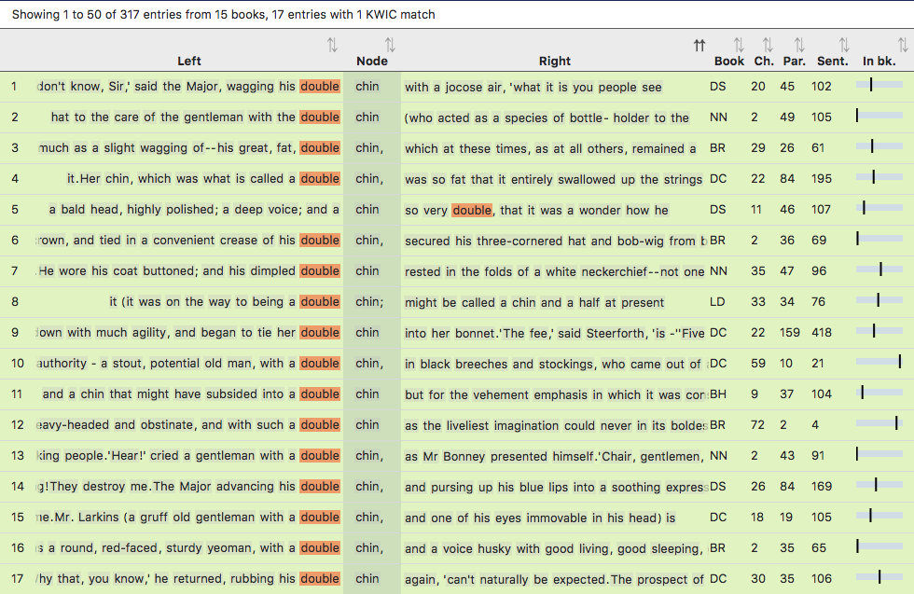
Figure 9: ‘KWICGrouped’ lines containing chin and double in Dickens’s Novels
In this case it is very obvious that most of the results are of the pattern double chin. One match appears on the right: a chin so very double (line 5). We can target a case like this directly by restricting the search span of the KWICGrouper to certain positions; so we would find only the example from line 5 above if we restricted the search to the right as shown in Figure 10 and Figure 11.

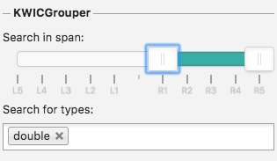
Figure 10: Settings for restricting the KWICGrouper search span (here, to the right)
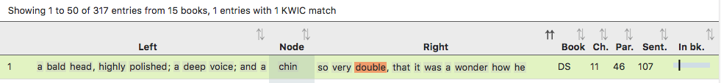
Figure 11: ‘KWICGrouped’ lines when restricted to matches on the right
Like the example of the chin so very double, the KWICGrouper has pulled up more interesting character descriptions such as the following (from line 8 in Figure 9):

'And that,' said Mrs Gowan, shaking her despondent head, 'that's all. That,' repeated Mrs Gowan, furling her green fan for the moment, and tapping her chin with it (it was on the way to being a double chin; might be called a chin and a half at present), 'that's all! On the death of the old people, I suppose there will be more to come; but how it may be restricted or locked up, I don't know. And as to that, they may live for ever. My dear, they are just the kind of people to do it.'
(Little Dorrit, Charles Dickens, Chapter 33)

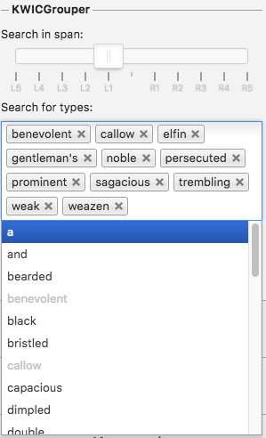
Figure 12: Using the KWICGrouper to select personifying expressions from the ‘L1’ (first to the left) position
Another way of exploring language expressions with noteworthy literary effects is to browse the KWICGrouper’s wordlist for particular positions on the left or right of the search term. Figure 12 demonstrates the process of identifying potentially personifying expressions of chin from all words in the L1 position in the concordance, the first word to the left of chin. As before, the KWICGrouper then highlights these words in the concordance and moves them to the top and therefore makes it easier to analyse the expressions in context (see Figure 13).

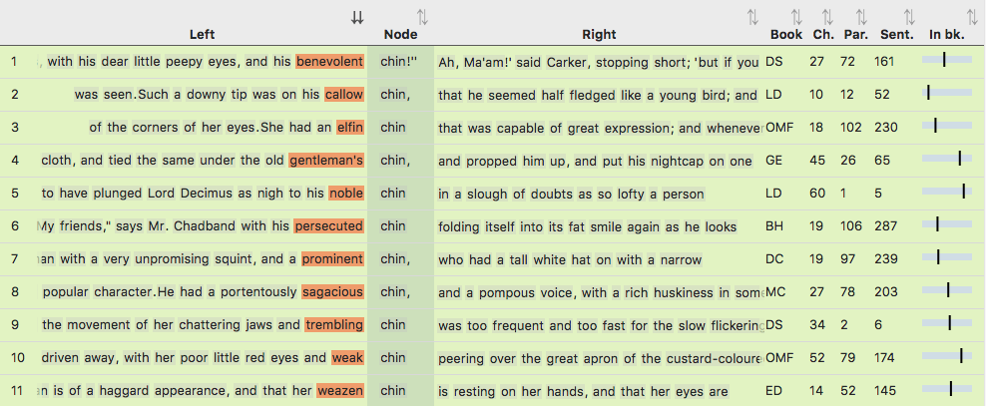
Figure 13: Personified expressions of chin, identified with the KWICGrouper
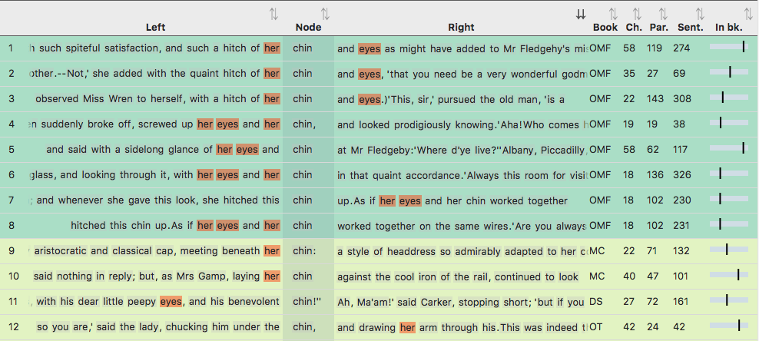
Figure 14: More than one KWICGrouper match: chin with her and eyes
The KWICGrouper can be a powerful tool when looking for combinations of words. The lines with the most matches will always be moved to the top, so that when we search for another body part word like eyes and the possessive her, lines containing both of these are shaded in a darker green and shown at the top in Figure 14. This shows that all instances of chin with her and eyes come from the novel Our Mutual Friend, and indeed all describe one character, Miss Jenny Wren, also called “the person of the house”:

'And she always has the use of this room for visitors,' said the person of the house, screwing up one of her little bony fists, like an opera-glass, and looking through it, with her eyes and her chin in that quaint accordance.' Always this room for visitors; haven't you, Lizzie dear?'
(Our Mutual Friend, Charles Dickens, Chapter 18)

In this way, the KWICGrouper can be used to highlight patterns across novels and provide examples for themes such as body language. Further extensions of the example might include an exploration of gender roles by KWICGrouping lines of chin with possesives such as his and her – see Part II, Section 9 below for more activities with the word chin.

Keywords: indicating what the text is about
Keywords are words that occur statistically significantly more frequently in a text (or a set of texts) compared to a reference corpus.

Keywords are useful as a first step to get an overview of a text and what it is about. They can be helpful starting points for further more detailed analysis. They might also be useful when you want to compare texts. It is important, however, to not overinterpret the literary relevance of a list of keywords. With your key stage 3 students, you might want to study, for instance, rural and urban settings in 19th century fiction. Among Dickens’s novels you will find examples to illustrate urban settings, but the word urban does not occur in any of them.
To get an understanding of the concept of keywords, word clouds are useful to start with. You might want to ask your students to produce a word cloud for a book of their choice and then the whole class can see whether they will know the book from the word cloud. The word cloud in Figure 15 is rather easy to recognise as a representation of Pride and Prejudice.
There are various free tools available to generate word clouds; the one below was created with https://www.wordclouds.com/. In the Pride and Prejudice cloud, the names Elizabeth, Darcy, Bennet, Bingley and Jane appear among the words displayed as the most frequent ones. In word clouds, font size is used to indicate which words occur more often than others.

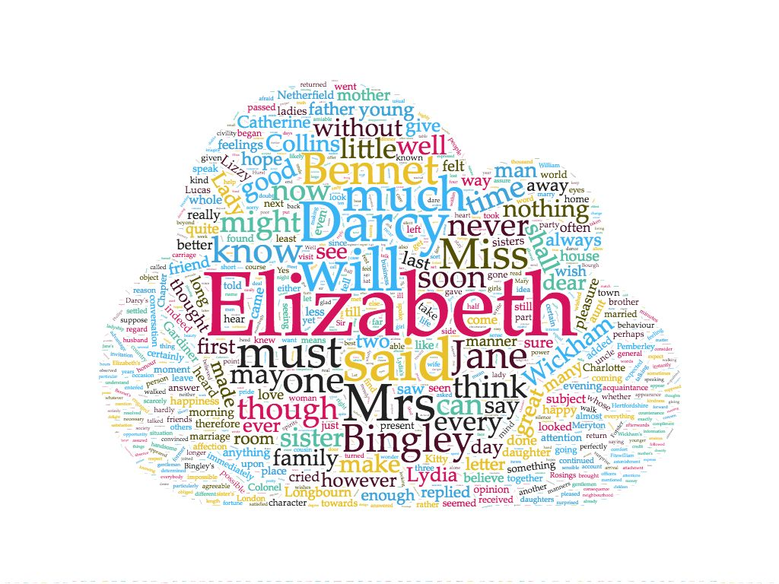
Figure 15: Word cloud for Pride and Prejudice generated with wordclouds.com
Table 2: 20 most frequent words in Pride and Prejudice and Jane Eyre
 | Pride and Prejudice |  | Jane Eyre
Rank | Word | Frequency | Word | Frequency
1 | the | 4331 | the | 7760
2 | to | 4137 | i | 7108
3 | of | 3608 | and | 6572
4 | and | 3577 | to | 5087
5 | her | 2204 | a | 4429
6 | i | 2064 | of | 4316
7 | a | 1949 | you | 2965
8 | in | 1865 | in | 2743
9 | was | 1844 | was | 2513
10 | she | 1695 | it | 2393
11 | that | 1540 | my | 2213
12 | it | 1535 | me | 2042
13 | not | 1421 | he | 1893
14 | you | 1327 | her | 1714
15 | he | 1325 | that | 1653
16 | his | 1258 | as | 1575
17 | be | 1240 | not | 1542
18 | as | 1179 | had | 1485
19 | had | 1173 | she | 1469
20 | for | 1058 | with | 1400

Word clouds, however, may make implicit assumptions about which words are best included in the visualisation. Often ‘stop words’ are excluded. In the FAQ section, wordclouds.com explain: “We automatically remove stop words: frequently-used, but unimportant words, such as the, and, or or.” If we consider all words in Pride and Prejudice and list them in order of their frequency, the top 20 most frequent words are those shown in Table 2. None of the names in the word cloud are among the top most frequent words in the word list. All of the words, in fact, are function words that mainly fulfil grammatical functions rather than provide content information like nouns or verbs do. Table 2 also contains the 20 most frequent words in Jane Eyre – and the picture is similar – all of them are function words. Although the top 20 words in both novels are function words, Table 2 still reflects a difference between the novels. Jane Eyre is a first person narration, so the pronoun I ranks second place in the table whereas I in Pride and Prejudice is further down at rank 6. Additionally, my and me are among the top 20 words in Jane Eyre which also relates to the first person narration.
By looking at word clouds and simple frequency lists we are already able to make some initial observations on word frequencies and what the novels are about. Keywords go a step further in highlighting specific words. To generate a keyword list for Pride and Prejudice CLiC will compare the frequencies of all the words in that novel with the frequencies of the same words in a reference corpus. This reference corpus provides a norm for the frequencies that we expect individual words to occur with. If in Pride and Prejudice they are significantly more frequent than we would expect on the basis of their frequencies in the reference corpus they will show up as ‘key’. Figure 16 shows the top 10 keywords that result from a comparison of Pride and Prejudice with the other six novels by Jane Austen. The top keywords are all names. Elizabeth occurs 635 times in Pride and Prejudice but only 98 times in all the other six novels together. However, the comparison of frequencies does not work with raw figures. The name Jane occurs in Pride and Prejudice but also in the reference corpus that we created from the six other novels. The raw count is in effect higher in the reference corpus, but as the reference corpus also has more words altogether than the single novel, Jane is still relatively more frequent in Pride and Prejudice and hence shows as a keyword.

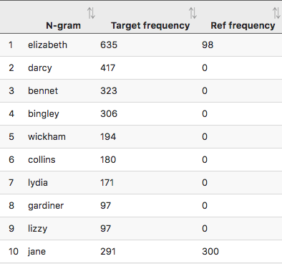
Figure 16: Top 10 keywords in Pride and Prejudice compared to the other 6 Austen novels

Just finding names might be useful to compile a cast list, but it is not so interesting in itself. If we look further down the keywords list, we also find words such as civility, pride, manner, behaviour, proud which are good candidates for more detailed analysis. Figure 17 shows the settings for retrieving these keywords from CLiC.
Analsying concordances for these words provides information that links in with an important theme in Pride and Prejudice – the behaviour of characters to one another is shaped by social norms and rules of polite and civil behaviour that at times can lead to misreading an important situation.

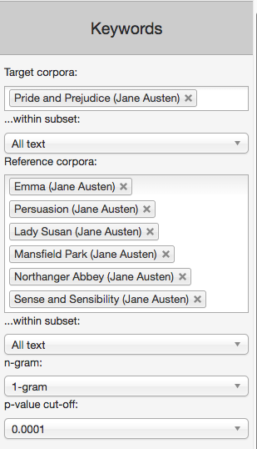
Figure 17: Keyword settings for comparing Pride and Prejudice to the other 6 Austen novels

Once a list of keywords is generated in CLiC the results can be saved to a csv file, which can be opened in a spreadsheet viewer such as Microsoft Excel. This makes it easier to share and format longer tables that do not easily fit into a screenshot such as the one shown in Figure 16 above. In order to save the results, click on the ‘Save’ button at the top of the sidebar in CLiC (see Figure 18). This function can also be used to save results from any of the other tabs, such as the concordance tab. For more detail on these technical features please see the user guide in the ‘Help’ menu.

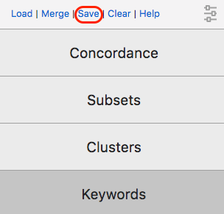
Figure 18: The ‘Save’ button in the sidebar allows you to save the results from any of the tabs to a csv file that can be opened in Excel

Clusters – repeated sequences of words
Clusters are repeated sequences of words in a corpus.

We can look at the frequent clusters – repeated sequences of words – in a corpus to explore its style and content. Figure 19 contains the 10 most frequent clusters with a length of 5 words in the corpus of Dickens’s Novels.

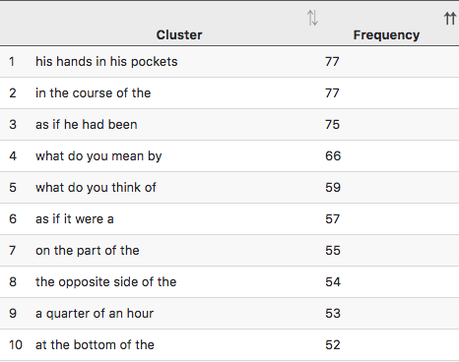
Figure 19: The 10 most frequent 5-word clusters in DNov

The cluster his hands in his pockets is the most repeated sequence of 5 words across the novels. The following three examples illustrate its use.

He walked a little to and fro after saying this to himself with a shudder, and then looked at me, and brightened, and came and sat down again with his hands in his pockets. (Bleak House, Charles Dickens, Chapter 8).

He was lounging with his back against the wall, and his hands in his pockets, and looked at Mr. Mell with his mouth shut up as if he were whistling, when Mr. Mell looked at him. (David Copperfield, Chapter 7)

'Mrs. Sparsit, ma'am,' said Mr. Bounderby, putting his hands in his pockets, and assuring himself with his right hand that the cork of the little bottle was ready for use, 'I have no occasion to say to you, that you are not only a lady born and bred, but a devilish sensible woman.' (Hard Times, Chapter 16)

As these examples illustrate, the phrase is used in describing the behaviour of characters and is interesting with respect to body language. In fact, the cluster his hands in his pockets may occur together with other forms of body language, as indicated by the underlined examples.
The main value of clusters is that they provide information on frequently repeated patterns without requiring a particular search term, unlike the concordance tab. Creating a cluster list of a corpus therefore makes it possible to notice patterns like these which can then be followed up by a more detailed analysis in concordances and the close reading of examples in their chapter views.
The clusters shown above were generated from “All text” in the novels, including both character speech and narration. However, it is also possible to identify clusters for only the spoken (‘quoted’) or narrated (‘non-quoted’) sections of texts, by selecting the correct subset in the options, as shown in Figure 20. Section 17 in Part II below introduces an activity about fictional speech that makes use of clusters.

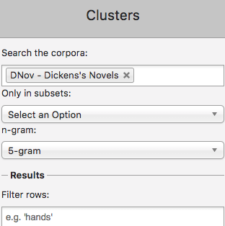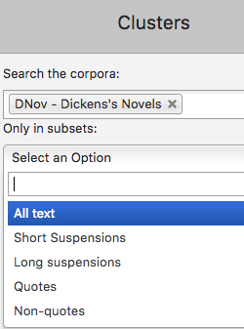
Figure 20: Cluster settings

User-defined tags – adding information to your text
While analysing concordance lines we often develop categories into which we would like to group them. The KWICGrouping function introduced above is helpful for this purpose, but we may want to keep a clearer record of which lines we categorise in a certain way. The CLiC annotation tags can be used for this purpose.
In order to illustrate the tagging function, we will look at suspensions in Oliver Twist. As introduced above, CLiC can differentiate not only between quotes and non-quotes, but also recognises so-called ‘suspensions’. These are interruptions of character speech by the narrator and can contain speech verbs and useful related character information.
One direct way of retrieving character information is therefore to search for a character name in suspensions. Figure 21 shows concordance lines of Oliver (and Oliver’s) in long suspensions (suspensions of at least 5 words in length). We would usually expect to find a character’s name in a suspensions when this character has been speaking and is being interrupted by the narrator. As Figure 21 shows, however, this is not always the case with Oliver.

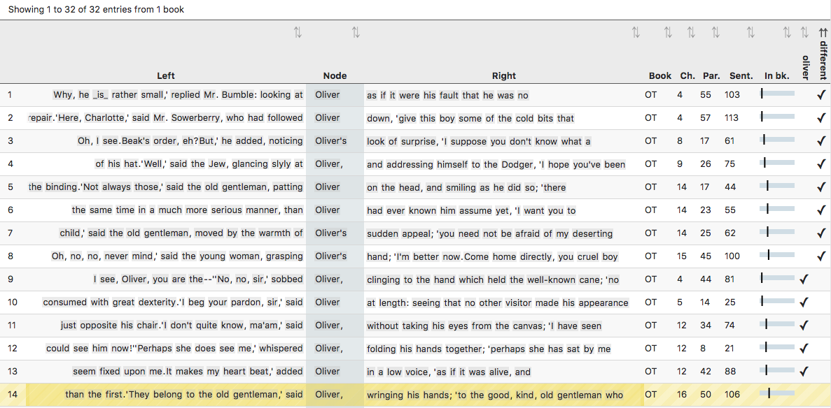
Figure 21: Sample of long suspensions containing Oliver (and Oliver’s) with annotation
The concordance of Oliver in long suspensions contains several instances of other characters being interrupted by the narrator, such as line 2 (“replied Mr. Bumble, looking at Oliver as if it were his fault”…) and line 13 (“said the young woman, grasping Oliver’s hand”). It is striking that in these examples Oliver appears as a passive agent; other characters do something to him; and this is also useful chracter information.
For a complete analysis we would need to go through all examples and keep a record of whether it is Oliver or a different character whose speech is being interrupted. We can use the CLiC tagging feature for tagging each line as ‘oliver’ when he is being interrupted and ‘different’ when it is a different character. Here we have already annotated some of the lines for whether Oliver or a different character is being interrupted and this annotation is shown in the additional columns on the right in Figure 21. When selecting a line (by clicking on it) it is highlighted in yellow (like line 14) and can then be assigned a tag from the tags menu in the sidebar (see Figure 22).

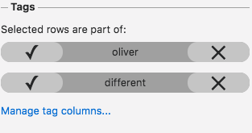
Figure 22: The tags menu – with custom-created tags for the ‘Oliver’ example
As mentioned for the keywords above, we can then export the concordance – with its tags – into a csv file to be opened in a spreadsheet viewer like Excel, for our own record or for formatting, sorting, counting and sharing the data. Section 11 in Part II below contains an activity that makes use of the tagging function.

Part II – Thematic Activities

In this part of the CLiC Activity Book we begin with questions that you might want to study with your students. While the first part was on the technicalities of how to use CLiC, we now focus on how CLiC can help to address specific questions of the sort that might occur ‘naturally’ in a literature classroom. For example, you might notice a feature, theme, issue or pattern in your reading of a novel, but your sense of it might be rather vague and you would like to explore it further: CLiC can help you do this. It can also help you to refine your thinking, find evidence to support your intuitions, and reveal further patterns in the text that you might not have noticed explicitly.

8. The creation of fictional characters
Characters in literary fiction are essentially the same as actual people, apart from the fact that they are not real and sometimes we seem to have a telepathic ability to see inside their minds. But in every other respect, we ‘mind-model’ fictional characters in exactly the same way as we model the minds of actual people in our lives. That is, we imagine them to have consciousness as we do, with beliefs, experiences, sensations, emotions and feelings; they possess the same bodily relationship to their physical environment as us; they engage in human interaction and conversations with other characters in the same fictional world as themselves. Fictional people are people, and as readers we use essentially the same cognitive processes as in real life to flesh them out into rich psychological characters. This explains how readers can often have strong emotional and ethical reactions to people who are not real, but have been invested with life in the process of reading.
Texts provide the cues and patterns by which this rich readerly imagining and modelling can happen, and CLiC is very good at finding these textual features, so that we can better understand the process of characterisation. As an example in this section, we describe a process of moving from intuitive reading to corpus analysis in relation to a character in Dickens’s David Copperfield.
The character of Mr. Dick, though apparently a minor person in the novel, seems highly significant to the work as a whole. David Copperfield is often thought of as Dickens’s most autobiographically-flavoured novel, beginning with the most basic statement of his own existence (“I am born”), and following a character with several similarities to Dickens himself. Both David Copperfield (D.C.) and Charles Dickens (C.D.) follow careers in a factory, and then as a reporter and a novelist. Mr. Dick himself is clearly a form of Mr Dickens, shortened from Mr Richard Babley (and even the surname here suggests both childishness and the verbosity of the novelist). Mr. Dick is writing an autobiograhical ‘Memorial’, while being constantly distracted by an image of the head of Charles I – the primary authorial Charles.
Mr. Dick describes himself as ‘simple’, and indeed Dickens’s characterisation of him is an early example of a sympathetic representation of mental illness. A simple CLiC search for Mr. Dick presents you with every scene in which he appears, and it is noticeable that there are no scenes in which he is mentioned but absent: no one talks about him unless he is there. We first thought to look for the characterisation of Mr. Dick because of an intuitive sense that there is a narratorial focus on his head and face, perhaps suggested by a feeling that there were many sentences like: “Mr. Dick put his head into the parlour”.
So we ran a concordance on Dick in the novel and found hundreds of examples, almost all of which had the full form Mr. Dick. We also then explored the specific patterns and contexts amongst these examples, using CLiC at each stage. You can trace our procedure as follows.

Activity 8.1 Picking out the character
- Go to the CLiC Concordance tab (http://clic.bham.ac.uk/concordance).
- Select David Copperfield in the “Search the Corpora” box and select the subset “All text”.
- Enter Dick in the “Search for terms” box. Hit Return.

This will give you every occurrence in the novel. At this point, you might like to scan down the lines of examples to see what strikes you about the presentation of Mr. Dick in general. Are there any patterns or oddities that you can see?
One pattern we noticed was that the verbs associated with Mr. Dick tend not to have much agency. In other words, he is often the recipient of action or comment by being placed in direct or indirect object position, or by appearing in a prepositional phrase. Where he is associated with agentive verbs, their agency is actually rather weak: leaning, yet lingered, and so on. His most active and agentive verbs are perceptual or cognitive: he thought, anxiously watched. In general, this builds up a picture of a character that cogitates, perceives, and is the recipient of comment and action, but who does little materially himself.
Of course, quite a lot of the examples occur within direct speech, where other characters are talking about or addressing Mr. Dick directly. We can remove these so that we focus on the narratorial characterisation:

Activity 8.2 Picking out the characterisation
- Carry on from step 3 of Activity 8.1 above.
- In the “Concordance” column on the right, change the instruction in “Only in subsets” from “All text” to “Non-quotes”.
- Hit Return.

You should now see just under 200 examples of narrative description of the character. Cast your eye down these. What do you notice?
If you like, you can export these results to an Excel spreadsheet (it’s a .csv file) by clicking “Save” at the top right. This will alllow you to peruse the lines in more detail. You could pick out any patterns that you spot, and remove non-patterns, and print out your results manually. Back within CLiC, you might notice that a lot of the examples are reporting clauses such as said Mr. Dick. You can look exclusively at these, and work out how many of them there are, as follows.

Activity 8.3 Isolating the reporting clause
- Carry on from step 6 of Activity 8.2 above.
- In the “Concordance” column on the right, change the instruction in “Search for terms” to said Mr. Dick. Don’t forget the full-stop after Mr.
- Hit Return.

You can see that around a third of all occurrences of narratorial mentions of Mr. Dick are reporting of his speech. If you look at your long list, you might also add in other speech verbs such as returned, suggested, rejoined, asked, cried, and so on. In other words, the character is allowed to speak for himself in a significant proportion of mentions.
You might also notice, from the concordance list, that there are interesting narratorial descriptions around the reporting clause (said Mr. Dick), where the narrator interrupts the character’s speech to interject a comment. These interruptions are ‘suspensions’ (as described earlier in Part I, Section 3); as you know, CLiC can pick these out easily too, as follows.

Activity 8.4 Exploring the narrative comments on the character
- Start again by going to the CLiC Concordance tab (http://clic.bham.ac.uk/concordance).
- In “Search the corpora”, select “David Copperfield”.
- In “Only in subsets”, select “Long suspensions”.
- In “Search for terms”, insert Dick
- Hit Return.

You will see quite a short set of concordance lines, but notice that almost all of these contain body language or correlations of emotions or internal mental states. Finally (and this confirmed our sense that Mr. Dick’s head and face are prominent throughout), you can filter the results by different body parts and peruse the concordance lines for ways that are suggestive of your characterisation of Mr. Dick.

Activity 8.5 Face and features of the character
- Start again by going to the CLiC Concordance tab (http://clic.bham.ac.uk/concordance).
- In “Search the corpora”, select “David Copperfield”.
- In “Only in subsets”, select “All text”.
- In “Search for terms”, insert Dick
- In “Filter rows”, try out a range of terms such as head, face, eyes, mouth, or looked, watched, seemed. Hit Return after each one.
- Try other synonyms or alternatives as they occur to you.

Overall, you can use CLiC in this way to support, enrich and develop your interpretation of particular textual patterns in the novel.

Further reading
You can find a full version of our exploration of mind-modelling in David Copperfield in this journal article:
“Mind-modelling with corpus stylistics in David Copperfield”, Language and Literature 24 (2): 129-47 (2015).
HYPERLINK "http://journals.sagepub.com/doi/abs/10.1177/0963947015576168" http://journals.sagepub.com/doi/abs/10.1177/0963947015576168

9. Body language and characterisation
As we have seen at the end of Section 8 above, the narratorial description of bodily features can play an important role in the creation of fictional characters. This is because these descriptions are often not only physical cues to a character’s appearance, but are also used symbolically to indicate their emotional state or outlook. Body language – both in fiction and in real life – is an important cue for our mind-modelling of other people. We suggested that to start to find examples of body language you can begin by searching body part nouns such as eyes, mouth, head etc. or words that refer to facial expressions (smiled, smiling) or other gestures and bodily movements (nodded). Remember: CLiC does not use wild cards, so if you want the forms smiled and smiling you need to search for both of them; they will not be found by searching smile (and you cannot enter smil*). The example of smile is a good one to illustrate how you can combine language and literature questions: smile can be a noun or a verb, and differences between the use of smiled and smiling relate to functions in narrative text. To get a sense of how body language is used in one book it is very helpful to compare descriptions of body language across several books.
In this activity we will look at the noun chin. We can find different ways in which the noun is used to describe fictional characters. To begin with, we can check how frequently chins appear in Dickens compared with other authors, or compared with general usage.

Activity 9.1 Looking for chins in Dickens
- Go to the CLiC Concordance tab (http://clic.bham.ac.uk/concordance).
- Select DNov – Dickens’s Novels in the “Search the Corpora” box. DNov is a corpus of all of Dickens’s novels.
- In “Only in subsets”, make sure “All text” is selected. and select the subset “All text”.
- In ‘Search for terms”, enter chin. Hit Return.

This will give you a set of concordance lines in which chin appears across Dickens’s works. Make a note of the overall count at the top left of the page. Then try the same chin search, but across all of the 19th Century texts that are in CLiC, as follows.

Activity 9.2 Looking for chins in the 19th century
- Go to the CLiC Concordance tab (http://clic.bham.ac.uk/concordance).
- In the “Search the Corpora” box, click in the box and then scroll down slightly to select “19th – 19th Century Reference Corpus”.
- In “Only in subsets”, make sure “All text” is selected.
- In ‘Search for terms”, enter chin. Hit Return.

Again, make a note of the frequencies.

Lastly, we can compare Dickens with another specific author such as Jane Austen.

Activity 9.3 Looking for Jane Austen chins
- Go to the CLiC Concordance tab (http://clic.bham.ac.uk/concordance).
- In the “Search the Corpora” box, click in the box and then scroll quite a way down until you find a set of Jane Austen’s novels. Some are listed as part of the “19th Century Reference Corpus” and some are right at the bottom of the list. You can select all of these one after another.
- In “Only in subsets”, make sure “All text” is selected.
- In ‘Search for terms”, enter chin. Hit Return.

You now have three sets of frequencies for chin in different corpora. Obviously each corpus has a different number of words, so you might like to work out the percentage of chins for each of the three.
You can then close in your analysis by looking carefully at specific textual examples in each concordance line. If you click on the graphic below “In bk.” to the right of each line, then CLiC will show you the line in the context of its chapter. For a selected few examples, you might consider:

- Whose chins are being described?
- What types of adjectives are associated with them?

Going back to the activities in this section, you should find that the word chin occurs relatively more frequently in the corpus of Dickens’s Novels (DNov) than in Austen’s. You can show this with your simple percentage calculation. Whereas chin occurs 317 times in DNov, which contains 15 books, it only occurs 1 time in Austen, which contains 7 books. This observation is already quite convincing, but we can also look at the total number of words in the books. The table below shows that DNov has around 3.8 million words. To get the ‘relative frequency’ of chin, we divide its frequency of 317 by the total number of words (3,835,807). As this will give us a very small number, we multiply it by 100,000 to give us an index number that we can work with more easily. We can now say that chin occurs around 8.26 times per 100,000 words in DNov. For Austen, we follow the same procedure:
The relative frequency of chin in DNov, 8.26 per 100,000 words, is much higher than that in Austen, 0.25 per 100,000 words, so that we can conclude that the word chin occurs relatively more often in Dickens’s than in Austen’s novels.

Table 3: Absolute and relative frequencies of chin
 | DNov | 19C | Austen
Absolute frequency of chin | 317 | 113 | 1
Relative frequency of chin (per 100,000) | 8.26 | 2.50 | 0.25
Number of words in the corpus | 3,835,807 | 4,513,070 | 401,017

So what? Well, this is where your own interpretative sense of the worlds of Dickens and Austen respectively comes into play. Here we have solid evidence of a difference between these two writers, and between them and literary fiction in the 19th century in general. (Note: 19C contains three novels by Jane Austen as well, being aware of what is in a corpus is important when assessing the results. In this case, there is no big effect, as chin occurs only once in Austen.) Why do you think there are more chins in Dickens than elsewhere? What does that seem to point to about how Dickens creates characterisation? Which term might we alternatively search for, using the same technique as here, that we intuitively feel might be overly used by Jane Austen, comparatively?
For example, students may pick up on gender role differences. The chins that are mentioned in the Dickens novels often belong to male characters and tend to be evaluated less harshly than female chins. The single Austen example is in the following extract from Pride and Prejudice:

Jane and Elizabeth looked at each other, and the waiter was told he need not stay. Lydia laughed, and said: "Aye, that is just like your formality and discretion. You thought the waiter must not hear, as if he cared! I dare say he often hears worse things said than I am going to say. But he is an ugly fellow! I am glad he is gone. I never saw such a long chin in my life. Well, but now for my news; it is about dear Wickham; too good for the waiter, is it not? There is no danger of Wickham's marrying Mary King. There's for you! She is gone down to her uncle at Liverpool: gone to stay. Wickham is safe."
(Pride and Prejudice, Jane Austen, Chapter 39)

Lydia is a character who is generally rude and ill-mannered, with no sense of decent propriety, and her comment here on the appearance of one of the servants is perfectly in line with how she is presented and how she presents herself in the novel.
In Dickens, chins are generally impolite – often (as double chins; see our example on concordancing and KWICGrouping chin in Part I, Section 4) used to signify over-indulgent characters, or as an index of wealth and higher, pampered class. Chins are often stroked, rubbed, touched, and held as a sign of internal thought, careful perusal, or scheming.
Think of other body parts that you might search for in a similar way. This can either be ones that you just think of randomly, or you might feel that your reading of a particular novel suggests a focus on a body part – or a gesture – that feels significant.

10. Setting and atmosphere in novels
For the creation of fictional worlds, the setting and atmosphere play an important role. While each novel creates its own particular world, it is still possible to identify similarities across novels and we can interpret accounts of settings against the social and historical context of the time. Charles Dickens is often referred to as an author who was concerned with living and working conditions in the city, Jane Austen, in contrast often shows us social life away from the city. A starting point to compare the type of fictional worlds that these two authors write about is a ‘key comparison’.

Activity 10.1 Keywords comparing Austen and Dickens
- Go to the keywords tab either directly here (http://clic.bham.ac.uk/concordance) or by selecting the “Keywords” box on the right side of CLiC.
- Select all of Austen’s novels as “Target corpora” (you will have to enter each one separately from the scroll-down list; if you start typing “Aus” into the Target box, then Austen’s novels will be collected at the top, which will save a bit of time). And select all Dickens’s novels as “Reference corpora” (easily done by selecting “DNov”).
- Select “All text” from the option box “...within subset” and keep the default settings (which will give you words as 1-gram, and so on), as follows.

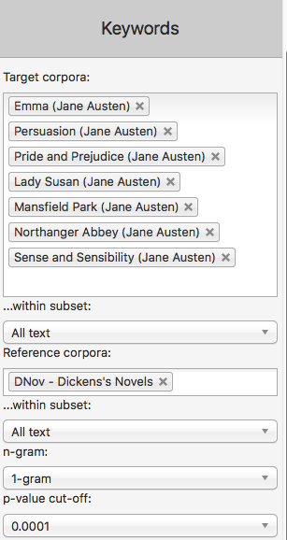
Figure 23: Keyword settings for Austen vs Dickens

- This will give you a list of keywords for Austen (in comparison with Dickens) down the left hand side, ordered by their degree of difference from the Dickens corpus.
- To find the keywords in Dickens, compared with Austen, simply reverse the choices you entered in the “Target” and “Reference corpora”.
- Compare the two keyword lists and try to find words that seem relevant to setting and atmosphere.

Table 4: Keywords for Austen vs Dickens and Dickens vs Austen
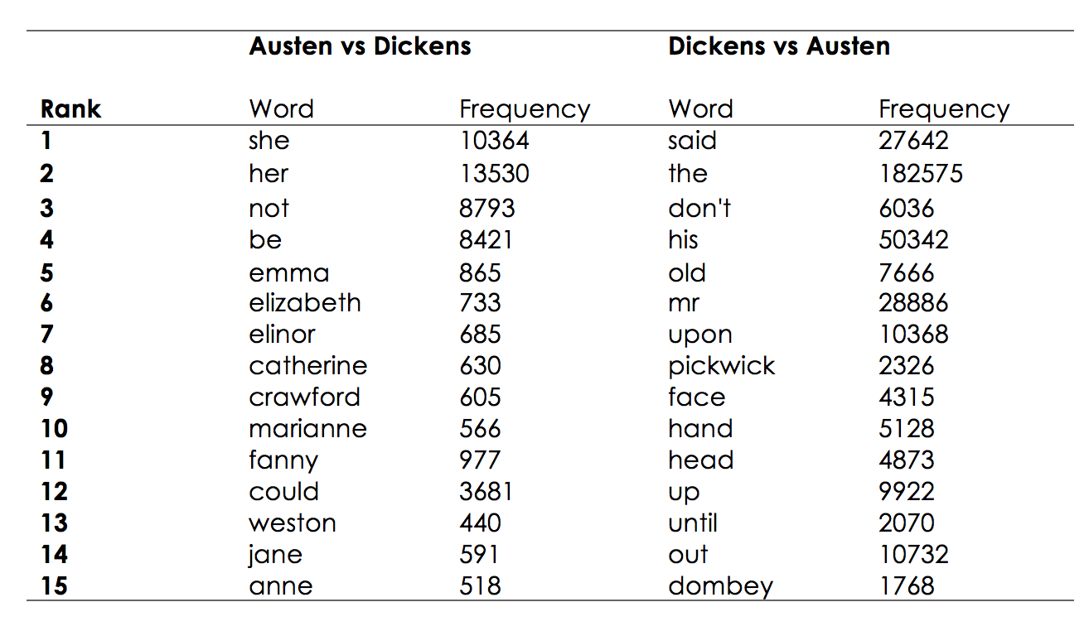
This table only lists the top 15 keywords for each comparison. However, this small selection already provides some useful pointers. In Austen, the female pronoun she and the possessive determiner her are relatively more frequent than in Dickens. In Dickens, his and Mr are relatively more frequent than in Austen. In Dickens we also find the body part nouns face, hand and head more often than in Austen.
As explained in the section on keywords in Part I of this Activity Book, a keyword comparison takes the absolute frequencies in a target text and compares them to the frequencies in the reference corpus, while taking the overall number of words in the corpus into account. From the keyword list we cannot always draw simple and direct conclusion; we will need to look at the words in context to assess why they come up as key. For example, we might ask ourselves whether there are simply more female protagonists in Austen, or whether certain books are female-focused, and so on. Or we might wonder whether there are specific books in Dickens where individual body parts are emphasised, or perhaps Dickens just refers to body parts more often overall. If he does, we can then explore why this might be the case, and how his techniques for characterisation and setting are different from other writers, such as Austen.
Clearly an understanding of keywords can help us to explore matters of genre and authorial style. Often, the keywords further down the frequency list are highly informative (usually, the names of characters are prominent towards the top, unsurprisingly). The following are a selection of keywords that you find as you go through the lists.
For Austen there are words like feelings, happiness, manners, behaviour, civility, conduct, pleasing, kindness – which seem to suggest themes around interpersonal relationships. Another set are: marry, marriage, marrying, invitation, dance, ball with can be seen to relate to romantic relationships.
For Dickens on the other hand, we have words like gentleman, boy that connect the male words from the top of the keywords list. Another connection to the top of the keyword list are body part nouns, like eyes, hands, but there are also very concrete objects and elements of settings, such as door, fire, light, glass, bed, wall, water and specific terms that relate to the city: streets, city, money, prison. These initial groups are only derived from going through the keyword list, but they already indicate differences between the two authors. The words, and groups of words, can be analysed in more detail by running concordances for them and relating them to specific themes. For example, fire appears as a keyword in A Christmas Carol, and a closer exploration of the passages with fire in them reveals an atmospheric and thematic pattern across the narrative (see Section 13 below).

Further reading
For more ideas on how to classify and categorize keywords see:
Mahlberg, M., & McIntyre, D. (2011). A case for corpus stylistics: Ian Fleming's Casino Royale. English Text Construction, 4(2), 204-227.

11. Exploring theme in The Sign of the Four
In this activity we will make use of the concordance and annotation tools to explore two themes in Arthur Conan Doyle’s 1890 novel featuring Sherlock Holmes, The Sign of the Four. We will look at justice and the role of women.

Activity 11.1 Justice
- Go to the CLiC Concordance tab (http://clic.bham.ac.uk/concordance).
- Select The Sign of the Four in the “Search the Corpora” box. You can start typing the book title and CLiC will autocomplete or you can scroll down to find it in the section entitled “ArTs – Additional Requested Texts”.
- Select the subset “Quotes”.
- Under “Search for terms”, type the word justice.

Who speaks about justice in the novel? Go through the concordance lines and check the speaker. (Remember – you can click on the graphic in the column “In bk.” to the right hand side in order to go to the concordance line in the full context of the book itself).
We can tag each line to keep track of who the speaker is in each case, as follows. In this example, there are not many speakers, but you can see how this technique would be very useful with a very large number of concordance lines or many more speakers.

Activity 11.2 Who speaks about justice?
- Carry on from step 4 of Activity 11.1 above.
- Click on “Manage tag columns” on the right side-panel and add a tag for each speaker that you can find. To do this, click on “Add new”, and a tag will appear in the box above labelled “new-tag”. Click on this label to highlight it, and then in the box below (headed “Rename selected tag column”) type, for example, holmes. Click anywhere in the blank space in the top box and the “new-tag” will change its name.
- Repeat for each speaker you can find, as shown in this screenshot.

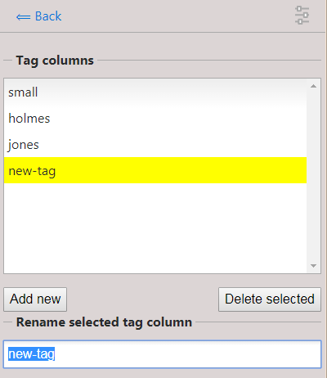
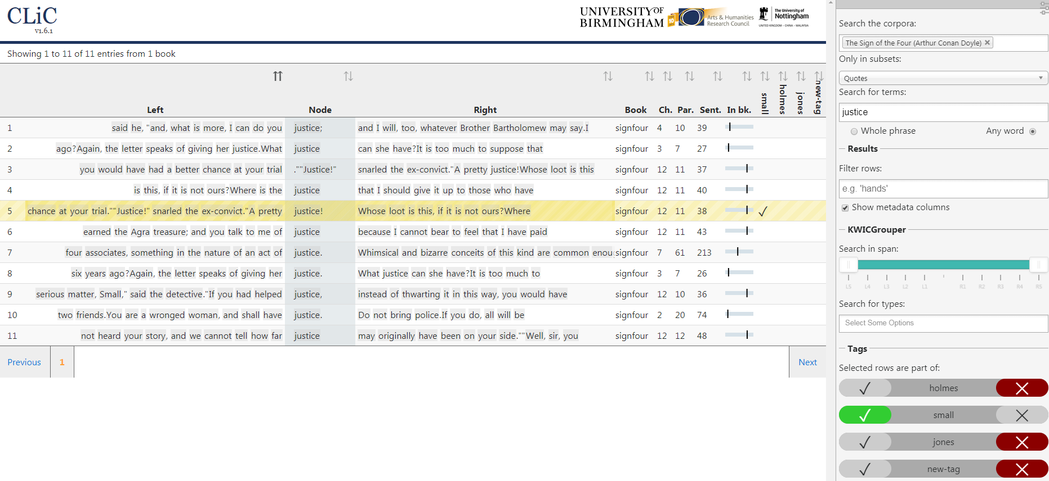
Figure 24: Creating and renaming new tags for annotation.

Figure 25: The procedure for annotating instances of justice for the character name
- When you have finished, click “⟸ Back” at the top of the grey panel to take you back to the Concordance column. You will see your tags listed at the bottom, and also listed to the right of “in bk.” for each concordance line.
- To tag each line with the right speaker, select the concordance line (by clicking on it) and press the tick in the tag menu as shown in the following screenshot. You will see a tick appear to the right of each line, under the selected speaker.

You will be able to see at a glance which character mentions the word justice the most. In this case, it is Sherlock Holmes, and then Jonathan Small. Again, this small simple example can be scaled up to search for similar terms across larger texts or corpora, and with many more characters.
It is worth drilling down into the chapter contexts to see whose justice Holmes and Small are talking about. You could repeat the activity so far with different terms from justice to explore other themes that preoccupy characters in the novel.

A simple way of exploring themes relating to gender representation in the novel can be undertaken as follows.

Activity 11.3 The role of women in Sherlock Holmes
- Start again. Go to the CLiC Concordance tab (http://clic.bham.ac.uk/concordance).
- Select The Sign of the Four in the “Search the Corpora” box, as before.
- Under “Search for terms”, type the words woman and women. Select the option “Any word” to search for both at once.
- Read through the concordance lines: how are women described?

You might notice that the concordance shows that the words woman and women often occur with adjectives in the ‘L1’ position (directly to the left of the search word) in The Sign of the Four. These adjectives relate to appearance (for example, attractive, be-diamonded, graceful, red-faced, slatternly, small). And of course the adjective wronged links back to the theme of justice. Some of these patterns suggest that women are weak objects of attraction (see the appearance words) and need help (“the shrill, broken whimpering of a frightened woman”).
Other possible themes for exploration include, for example, imperialism and the Victorian fear of foreign influences. It is always worth checking what themes other readers have noticed, either by consulting works of published literary criticism for scholarly material, or by searching for reading groups and social media responses more informally. Intuitions of such readers can be explored systematically using the CLiC tool.

Activity 11.4 Finding and exploring further themes
- Watch the BBC Bitesize video “Themes in The Sign of Four” at https://www.bbc.co.uk/education/guides/zx7mxnb/revision
- Choose another theme mentioned in the video and look for related words or phrases in the CLiC concordance tab, following the proecdures set out in the Activities above.

Further reading
“BBC Bitesize learner guides and class clips for The Sign of the Four”: https://www.bbc.co.uk/education/topics/zx8pycw
“The Sign of the Four – Big Ideas” – Teaching resources shared by Millie Frost (@MissMFrost on Twitter), shared with the #TeamEnglish Twitter community: https://www.dropbox.com/sh/s16vspfqod4ez6q/AADGsZoG0c1c2FxM8TGiT8I-a?dl=0

12. Character and structure in A Christmas Carol
The opening of a text is crucial for the creation of the fictional world. In this activity, we look at how a text can draw on conventional patterns to begin a story and how an opening chapter can use repetition to bring crucial elements of the fictional world into focus.

Activity 12.1 The opening of fairy tales
- Read the first two pages of A Christmas Carol up until the extract below. How does the phrase once upon a time function in the context of the first two pages?
- Begin by comparing the occurrence of once upon a time in A Christmas Carol to how it is used in ChiLit, 19C and DNov. You would do this by selecting these corpora in CLiC, and then search for the term once upon a time as a “Whole phrase”.

Once upon a time--of all the good days in the year, on Christmas Eve--old Scrooge sat busy in his counting-house. It was cold, bleak, biting weather: foggy withal: and he could hear the people in the court outside, go wheezing up and down, beating their hands upon their breasts, and stamping their feet upon the pavement stones to warm them. The city clocks had only just gone three, but it was quite dark already-- it had not been light all day--and candles were flaring in the windows of the neighbouring offices, like ruddy smears upon the palpable brown air. The fog came pouring in at every chink and keyhole, and was so dense without, that although the court was of the narrowest, the houses opposite were mere phantoms. To see the dingy cloud come drooping down, obscuring everything, one might have thought that Nature lived hard by, and was brewing on a large scale.
(A Christmas Carol, Charles Dickens, Chapter 1)

Below is a screen shot of the concordance search for once upon a time in ChiLit. Examples such as lines 10, 11, and 13 show how once upon a time is found at the very beginning of the book. This is also indicated by the last column, where the slider indicates the position in the text. Although line 17 looks as if there is text before the sentence with once upon a time, this text is a Wordsworth quotation, before the story of the Water-babies begins with “Once upon a time there was a little chimney-sweep, and his name was Tom.”

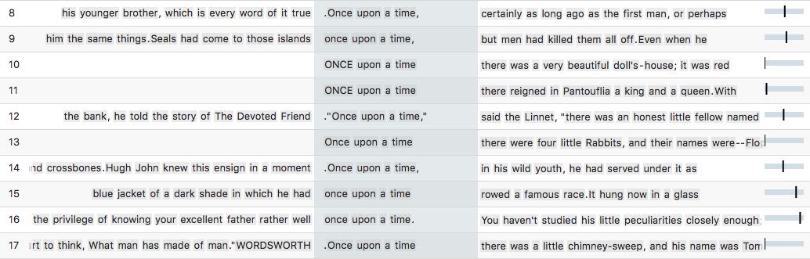
Figure 26: Sample of instances of once upon a time in the 19th Century Childrens Literature Corpus ChiLit

While today we recognize once upon a time as a typical beginning for a children’s story or a fairy tale, in the 19th century, the phrase could also be used as a more general time adverbial as in the example below:

"No, no; it's not so bad as that, my boy. I've better eyes than most people, and then I had the privilege of knowing your excellent father rather well once upon a time. You haven't studied his little peculiarities closely enough; but you'll improve. By the way, where _is_ your excellent father all this time?"
(Vice Versa, F. Anstey, Chapter 18)

Concordances for once upon a time in 19C and in DNov show that the phrase is used in neither of the two corpora to begin a text. It is used either as a general time adverbial as in the above example, or when a story is told at some point in the narrative. In A Christmas Carol, once upon a time appears two pages into the narrative. The first person narrator starts by talking about the fact that Marley is dead and by describing Scrooge as a miserly and unfeeling person. Both these points are extensively made. The fact that Marley is dead is restated, emphasized – “You will therefore permit me to repeat, emphatically, that Marley was dead as a door-nail” – and backed up with evidence – “The register of his burial was signed by the clergyman, the clerk, the undertaker, and the chief mourner”. Because Scrooge was Marley’s only friend, he is very clear about the fact Marley is dead – note the list of “sole executor, etc”. The narrator puts equal emphasis on the fact that Scrooge has a miserable and monotonous existence: see the list of squeezing, wrenching, grasping, etc. And he can’t be moved by anything: “External heat and cold had little influence on Scrooge.” Both points (Marley dead and Scrooge cold and unmoved by anything) are crucial preparation for the story that starts with once upon a time.
At the beginning of the story, important points are made that are linked back to in later parts of the text. Look at the extract below. In this passage, Scrooge sees the door-knocker as Marley’s face. The word knocker is repeated five times to help make the point. Also note how the door-nail from the beginning of the text (“Old Marley was as dead as a door-nail”), relates to “the screws and nuts that held the knocker on” in the last sentence of this extract.

Now, it is a fact, that there was nothing at all particular about the knocker on the door, except that it was very large. It is also a fact, that Scrooge had seen it, night and morning, during his whole residence in that place; also that Scrooge had as little of what is called fancy about him as any man in the city of London, even including--which is a bold word--the corporation, aldermen, and livery. Let it also be borne in mind that Scrooge had not bestowed one thought on Marley, since his last mention of his seven years' dead partner that afternoon. And then let any man explain to me, if he can, how it happened that Scrooge, having his key in the lock of the door, saw in the knocker, without its undergoing any intermediate process of change--not a knocker, but Marley's face.

Marley's face. It was not in impenetrable shadow as the other objects in the yard were, but had a dismal light about it, like a bad lobster in a dark cellar. It was not angry or ferocious, but looked at Scrooge as Marley used to look: with ghostly spectacles turned up on its ghostly forehead. The hair was curiously stirred, as if by breath or hot air; and, though the eyes were wide open, they were perfectly motionless. That, and its livid colour, made it horrible; but its horror seemed to be in spite of the face and beyond its control, rather than a part of its own expression.

As Scrooge looked fixedly at this phenomenon, it was a knocker again.

To say that he was not startled, or that his blood was not conscious of a terrible sensation to which it had been a stranger from infancy, would be untrue. But he put his hand upon the key he had relinquished, turned it sturdily, walked in, and lighted his candle.

He did pause, with a moment's irresolution, before he shut the door; and he did look cautiously behind it first, as if he half expected to be terrified with the sight of Marley's pigtail sticking out into the hall. But there was nothing on the back of the door, except the screws and nuts that held the knocker on, so he said "Pooh, pooh!" and closed it with a bang.
(A Christmas Carol, Charles Dickens, Chapter 1)

In A Christmas Carol, the word knocker appears 7 times overall. We have seen the first five occurrence in the extract above. The concordance in Figure 27 shows that there are two more occurrences which are both at the end of the book, in the final chapter.

The hand in which he wrote the address was not a steady one, but write it he did, somehow, and went down-stairs to open the street door, ready for the coming of the poulterer's man. As he stood there, waiting his arrival, the knocker caught his eye.

"I shall love it, as long as I live!" cried Scrooge, patting it with his hand. "I scarcely ever looked at it before. What an honest expression it has in its face! It's a wonderful knocker!--Here's the Turkey! Hallo! Whoop! How are you! Merry Christmas!"

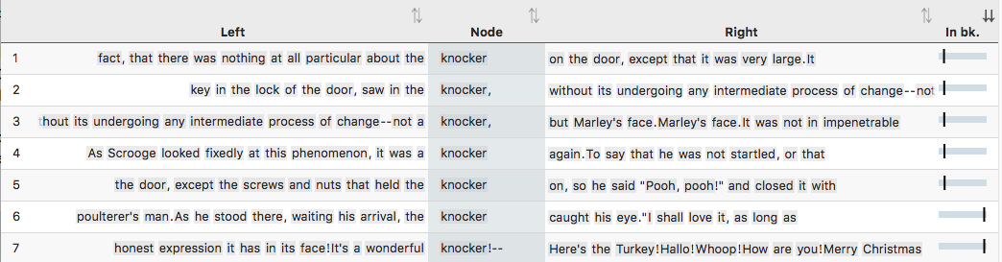
Figure 27: All 7 instances of knocker in A Christmas Carol

While the door-knocker supports the framing of the story, the word fire also appears at the beginning but runs more through the story.

Activity 12.2 Fire in A Christmas Carol
- Read the extract below and describe what fire means for Scrooge.

The door of Scrooge's counting-house was open that he might keep his eye upon his clerk, who in a dismal little cell beyond, a sort of tank, was copying letters. Scrooge had a very small fire, but the clerk's fire was so very much smaller that it looked like one coal. But he couldn't replenish it, for Scrooge kept the coal-box in his own room; and so surely as the clerk came in with the shovel, the master predicted that it would be necessary for them to part. Wherefore the clerk put on his white comforter, and tried to warm himself at the candle; in which effort, not being a man of a strong imagination, he failed.
(A Christmas Carol, Charles Dickens, Chapter 1)

- Go to http://clic.bham.ac.uk/concordance
- Run a concordance for fire in A Christmas Carol (you will find the text in the set of corpora titled ArTs – Additional Requested Texts, but you can also start typing the book title and CLiC will just autocomplete the search box).
- Notice (by looking at the distribution of locations under the “In bk.” column) that fire is evenly distributed across the text.
- Look at the different types of fire: large or small, strong or feeble, social or solitary, and note whose house each one is in.

13. The fireplace pose – texts and cultural context
This activity aims to make connections between textual patterns in the novels and social or cultural behavious and conventions in the real world. As most texts in CLiC were written in the 19th century, we focus on the cultural context of that period.
Section 12 above looked at the role of fire in A Christmas Carol and here we focus on a related topic: the so-called ‘fireplace pose’ in 19th century fiction. This pose has been identified in literature and other cultural material from the time, such as paintings; Barbara Korte describes this in her book on body language (Korte 1997: 212). Mahlberg (2013) has looked at textual patterns of the fireplace pose in Dickens’s novels and finds that the cluster with his back to the fire is particularly frequent. She explains that:

One of the reasons why it is men and not women who take up the fireplace pose may have been the difference in clothing. Floorlength skirts can easily catch fire. Perhaps even more importantly, the pose also relates to gender roles. The fireplace is a prominent area of the room and standing in front of it puts men in a prominent and powerful position. Women, in contrast, were required by propriety to take a sitting position (cf. Korte 1997: 212).
(Mahlberg 2013: 112)

In CLiC you can trace the textual patterns which describe how fictional characters sit or stand in front of the fire or look at it and compare the patterns found in Dickens with those of other authors.

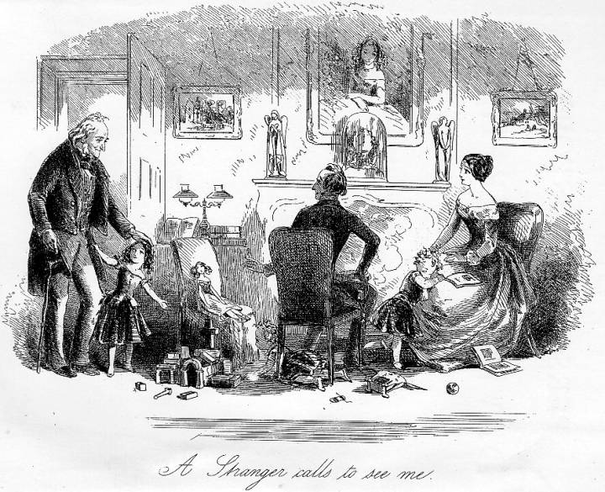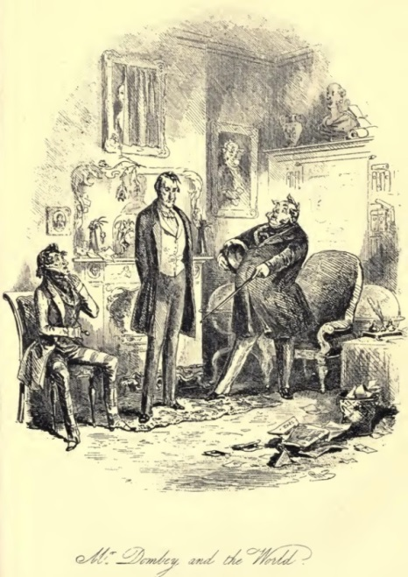
Figure 28: Images from David Copperfield (left, Chapter 63) and Dombey and Son, Chapter 51)
http://www.victorianweb.org/art/illustration/phiz/dc/40.html
https://www.gutenberg.org/files/821/821-h/images/0654.jpg

You can start with a simple concordance for the word fire and then look for particular patterns using the KWICGrouper.

Activity 13.1 The social importance of the fire-place
- Search for fire in DNov (Dickens’s Novels) in “All text”. This should give you over 1700 hits – too many to analyse in detail so that it’s best to use the KWICGrouper for narrowing down the search.
- Use the KWICGrouper and left-right sorting to search through the concordance. First set the “Search in span” from L5 to L1 by dragging the slider. Next “Search for types” by typing in back. Hit Return.
- You should see a highlighted set of concordance lines showing phrases such as back to the fire, like the one below.
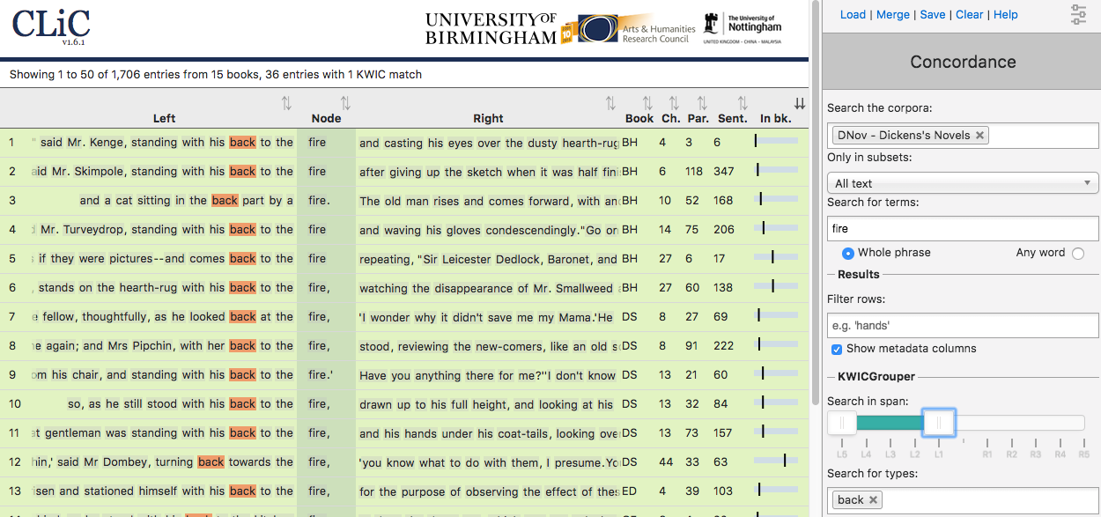
Figure 29: Sample concordance for back and fire in DNov
Can you find patterns of a fireplace pose similar to those described above? You could also explore the concordance further by adding more words to the KWICGrouper.
Activity 13.2 The fire-place pose in 19th century literature
- Open another browser tab and run the concordance search for fire on the other 19th century novels.
- Use the KWICGrouper again: are your observations on the fireplace pose patterns in the other 19th century novels similar to those in Dickens?

Further reading
Our guest post on the Programming Historian blog, explaining the use of the CLiC KWICGrouper with the example of the fireplace pose:
https://programminghistorian.org/posts/corpus-linguistics-in-action

14. Social protest writing: Hard Times and Oliver Twist
The character of Mrs Sparsit, in Dickens’s Hard Times, represents a fall in social class from the aristocracy after the failure of her marriage. She tries to maintain her former haughty demeanour, and comes across as dishonest and manipulative. We can easily explore some aspects of her characterisation by looking for her name and the narratorial descriptions that appear between chunks of her direct speech (‘suspensions’).

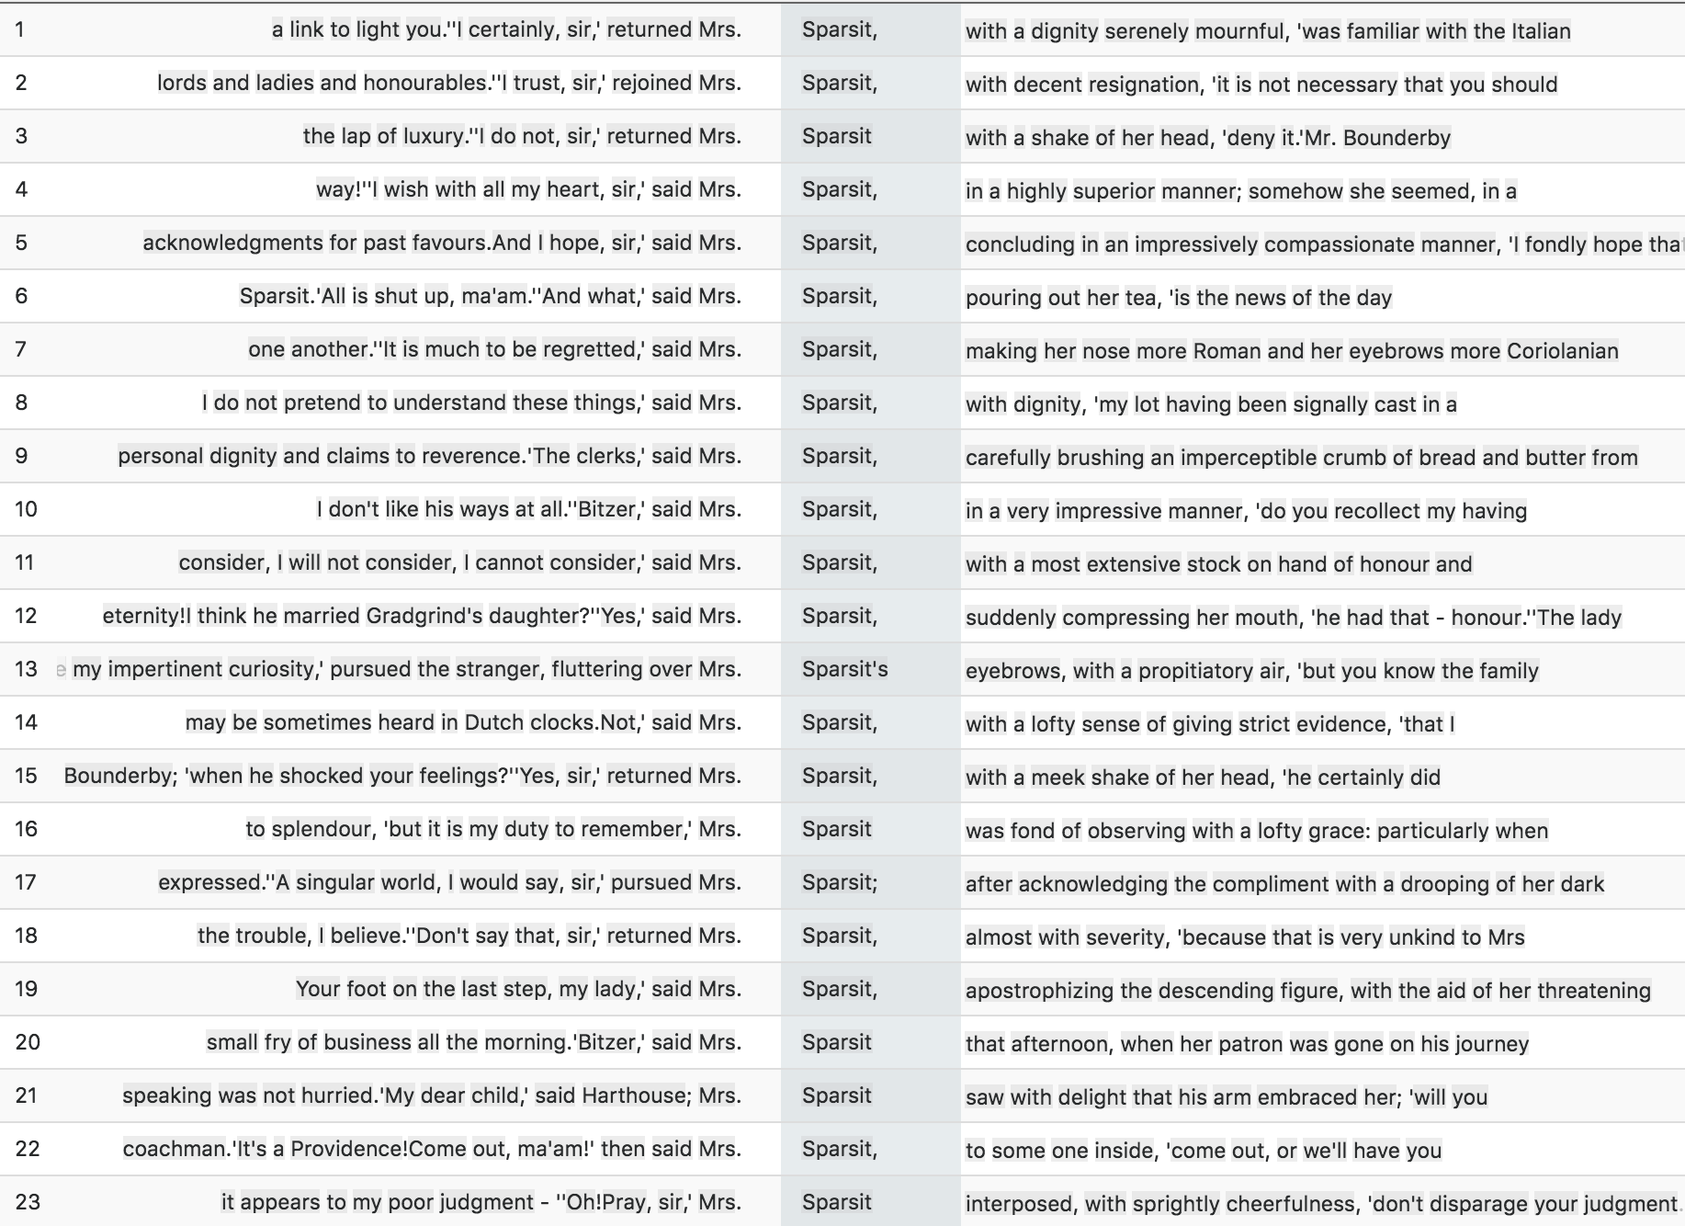
Figure 30: All 23 instances of Sparsit in long suspensions

Activity 14.1 Sparsit
- Go to the CLiC Concordance tab (http://clic.bham.ac.uk/concordance).
- Run a concordance in the DNov corpora for the term Sparsit. (Mrs Sparsit only appears in Hard Times so it is not necessary to select a specific novel).
- You should retrieve just under 300 concordance lines. In “Only in subsets”, select “Long suspensions” to find the narratorial description near her direct speech.
- What kind of character information can you get from these 23 suspensions?

The concordance in Figure 30 contains all the occurrences of Mrs Sparsit which you should retrieve when limiting the search to long suspensions. Notice how nearly all of the suspensions are interruptions of Mrs Sparsit’s own speech, as can be seen from the speech verbs (said Mrs. Sparsit, pursued Mrs. Sparsit, Mrs. Sparsit interposed). Another point that students may pick up is that the suspensions contain descriptions of Mrs. Sparsit’s body language and manner such as with a shake of her head, in a very impressive manner and in a highly superior manner

Activity 14.2 Oliver
- Now do the same but this time for the search term Oliver. Again, you can use DNov because there are no other “Olivers” in Dickens (apart from a single mention of “Oliver Cromwell” in The Old Curiosity Shop).
- You should retrieve over 800 concordance lines. In “Only in subsets”, select “Long suspensions” to find the narratorial description near direct speech.
- What kind of character information can you derive about Oliver from the suspensions?

Here is a sample concordance of some of your results.
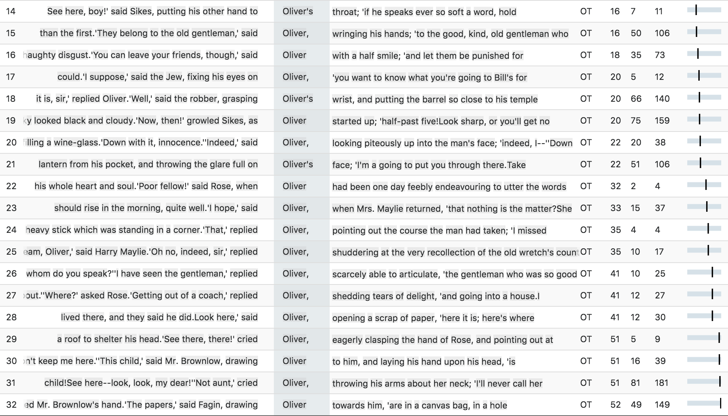
Figure 31: Sample of long suspensions containing Oliver

Notice how many of the phrases in these suspensions are concerned with intensity, physical action, coercion, or sinister body language. For comparison, run the same Activity with a different character, for example using the search term Sikes to bring up all of the suspensions around the evil character Bill Sikes. In his case, note how violent are the phrases associated with him.
Another possibility to approach this activity is to use the tag annotation feature. For an idea of how to do this, you can refer to the explanation of the user-defined tag feature in Part I, Section 7, which also makes use of this example.

15. Education, women and governesses in the 19th century
Following on from the very simple search for gender terms in Activity 11 above, we can explore further and more specific aspects of gender roles in 19th century fiction using CLiC. Young, educated women could find respectable work in upper middle class and landowning households as governesses for the family’s children. These positions occupied an uneasy location between being a servant and being part of the household, and as a consequence governesses were often isolated or in an ambivalent social position. These factors, of course, make the role an ideal one for literary fictional narrative.

Activity 15.1 The governess
- Watch the British Library video “The Governess” on Youtube (or search for “British Library” and “governess”.
- Summarise how the video describes the life of a governess in 19th century British society and literature. Can you think of any novels with a governess among the characters?

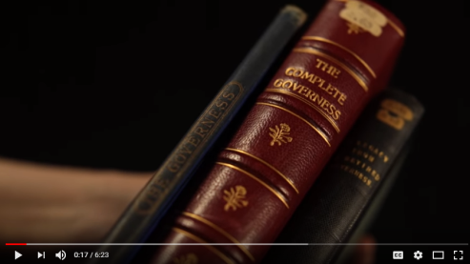
British Library – “The Governess”

https://www.youtube.com/watch?v=tlOkWIxqqWs

Examples of famous literary governesses include Rebecca Sharp in Thackeray’s Vanity Fair, Jane Eyre in the novel by Charlotte Brontë, Agnes Grey in Anne Brontë’s novel, Madame de la Rougierre in Le Fanu’s Uncle Silas, the unnamed governess in Henry James The Turn of the Screw, Miss Wade in Dickens’s Little Dorrit, Jane Fairfax in Jane Austen’s Emma, and many others. Given her interest in the grand country house and estate as the setting for several novels, Jane Austen’s writing features several instances of a governess as a significant character.

Activity 15.2 Austen’s governesses
- Go to the CLiC Concordance tab (http://clic.bham.ac.uk/concordance).
- Select novels by Jane Austen in the “Search the Corpora” box. You can start typing “Austen” and CLiC will show all of Austen’s novels which you then need to select one by one.
- Select the subset “All text”.
- Under “Search for terms”, type the word governess.

You should get a concordance that looks like this:

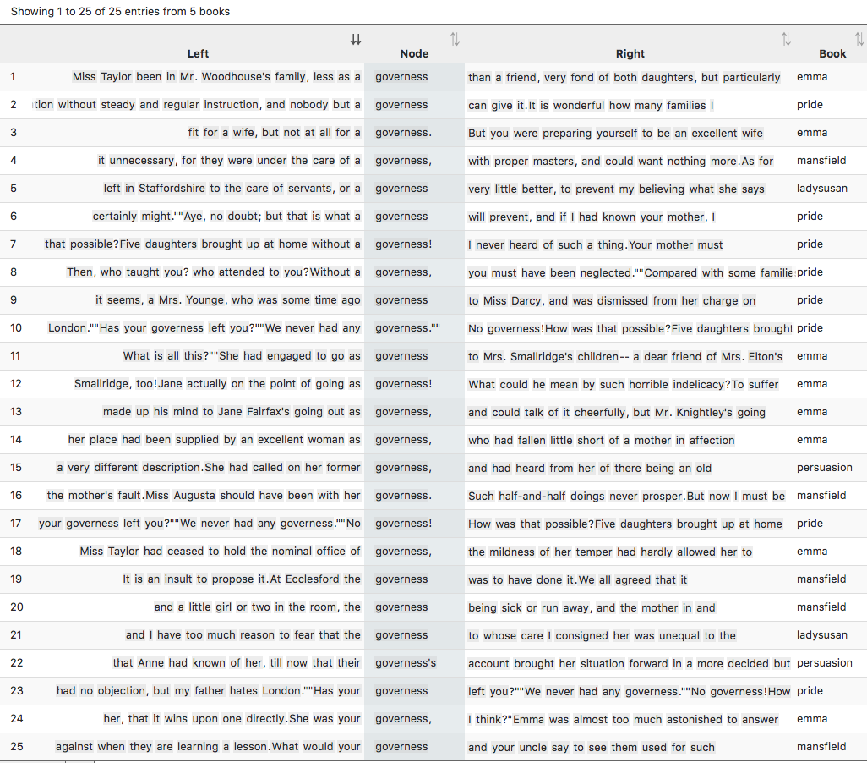
Figure 32: All 25 instances of governess in Jane Austen’s novels

This shows all instances of governess in Jane Austen’s novels. Look closely at the concordance lines to get a swift overview of how governesses are described and their position in society. Again, clicking on the “In bk.” column to the right of a line will give you the full context of the line in its original passage.

Activity 15.3 The social status of governesses in Pride and Prejudice
- Following on from step 6 above, find the line that includes the sentence “Has your governess left you?” You will see to the right of the concordance line that this is from “pride” (Pride and Prejudice), chapter 29, paragraph 26, and it is sentence 71. Click on the “in bk.” graphic to the right, and CLiC will open the passage concerned from the novel.
- The short passage contains a wealth of evidence for the status of governesses and the attitudes of families towards them. What does it telll you about families who employed a governess and those that didn’t?

Here is the passage.

"Has your governess left you?"
"We never had any governess."
"No governess! How was that possible? Five daughters brought up at home without a governess! I never heard of such a thing. Your mother must have been quite a slave to your education."
Elizabeth could hardly help smiling as she assured her that had not been the case.
"Then, who taught you? who attended to you? Without a governess, you must have been neglected."
"Compared with some families, I believe we were; but such of us as wished to learn never wanted the means. We were always encouraged to read, and had all the masters that were necessary. Those who chose to be idle, certainly might."
"Aye, no doubt; but that is what a governess will prevent, and if I had known your mother, I should have advised her most strenuously to engage one.I always say that nothing is to be done in education without steady and regular instruction, and nobody but a governess can give it. It is wonderful how many families I have been the means of supplying in that way. I am always glad to get a young person well placed out. …"
(Jane Austen, Pride and Prejudice, Chapter 29)

Note that it is also important to frame these comments by noticing whose views are being expressed. In this passage, the character Lady Catherine is allowed almost to speak for herself: her speech is even largely free of the narrator adding reporting clauses like she said. Elsewhere in the novel, the narrator gives opinions about governesses directly, and sometimes a character’s perspective is blended with or filtered through the narratorial content (as ‘Free Indirect Discourse’). This happens in the narrated paragraph just above the passage excerpted here from Chapter 29. Go and read through it in the CLiC context page (you can find it from the CLiC table of contents at clic.bham.ac.uk under Pride and Prejudice). You can see Austen using her narrator to provide characterisation of Lady Catherine in the manner in which she is presented, before she speaks.
CLiC includes a section of corpora of “ChiLit – 19th Century Children’s Literature”, which you can find in the “Search the corpora” box. Scroll down to find individual novels, such as Frances Hodgson Burnett’s The Secret Garden.

Activity 15.4 Children’s feelings about governesses
- Start again by going to the CLiC Concordance tab (http://clic.bham.ac.uk/concordance).
- Find “The Secret Garden” in the “Search the corpora” box, and select it.
- Search in “All text” for the term governess.
- You should find 8 examples.
- Explore their contexts by clicking on the graphic “In bk.” for each line.

The line containing the speech, “‘I don’t want a governess’, said Mary sharply”, occurs in the following passage.

"Why, our Dickon's eyes nearly started out o' his head, they got that round," answered Martha. "But mother, she was put out about your seemin' to be all by yourself like. She said, 'Hasn't Mr. Craven got no governess for her, nor no nurse?' and I said, 'No, he hasn't, though Mrs. Medlock says he will when he thinks of it, but she says he mayn't think of it for two or three years.'"
"I don't want a governess," said Mary sharply.
"But mother says you ought to be learnin' your book by this time an' you ought to have a woman to look after you, an' she says: 'Now, Martha, you just think how you'd feel yourself, in a big place like that, wanderin' about all alone, an' no mother. You do your best to cheer her up,' she says, an' I said I would."
(Frances Hodgson Burnett, The Secret Garden, Chapter 8)

What advantages do the adults see in getting a governess for Mary? And what does Mary think about it?

Activity 15.5 Broadening the exploration
- Choose one of the following corpora in CLiC from the Concordance tab (http://clic.bham.ac.uk/concordance):
  - Dickens’s Novels (DNov)
  - The 19th Century Reference Corpus (19C)
  - The 19th Century Children’s Literature Corpus (ChiLit)

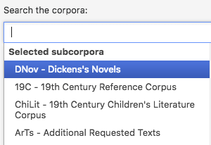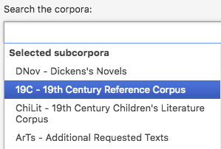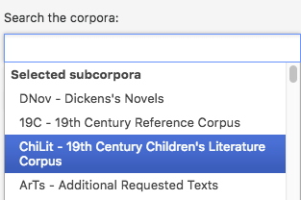
Figure 33: Choosing corpora

- Run a concordance for governess in the chosen corpus.
- Go through the concordance and try to find examples for at least one of the following questions:
  - What examples can you find for the points mentioned in the British Library video, in Activity 15.1 above, about the tension that a governess would have felt in the 19th century, being neither part of the family nor of the servants?
  - Which children do the governesses look after? What does this tell you about childhood in the 19th century?
  - What is the social background of the governesses? Why do they choose the job?

Further reading
“Orphans in fiction” – British Library
https://www.bl.uk/romantics-and-victorians/articles/orphans-in-fiction

16. Growing up in Great Expectations
If governesses largely came from the ranks of educated middle class young women, the situation of less fortunate youngsters in 19th century fiction was more precarious. The social and economic circumstances of the poor and destitute, orphans, the disabled, disinherited and oppressed were all highly productive source material for 19th century writers in particular. In Dickens’s Great Expectations, the narrative follows the protagonist Pip, an orphan, as he grows up and narrates his own story from the viewpoint of being an adult.
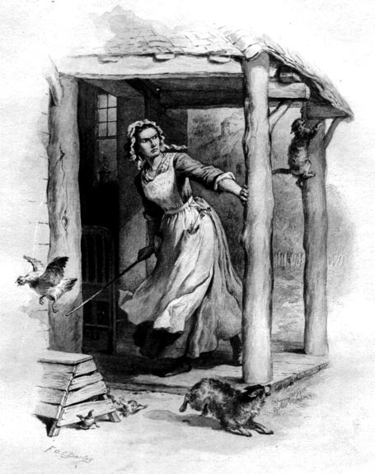
Figure 34: Mrs. Gargery on the Ram-page, illustration by Felix O.C. Darley (1861)
(scanned by George P. Landlow for the Victorian Web, http://www.victorianweb.org/art/illustration/darley/1.html )

In a striking phrase, Pip describes how he was “brought up by hand’ by his sister. Let’s explore this phrase.

Activity 16.1 Parenting in Great Expectations
- Run a concordance with Great Expectations selected, searching for the phrase up by hand. This will cover variations such as brought/bringing (you/me) up by hand.
- Remember to Search for “Whole phrase” here, rather than “Any word”.
- Hit return to show 14 examples.

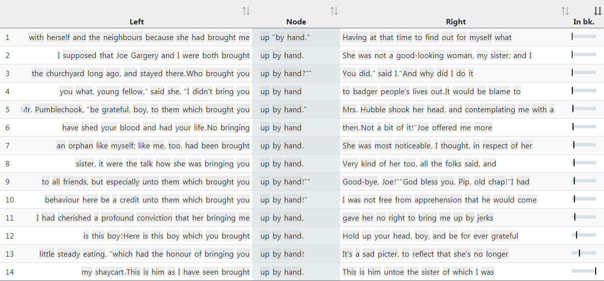

Consider from these concordance lines who uses the phrase brought up by hand or its equivalents. What is the context in which it is used? Click on the column for “In bk.” to see the passage in which the concordance lines occurs. What does this tell you about Pip’s experiences of parenting and guardianship while growing up?
In Geat Expectations, Pip is constantly being told to be thankful, and yet he feels regret. We can explore these not only by searching for these words themselves, but by searching also for their synonyms – these will give us a set of associated words for the ‘semantic fields’ of gratitude and regretfulness, respectively. CLiC makes this sort of search easy.

Activity 16.2 Gratitude and regret in Great Expectations
- Start a Concordance on Great Expectations, focusing in the subsets only on “Non-quotes”.
- In the “Search for terms” box, type grateful gracious thankful with spaces but no punctuation. You can search a thesaurus for synonyms of gratitude.
- Remember to highlight the button next to “Any word”.
- Read through the concordance lines that are produced.
- You can repeat this procedure, replaing the Search terms with remorse remorseful guilt regret, to produce a comparable concordance.

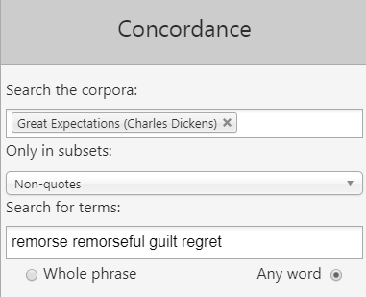
Figure 35: Searching for several words in the same concordance by checking “Any word”

The Concordances below show results for the semantic fields of gratitude and reget across the novel.

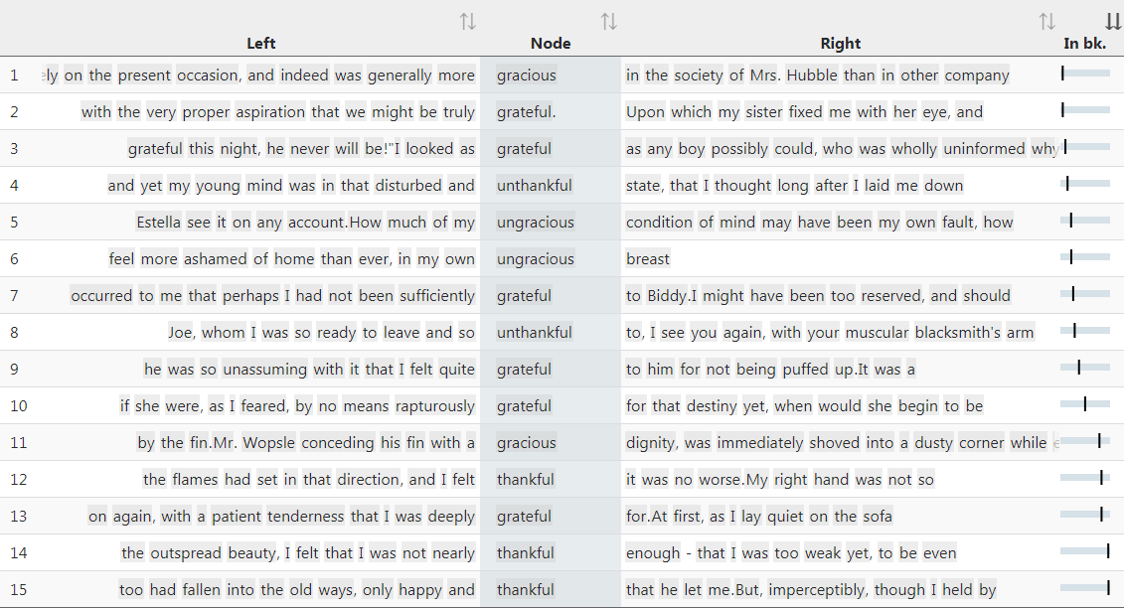
Figure 36: Examples of being (un)grateful in Great Expectations.

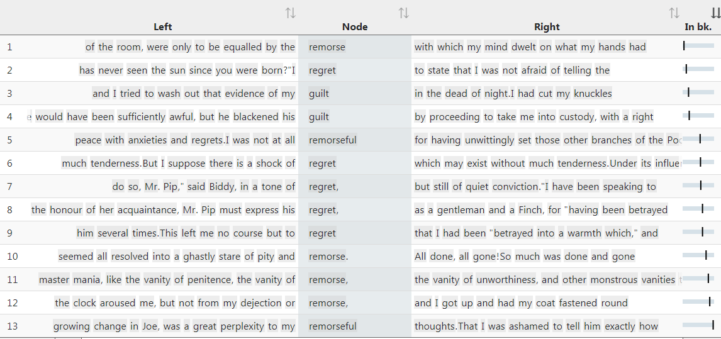
Figure 37: Examples of being (un)grateful in Great Expectations.

Which lines are referring to Pip’s feelings? Why is he feeling like this?

The lines are ordered by occurrence in the book so that you can trace them in the sequence of the plot. The whole story is narrated by Pip when he is older. Can you see any development in Pip’s self-perception?

Further Reading
BBC Bitesize Great Expectations – “Growing up”
https://www.bbc.co.uk/education/guides/zy3r4wx/revision/3

17. Fictional and real speech in Jane Austen and the 19C
In most literary fiction, even where dialect or pronunciation is imitated, the speech of characters does not accurately equal the hesitancy, non-fluency, and fragmented nature of actual real speech. Instead, speech is used for characterisation, for narrative dynamic, for dramatic intensity, and for symbolic and thematic purposes.
This section examines some patterns in fictional speech and looks at how they overlap, or not, with patterns in real spoken language.
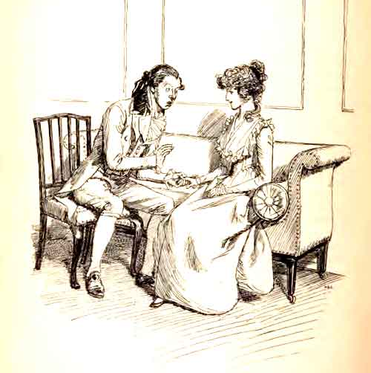
Figure 38: “Of one thing I may assure you”, Illustration by Hugh Thomson (1902) http://www.gutenberg.org/ebooks/21839

Activity 17.1 Speech in the 19th Century Reference Corpus (19C)
- Look at the following list of the 15 most frequent speech clusters in the 19C, a corpus within CLiC containing 29 novels from the 19th century.

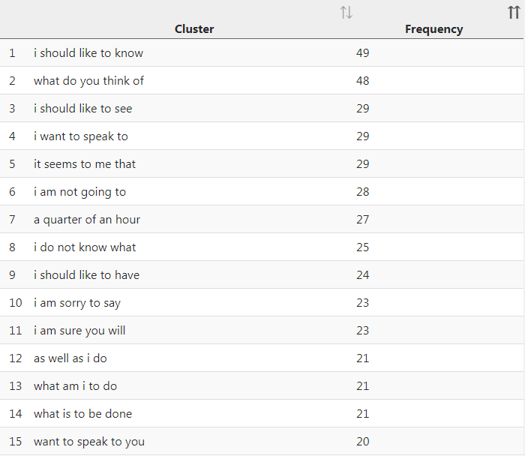
Figure 39: The 15 most frequent speech clusters in the 19C
- In which contexts do you expect the clusters to be used? Categorise the clusters according to their ‘function’ (purpose or how the character uses it).
- Do we use any of the clusters in real spoken language nowadays? How?

Note the element of polite discourse that flavours many of these phrases. If you run a few of these phrases through a concordance in CLiC, what can you discover about the characters or narratior who uses them?
Activity 17.2 Comparing it seems to me that then and now
- Compare the concordance lines of it seems to me that in the 19C novels and the authentic spoken language data from the British National Corpus below.
- Can you see any similarities and differences in the form (how the text is presented) and the function of the cluster?

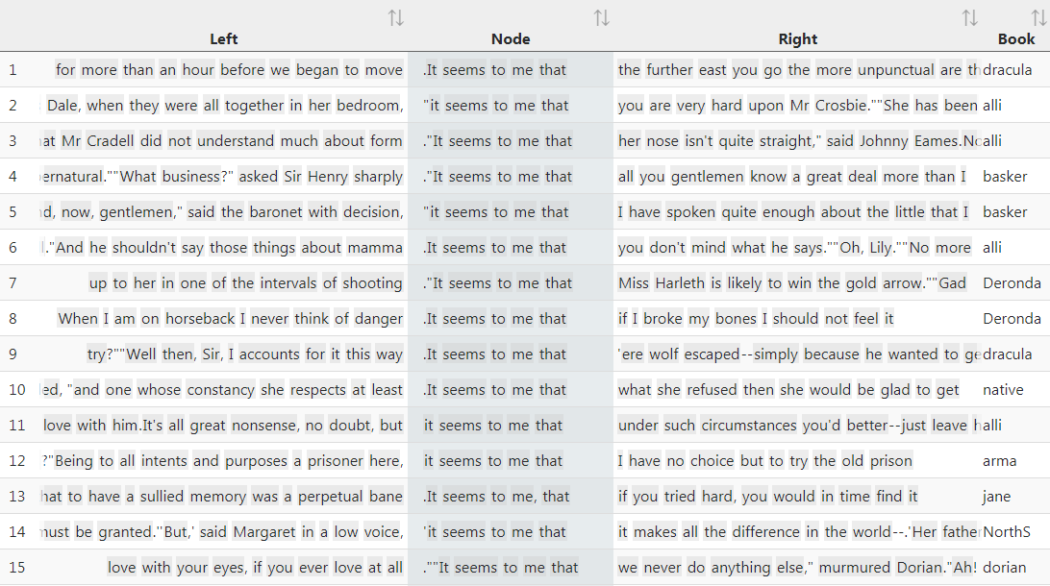
Figure 40: 15 examples of it seems to me that in the 19C

1 | . Mr [gap:name] ? [unclear] | it seems to me that | often , especially with this
2 | free choice . Yes . | It seems to me that | she 's also saying ,
3 | reference to those policies , | it seems to me that | erm the references to in
4 | all the factors . So | it seems to me that | these were a set of
5 | ahead , actually goes . | It seems to me that | all that we would be
6 | to look at and again | it seems to me that | it ought to be a
7 | about the art public ? | It seems to me that | ultimately artists must be successful
8 | you in six months . | It seems to me that | would be a real pain
9 | father are one . And | it seems to me that | that oneness , that that
10 | some sort , erm and | it seems to me that | the established Greater York erm
11 | the teacher might recognise . | It seems to me that | another problem , as far
12 | , agreed before , and | it seems to me that | there 's been some re-thinking
13 | absolutely made our evening . | It seems to me that | that attention to the moment
14 | expect you to pay . | It seems to me that | the trade unions are welcomed
15 | can be discarded . So | it seems to me that | the existence of death ,
Figure 41: 15 examples of it seems to me that in the British National Corpus (BNC) Spoken component, a collection of authentic spoken language from the late 20th century.
There are very many conversations and examples of direct speech and other speech presentation types in the novels of Jane Austen. Indeed, much of the sense of irony across her writing can be located in the transitions and tensions between different people speaking in different characteristic styles.

Activity 17.3 Speech in Jane Austen’s novels
- Go through the list below of the 15 most frequent clusters in quotations in Austen’s novels.
- Compare the clusters to those from the more general corpus of 19th century novels, the 19C, given in Activity 17.1 above. Do the lists overlap?
- In what contexts and with what function do you expect them to be used?

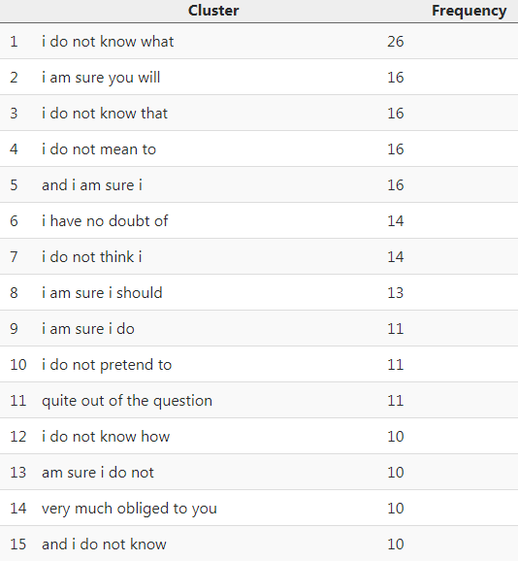 | 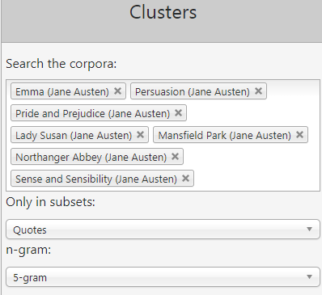

Figure 42: The most frequent speech clusters in Austen’s novels and the settings used to find them
- Read through the concordances in Figure 43 and Figure 44. Do the examples confirm your expectations for these two clusters?
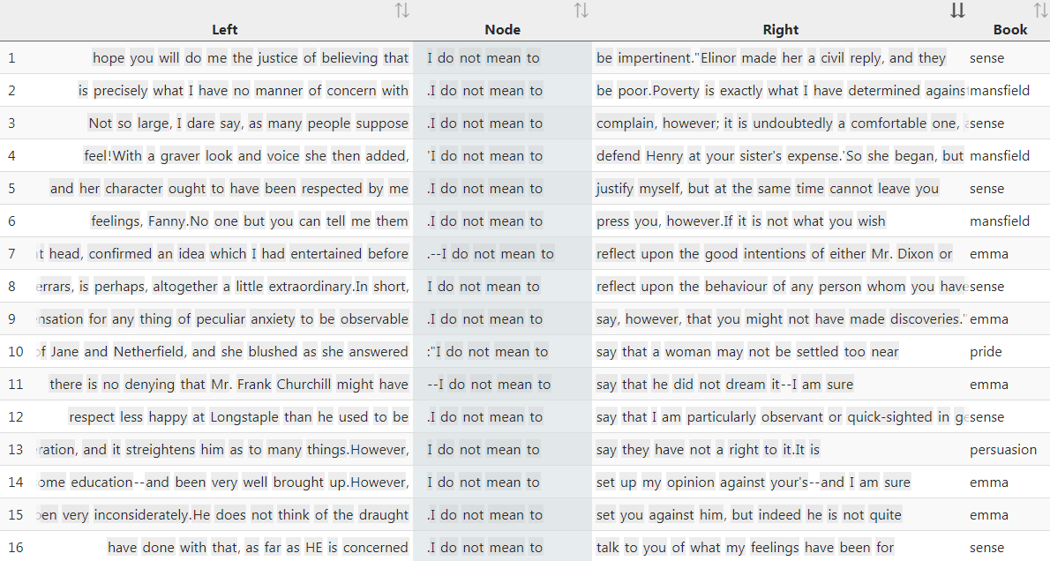
Figure 43: All 16 instances of I do not mean to in Austen’s novels
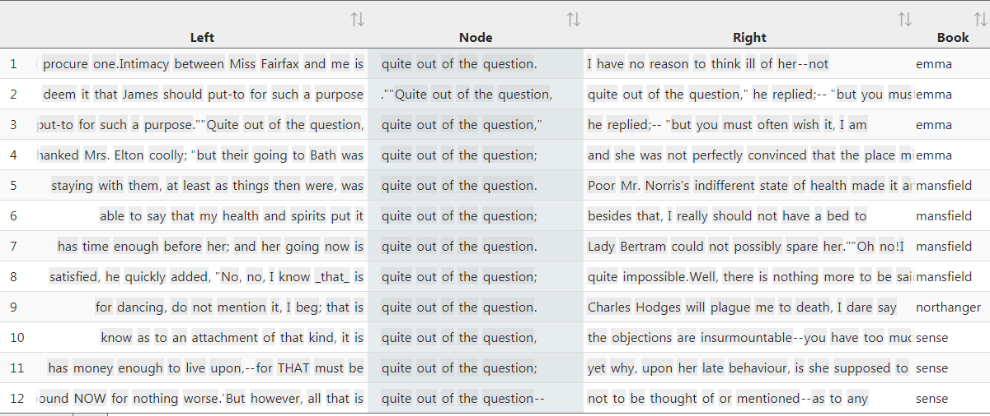
Figure 44: All 15 instances of quite out of the question in Austen’s novels
Students may pick up that both I do not mean to and quite out of the question are used in dialogue to negotiate opinions. I do not mean to also tends to be used as a hedge for politeness. Note that it is sometimes followed by however. Students can explore the context of these phrases by running the concordance themselves in Austen’s novels and exploring the chapter view via the “in bk.” button.

Activity 17.4 The speech of Austen’s characters
- Go to the CLiC concordance tab (http://clic.bham.ac.uk/concordance?).
- Type Austen into the corpora box and select each of Austen’s novels.
- Choose the subset “Quotes”.
- Search for one more cluster from the cluster lists in 17.1 and 17.3 above. How is it used in context?

Activity 17.5 Speech of Austen characters compared with Austen’s narrator
- Go to the CLiC Clusters tab (http://clic.bham.ac.uk/clusters?).
- Type “Austen” into the corpora box and select each of Austen’s novels.
- Now choose the subset “Non-quotes” instead for narrated text.
- How does the list of non-quote clusters differ from the quote clusters?

Here you are comparing the literary imitation of characters’ speech (in 17.4) with the style of the narrating persona (in 17.5). Note how they are different, signalling both a difference between represented speech and writing, and differences in the stylistic character of people in the novel and the narrator.

Resources and references
The CLiC project website
We regularly update our website (http://www.birmingham.ac.uk/clic), so do check back for forthcoming resources and news.

References
Cheng, W. (2012). Exploring Corpus Linguistics. Language in Action. London: Routledge.
Flowerdew, L. (2012). Corpora and Language Education. Basingstoke: Palgrave Macmillan.
Giovanelli, M., A. Macrae, F. Titjen & I. Cushing (Eds.) (2015). English Language and Literature. A/AS Level for AQA Student Book. Cambridge: CUP.
Korte, B. (1997). Body Language in Literature. Toronto: University of Toronto Press.
Lindquist, H. (2009). Corpus Linguistics and the Description of English. Edinburgh: EUP.
Mahlberg, M., Stockwell, P., Joode, J. de, Smith, C., & O’Donnell, M. B. (2016). CLiC Dickens: novel uses of concordances for the integration of corpus stylistics and cognitive poetics. Corpora, 11(3), 433–463. (PDF available from https://doi.org/10.3366/cor.2016.0102)
Mahlberg, M. & Stockwell, P. (2016). Point and CLiC: teaching literature with corpus stylistic tools, in M. Burke et al. (eds.) Scientific Approaches to Literature in Learning Environments (pp. 251–267). Amsterdam: John Benjamins. (PDF available from http://www.academia.edu/31169469/Point_and_CLiC_Teaching_literature_with_corpus_stylistic_tools)
Mahlberg, M. (2016). Corpus Stylistics. In V. Sotirova (ed.) The Bloomsbury Companion to Stylistics (pp. 139-156). London & New York: Bloomsbury.
Mahlberg, M. (2013). Corpus Stylistics and Dickens’s Fiction. New York & London: Routledge.
Mahlberg, M., Smith, C., & Preston, S. (2013). Phrases in literary contexts: Patterns and distributions of suspensions in Dickens’s novels. International Journal of Corpus Linguistics, 18(1), 35-56. (PDF available from http://www.jbe-platform.com/content/journals/10.1075/ijcl.18.1.05mah?)
Mahlberg, M., & McIntyre, D. (2011). A case for corpus stylistics: Ian Fleming's Casino Royale. English Text Construction, 4(2), 204-227.
McEnery, T. & A. Hardie, (2012). Corpus Linguistics. Cambridge: CUP.
Stockwell, P. (2009) Texture: A Cognitive Aesthetics of Reading. Edinburgh: Edinburgh University Press.
Stockwell, P & Mahlberg, M. (2015). Mind-modelling with corpus stylistics in David Copperfield, Language and Literature, 24(2), 129-147. (PDF available from http://journals.sagepub.com/doi/abs/10.1177/0963947015576168).

Appendix 1: Overview of CLiC texts listed in AQA, Edexcel and OCR A-Level / GCSE specifications
Author | Title | AQA GCSE Eng Lit (8702) | AQA AS Lang Lit (7706) | AQA A-Level Lang Lit (7707) | AQA AS Eng Lit A (7711) | AQA A-Level Eng Lit A (7712) | AQA AS Eng Lit B (7716) | AQA A-Level Eng Lit B2 (7717) | OCR GCSE Eng Lit (J352) | OCR AS Eng Lit (H072) | OCR A Level Eng Lit (H472) | OCR AS Lang Lit (H074) | OCR A-Level Lang Lit (H474) | Edexcel GCSE Eng Lit | Edexcel AS Lang Lit | Edexcel A-Level Lang Lit | Edexcel AS Eng Lit | Edexcel A-Level Eng Lit | Total
Jane Austen | Emma |  |  |  |  |  | ✓ | ✓ |  |  |  |  |  |  |  |  |  |  | 2
Jane Austen | Mansfield Park |  |  |  |  | ✓ |  |  |  |  |  |  |  |  |  |  |  |  | 1
Jane Austen | Northanger Abbey |  |  |  |  | ✓ |  |  |  |  |  |  |  |  |  |  |  |  | 1
Jane Austen | Persuasion |  |  |  | ✓ | ✓ |  |  |  |  |  |  |  |  |  |  |  |  | 2
Jane Austen | Pride and Prejudice | ✓ |  |  |  |  |  |  | ✓ |  |  |  |  | ✓ |  |  |  |  | 3
Jane Austen | Sense and Sensibility |  |  |  |  |  |  |  |  |  | ✓ |  |  |  |  |  |  |  | 1
Mary Elizabeth Braddon | Lady Audley's Secret |  |  |  |  |  |  |  |  |  |  |  |  |  |  |  | ✓ | ✓ | 2
Anne Brontë | The Tenant of Wildfell Hall |  |  |  |  | ✓ |  |  |  |  |  |  |  |  |  |  |  |  | 1
Charlotte Brontë | Jane Eyre | ✓ |  |  | ✓ | ✓ |  |  | ✓ |  | ✓ | ✓ | ✓ | ✓ |  |  |  |  | 8
Emily Brontë | Wuthering Heights |  |  |  | ✓ | ✓ |  |  |  |  |  |  |  |  | ✓ | ✓ | ✓ | ✓ | 6
Kate Chopin | The Awakening |  |  |  | ✓ | ✓ |  |  |  |  |  |  |  |  |  |  |  |  | 2
Wilkie Collins | Moonstone |  |  |  |  | ✓ |  |  |  |  |  |  |  |  |  |  | ✓ | ✓ | 3
Wilkie Collins | The Woman in White |  |  |  |  | ✓ |  |  |  |  |  |  |  |  |  |  |  |  | 1
Joseph Conrad | Heart of Darkness |  |  |  |  |  |  |  |  |  |  |  |  |  |  |  | ✓ | ✓ | 2
Charles Dickens | A Christmas Carol | ✓ |  |  |  |  |  |  |  |  |  |  |  | ✓ |  |  |  |  | 2
Charles Dickens | Great Expectations | ✓ |  |  |  |  |  |  | ✓ |  |  |  |  | ✓ | ✓ | ✓ |  |  | 5
Charles Dickens | Hard Times |  |  |  |  | ✓ |  | ✓ |  |  |  |  |  |  |  |  | ✓ | ✓ | 4
Charles Dickens | Oliver Twist |  |  |  |  |  |  | ✓ |  |  |  |  |  |  |  |  |  |  | 1
Sir Arthur Conan Doyle | The Sign of the Four | ✓ |  |  |  |  |  |  |  |  |  |  |  |  |  |  |  |  | 1
George Eliot | Silas Marner |  |  |  |  |  |  |  |  |  |  |  |  | ✓ |  |  |  |  | 1
George Eliot | The Mill on the Floss |  |  |  | ✓ | ✓ |  |  |  |  |  |  |  |  |  |  |  |  | 2
George Eliot | Middlemarch |  |  |  |  | ✓ |  |  |  |  |  |  |  |  |  |  |  |  | 1
E. M. Forster | A Room with a View |  |  |  | ✓ | ✓ |  |  |  |  |  |  |  |  | ✓ | ✓ |  |  | 4
Elizabeth Gaskell | North and South |  |  |  |  | ✓ |  |  |  |  |  |  |  |  |  |  |  |  | 1
Charlotte Perkins Gilman | The Yellow Wallpaper |  |  |  |  | ✓ |  |  |  |  |  |  |  |  |  |  |  |  | 1
Thomas Hardy | Tess of d'Urbervilles |  |  |  | ✓ | ✓ | ✓ | ✓ |  |  | ✓ |  |  |  | ✓ | ✓ | ✓ | ✓ | 9
Henry James | The Portrait of a Lady |  |  |  |  |  |  |  |  |  | ✓ |  |  |  |  |  |  |  | 1
Henry James | What Maisie Knew |  |  |  |  |  |  |  |  |  |  |  |  |  |  |  | ✓ | ✓ | 2
D. H. Lawrence | Women in Love |  |  |  |  |  |  |  |  |  | ✓ |  |  |  |  |  |  |  | 1
Solomon Northup | Twelve Years a Slave |  |  |  |  |  |  |  |  |  |  | ✓ | ✓ |  |  |  |  |  | 2
Mary Shelley | Frankenstein | ✓ | ✓ | ✓ |  | ✓ |  |  |  |  | ✓ |  |  | ✓ |  |  | ✓ | ✓ | 8
Robert Louis Stevenson | The Strange Case of Dr Jekyll and Mr Hyde | ✓ |  |  |  |  |  |  | ✓ |  |  |  |  | ✓ |  |  |  |  | 3
Bram Stoker | Dracula |  | ✓ | ✓ |  |  |  |  |  |  | ✓ |  |  |  | ✓ | ✓ | ✓ | ✓ | 7
William Makepeace Thackeray | Vanity Fair |  |  |  |  | ✓ |  |  |  |  |  |  |  |  |  |  |  |  | 1
Mark Twain | The Adventures of Huckleberry Finn |  |  |  |  |  |  |  |  |  | ✓ |  |  |  |  |  | ✓ | ✓ | 3
H. G. Wells | The War of the Worlds |  |  |  |  |  |  |  | ✓ |  |  |  |  |  |  |  | ✓ | ✓ | 3
Rebecca West | The Return of the Soldier |  |  |  |  | ✓ |  |  |  |  |  |  |  |  |  |  |  |  | 1
Oscar Wilde | The Picture of Dorian Gray |  |  |  |  | ✓ |  |  |  |  | ✓ |  |  |  |  |  | ✓ | ✓ | 4

Appendix 2: Corpus tools
CLiC –  the main focus of the  CLiC Activity Book    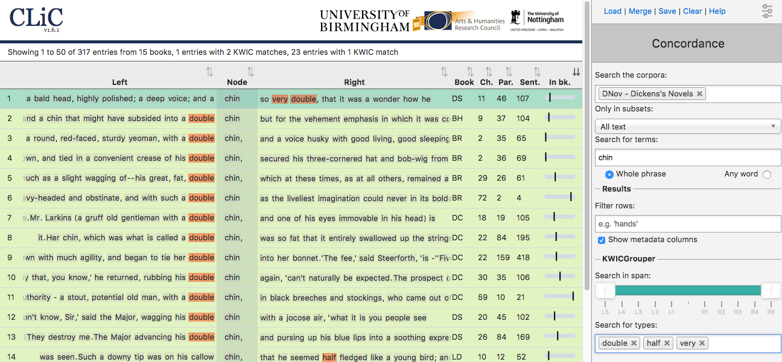 | - Web app that provides access to Dickens’s novels 138 novels in total, mainly from the 19th century:  - DNov (Dickens’s 15 novels)  - 19C (19th Century Reference Corpus)  - ChiLit (19th Century Children’s Literature)  - ArTs (Additionally Requested Texts)  - No registration or download necessary  - Access via clic.bham.ac.uk  - Provides basic corpus linguistic functionality + specific features for literary analysis: the ‘KWICGrouper’ for finding patterns in concordances and the function to compare subsets of texts (quotes, non-quotes, suspensions)  - Watch the KWICGrouper video tutorial at http://www.birmingham.ac.uk/schools/edacs/departments/englishlanguage/news/2017/kwicgrouper.aspx
AntConc  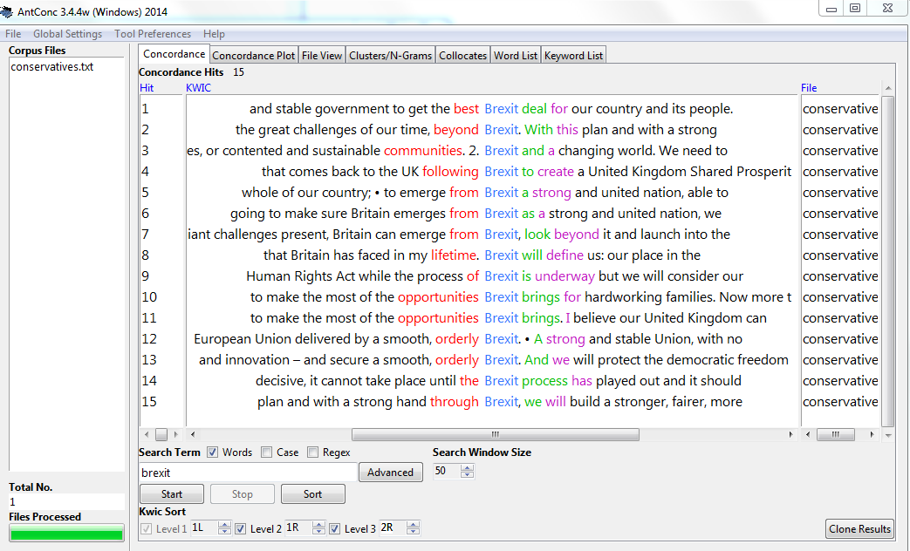 | - A basic corpus tool for concordance, collocation and keyword analysis of your own text corpora  - Available for Windows & Mac; no installation required (it runs directly from the executable file and can be stored on USB etc.)  - Free download from http://www.laurenceanthony.net/software/antconc/
BNCweb  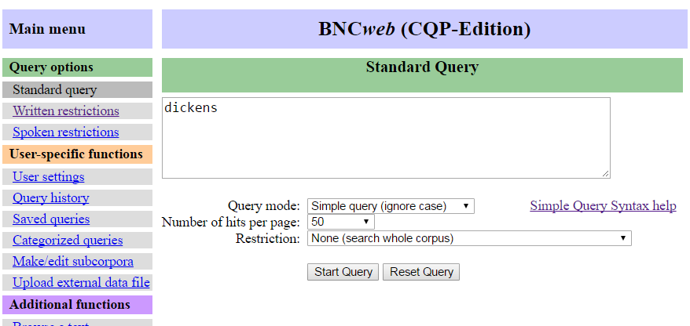 | - Online interface that provides access to the British National Corpus (BNC) – a collection of written language (~90 million words) & spoken language (~10 million words)  - Includes many registers  - Texts from 1970s-90s  - Enables similar functionality to AntConc, but contains a lot of text  - Free registration via http://bncweb.lancs.ac.uk/bncwebSignup/user/register.php  - Access analysis interface via http://bncweb.lancs.ac.uk/
WebCorp  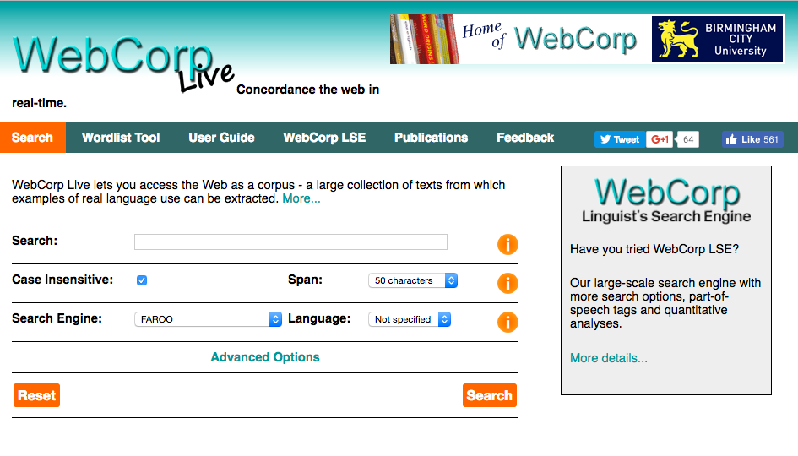 | - No registration or download necessary  - Produces simple concordance lines from live websites  - Can target newspaper websites  - http://www.webcorp.org.uk/live/

Appendix 3: Handouts for photocopying
This section contains sample handouts of the activities in Part II for photocopying. We will add more handouts to future versions of the CLiC Activity Book.

Activity: The creation of fictional characters

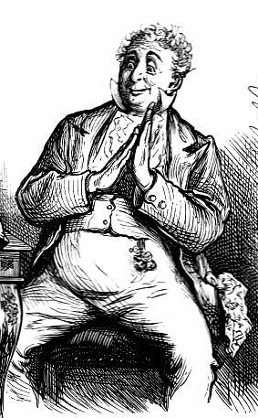
(Illustration for the 1872 edition of David Copperfield, by Fred Barnard
http://www.victorianweb.org/art/illustration/barnard/dc/45.html)

How can we use CLiC to discover more about characterisation?

1 Picking out the character
- Go to the CLiC Concordance tab (http://clic.bham.ac.uk/concordance).
- Select David Copperfield in the “Search the Corpora” box and select the subset “All text”.
- Enter Dick in the “Search for terms” box. Hit Return.
This procedure will extract all the references to the character ‘Mr. Dick’ from the novel David Copperfield. Consider how Dickens presents an early and rather enlightened picture of a person suffering from mental illness.

2 Picking out the characterisation
- Carry on from step 3 of Activity 8.1 above.
- In the “Concordance” column on the right, change the instruction in “Only in subsets” from “All text” to “Non-quotes”.
- Hit Return.
This focuses only on the narrative, so that every example of direct speech is excluded.

3 Isolating the reporting clause
- Carry on from step 6 of Activity 8.2 above.
- In the “Concordance” column on the right, change the instruction in “Search for terms” to “said Mr. Dick”. Don’t forget the full-stop on “Mr.”.
- Hit Return.
This shows how many of the examples invlove Mr Dick speaking. He is allowed to speak for himself to quite a large extent, rather than having other characters or the narrator speak for him.

4 Exploring the narrative comments on the character
- Start again by going to the CLiC Concordance tab (http://clic.bham.ac.uk/concordance).
- In “Search the corpora”, select “David Copperfield”.
- In “Only in subsets”, select “Long suspensions”.
- In “Search for terms”, insert “Dick”
- Hit Return.
This allows you to explore the interjections made by the narrator whenever characters are talking about or around Mr Dick.

5 Face and features of the character
- Start again by going to the CLiC Concordance tab (http://clic.bham.ac.uk/concordance).
- In “Search the corpora”, select “David Copperfield”.
- In “Only in subsets”, select “All text”.
- In “Search for terms”, insert “Dick”
- In “Filter rows”, try out a range of terms such as “head”, “face”, “eyes”, “mouth”, or “looked’, “watched”, “seemed”. Hit Return after each one.
- Try other synonyms or alternatives as they occur to you.
This sort of activity will help you to explore gestures and the symbolic importance of parts of the body in the creation of character in literary fiction.

You can follow up and compare your own findings here by searching for what other people have said about Dickensian characters like Mr Dick. Compare work by literary critics with online commentaries and students’ notes, for example.

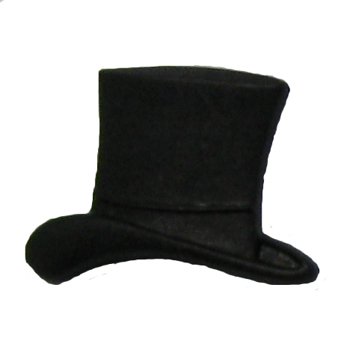
Activity: Exploring themes in The Sign of the Four
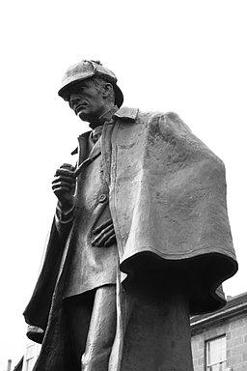
(Sherlock Holmes statue in Edinburgh, photo by Siddharth Krish. https://commons.wikimedia.org/w/index.php?curid=8863912)
1 Justice
- Go to the CLiC Concordance tab (http://clic.bham.ac.uk/concordance).
- Select The Sign of the Four in the “Search the Corpora” box. You will need to scroll down to find it in the section entitled “ArTs – Additional Requested Texts”.
- Select the subset “Quotes”.
- Under “Search for terms”, type the word justice.

Who speaks about justice in the novel? Go through the concordance lines and check the speaker. (Remember – you can click on the graphic in the column “In bk.” to the right hand side in order to go to the concordance line in the full context of the book itself).

2 Who speaks about justice?
- Carry on from the last step above.
- Click on “Manage tag columns” on the right side-panel and add a tag for each speaker that you can find. To do this, click on “Add new”, and a tag will appear in the box above labelled “new-tag”. Click on this label to highlight it, and then in the box below (headed “Rename selected tag column”) type, for example, holmes. Click anywhere in the blank space in the top box and the “new-tag” will change its name.
- Repeat for each speaker you can find, as shown in this screenshot.

- When you have finished, click “⟸ Back” at the top of the grey panel to take you back to the Concordance column. You will see your tags listed at the bottom, and also listed to the right of “in bk.” for each concordance line.
- To tag each line with the right speaker, select the concordance line (by clicking on it) and press the tick in the tag menu as shown in the following screenshot. You will see a tick appear to the right of each line, under the selected speaker.

3 The role of women in Sherlock Holmes
- Start again. Go to the CLiC Concordance tab (http://clic.bham.ac.uk/concordance).
- Select The Sign of the Four in the “Search the Corpora” box, as before.
- Under “Search for terms”, type the words woman and women. Select the option
- “Any word” to search for both at once.
- Read through the concordance lines: how are women described?

4 Finding and exploring further themes
- Watch the BBC Bitesize video “Themes in The Sign of Four” at https://www.bbc.co.uk/education/guides/zx7mxnb/revision

- Choose another theme mentioned in the video and look for related words or phrases in the CLiC concordance tab, following the procedures set out in the Activities above.

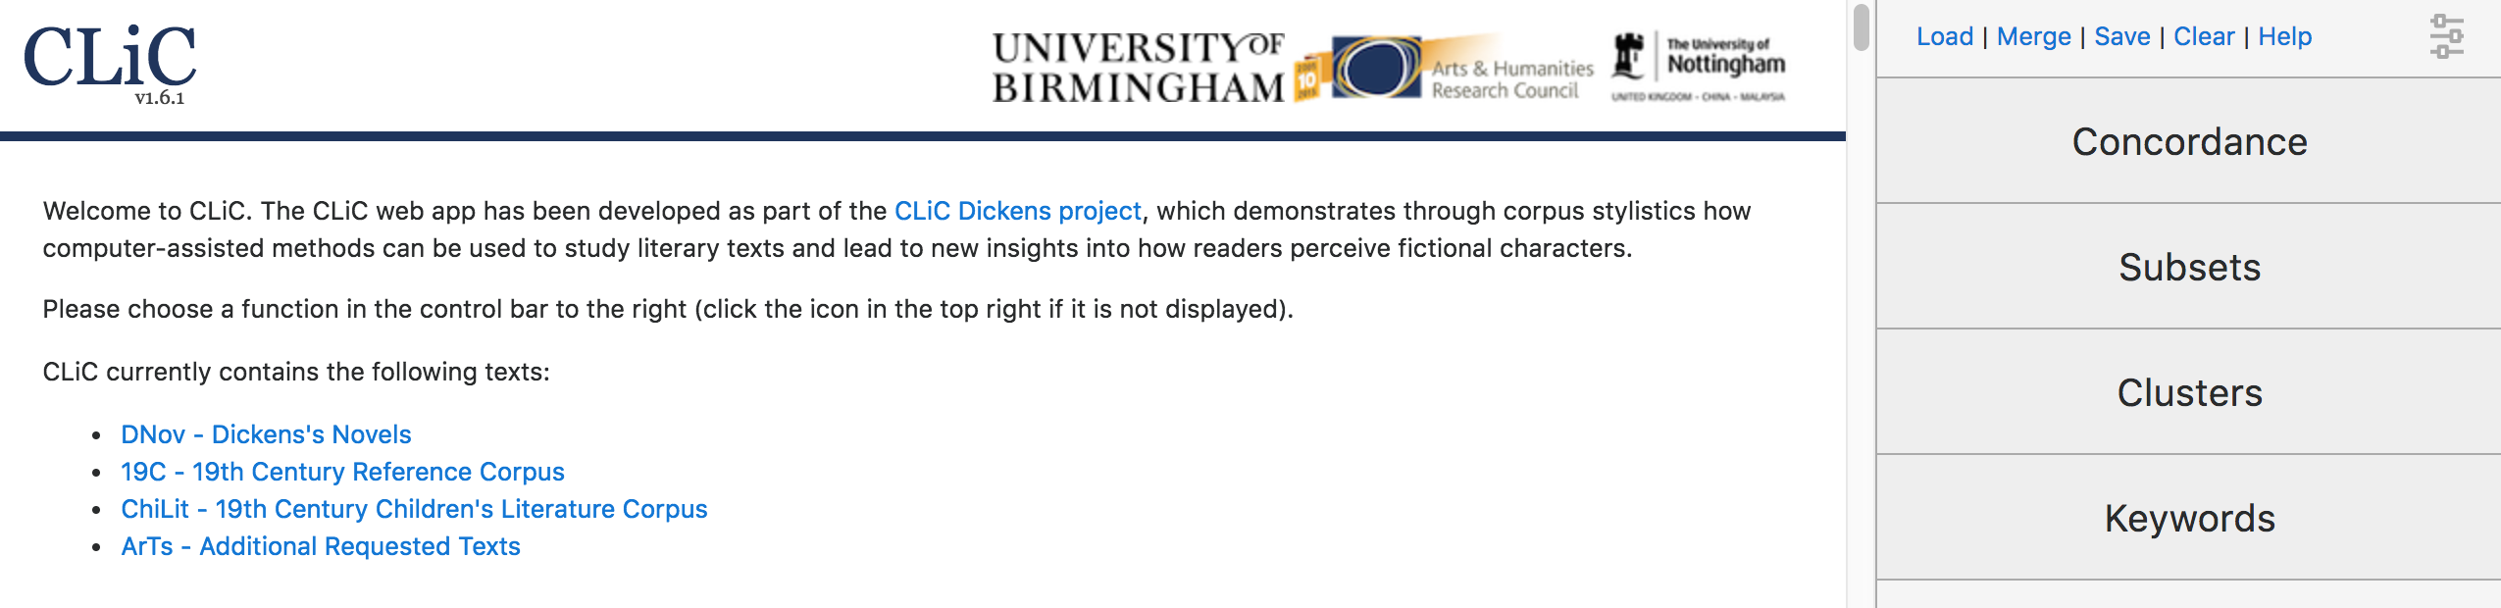
This book has been written for teachers and the exploration of literature in the classroom. Language and literature can be taught as separate subjects, but recent developments of language and literature specifications illustrate how both can and need to be integrated.
The CLiC – Activity Book makes suggestions for this integration. It provides examples of activities that teachers can adapt to or incorporate into their classes. It also includes activities that can inspire ideas for student projects for the NEA. However, even if you are looking for materials solely for language or literature this book provides relevant concepts and methods, as it is fundamentally concerned with how we derive meanings from texts – and especially how we ‘read’ literary texts.
The CLiC Dickens project demonstrates through corpus stylistics how computer-assisted methods can be used to study literary texts and lead to new insights into how readers perceive fictional characters. As part of the project we are developing the web app CLiC, designed specifically for the analysis of literary texts.

